UNIT TWO

FOLLOWING A NEW WAY

In this section we examine the beginning of the Franciscan movement, the early friars and the formation of the Rule of St Francis.

CHAPTER ONE: FRANCIS DISCOVERS A NEW FORM OF LIFE

- The First Friars form a Plan of Life
A Reflection
Discussion Questions

- The First Companions of Francis

- The Primitive Rule
Reflection Questions

- Francis and the Word of God
How Francis used Scripture
How to read Scripture

CHAPTER TWO: THE FORMATION OF THE OFM RULE

- The Formation of the Rule of 1221
The Rule of the Friars Minor
  - 3 phases

- The 4th Lateran Council (1215)
  - The Spirituality of the Tau Cross
Tau is salvation. Through the cross; through penance; a sign of life and victory

- Some Notes on the Early Rule
Rule written to address a present situation

- The Role of the General Chapter of the Order

- The Later Rule of 1223
  - Importance & content
  - Understanding the Rule today

- The Testament of St Francis (1226)

Review of Unit Two

Main Points of Unit Two

CHAPTER ONE

FRANCIS DISCOVERS A NEW FORM OF LIFE

Introduction:
To understand the spirituality of the Rule, we must see the Rule in its historical situation and know something about its development. Like Francis, we should reflect on the events that led to his new way of life and see God’s hand at work in the happenings of the past. The evolution of the Rule can be considered as a process over three or four stages. In the first chapter, we shall consider the development of the primitive Rule or Form of Life and how it came about. It is important that we spend time on this as it became the basis of all Franciscan life and later expressions of the Rule. We shall briefly identify some of the early followers of Francis and how they helped form the primitive rule that was to be presented to the Pope for approval.

In Chapter Two, we shall look at the formation of the Early Rule, the influence of the Fourth Lateran Council and then some notes on the Early Rule, and then the later Rule (1223) and its relationship to the Early Rule of 1221, its content and importance. Finally, we will briefly look at the Testament of St Francis (1226).

1. THE FIRST FRIARS FORM A PLAN OF LIFE
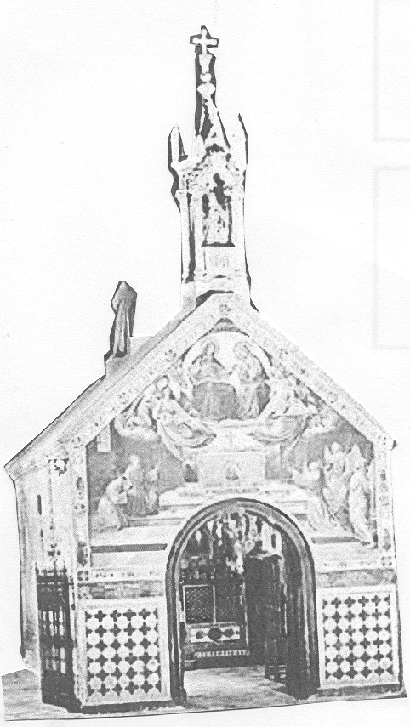
The command that Francis heard at the fallen-down church of San Damiano was: “Go, repair my church which as you can see, is falling into ruins.” This became a driving force behind all Francis’ actions in his efforts to please God. Celano tells us that, at first, Francis did not know what to do. He spent a whole month hidden. It was after this that his father had the dispute with Francis and where Francis chose God as his Father. After this, he turned to repairing the old church of San Damiano, which was falling down, as he was asked to do.

The second church that he turned his attention to was the church of Mary of the Angels. This had belonged to the Benedictines of San Sabasio but had been abandoned. In fact, it was to play a significant role in the life of Francis and the Franciscan movement. Francis liked that church very much because of its isolation and because it was named after the Mother of God. But as he worked he gradually came to understand that he was to do much more. God wanted him to renew a Church, many of whose members were morally and spiritually corrupt.

Francis had already consecrated himself to God. He began wearing the clothes of a hermit and spending more time at prayer. One day he was attending Mass on the feast of St Matthias when he heard the reading of the Gospel of Matthew:

“Go! preach the kingdom of heaven is near! Heal the sick, bring the dead back to life, heal those who suffer from dreaded skin diseases, and drive out demons. You have received without paying, so give without being paid. Do not carry any gold, silver or copper money in your pockets; do not carry a beggar’s bag for the journey or a spare shirt or shoes or a walking stick. A worker should be given what he needs.

When you come to a town or village, go in and look for someone to welcome you, and stay with him until you leave that place. When you go into a house, say, ‘Peace be with you.’ If the people in that house welcome you, let your greeting of peace remain; but if they do not welcome you, then take back your greeting.”

This reading made a great impression on Francis. He was not sure that he understood all that it was saying, so he went to see the priest after Mass to ask him to explain it to him. When Francis heard the priest’s explanation and that “the disciples of Christ should not possess gold or silver or money; nor carry on their journey a wallet or a sack, nor bread nor staff, nor to have shoes nor two tunics, but that they should preach the kingdom of God and penance,” Francis was overjoyed and exclaimed: “This is what I want. This is what I seek. This is what I desire with all my heart!” and “so after memorizing what he had heard, he joyfully fulfilled them.” Immediately he took off his shoes, put down the staff he was carrying and exchanged the leather belt for a cord. After this, he made a tunic for himself and marked it with a cross (the Tau) as a sign of his fight for Christ against evil. Br Thomas of Celano tells us also that the cloth was rough so that in this way Francis might do penance for sin. Francis understood that the Lord was inviting him to preach conversion and peace after the example of the apostles.

Francis went out to preach to share his new understanding with everyone. He wanted to share the joy he had discovered in a life of poverty and penance. His work of rebuilding ruined churches and his preaching attracted others who wanted to follow him in his new form of life.

The high point of Francis’ conversion was God’s revelation to him that he should live “according to the form of the holy Gospel.” It is important to stress that though this revelation came to Francis in an instantaneous flash, it was prepared for by a purifying inner transformation. This was what St Paul describes as “a complete change of mind” (cf. Rom 12:1-3). This revelation opened up to Francis a radically new way of life, one based on the literal observance of the Gospels.

A REFLECTION
Just imagine what this moment meant to Francis and what it could mean for us. This was the moment of discovery! He had found what he had been looking for after so much long soul-searching. He had already made his commitment to serving God standing naked before the Bishop and his father when he exclaimed, “…from now on, I will not say ‘my father, Pietro Bernadone’ but ‘Our Father who art in heaven.’” By this statement he expressed his commitment to God as God’s servant.

Now, Francis expressed his first understanding of his commitment to this new way of life. Now, he realized how he was to serve God. The “following of Christ” was to be his main source of action and spirituality. This was to lead to a deepening of his baptismal promises. It was through his reflection on this that he came to understand that he and his companions were to be “lesser brothers,” and that is why he gave them the name of “Friars Minor.” The brothers were to be “Lesser Brothers” and not to be put above others. Jesus was poor and always the Servant of others; so, too, the Friars Minor were to be servants not only of others but of each other. They were to be equal in rank, respectful of and caring for each other, especially when any one of them became ill. This was also why he placed such an emphasis on poverty, living like Jesus who made himself poor for us.

Discuss
- What significance do you see in this incident in the life of Francis for your own life?
- What should you do to deepen your life as a disciple of St Francis?

2. THE FIRST COMPANIONS OF FRANCIS

The first follower of Francis was Bernard of Quintavalle. He was a rich man, sensitive to his own conscience but who was also a very practical man. At seeing Francis he was uneasy but felt he needed to know more of Francis before he could decide what he was to do. He invited Francis to come to his house several times. One night he observed Francis at prayer. This was his deciding moment. He realized Francis was indeed a holy man and truly sincere and no idiot. He gave everything he had away and joined Francis.

The second man to join Francis was a canon of the cathedral. His name was Peter Catanii. He was not as rich as Bernard but he was an expert in Law. He was a canon at the cathedral of St Nicholas and became interested in Francis and his new way of life. He came to Francis for advice. Francis invited him to consult the Gospel book with him. It was after doing this that Peter decided to join Francis and follow his way of life.

The third man to join Francis was a priest called Sylvester. He had witnessed Bernard and Francis when they were distributing all that Bernard had to the poor. He was so surprised by this action that he thought about the time Francis had bought stones from him to rebuild the church of San Damiano and how little he had asked for the stones. He now went to Francis and said, “You did not pay me enough for the stones you bought from me.” Immediately, Francis went over to the bag of money that Bernard had and filled his hand with coins and gave them to the complaining priest. He then filled his hand a second time and giving this to Sylvester he said, “Have you enough payment now, Lord Priest?” “I have it completely, brother,” replied Sylvester and went home overjoyed with so much money. After a few days, however, the priest reflected on what he had done and was filled with remorse.
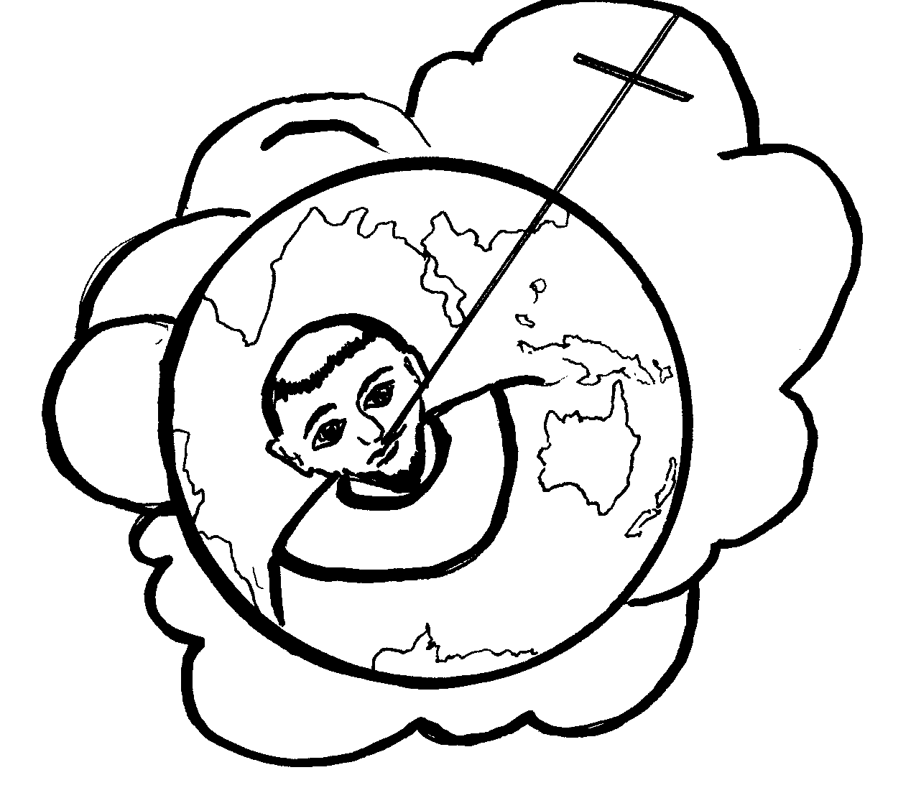
The following night he dreamt about an immense cross with its top reaching up to heaven and its base resting in the mouth of Francis. Its area stretched from one part of the world to the other. When he awoke, he understand that Francis was Christ’s friend and servant and that his way of life would spread throughout the whole world. He then began to do penance in his own home but it was not long before he, too, entered the Order.

It was after this that Francis moved with his brothers to live in the little abandoned church called “St Mary of the Portiuncula.” There they lived building little huts, one for each.

The fourth man to join the group was a man from Assisi called Giles. He came to Francis shortly after the brothers had moved to the Portiuncula. Francis was so impressed by his great sincerity that he willingly accepted him. “These four, united in immense happiness and the joy of the Holy Spirit, separated for greater spiritual advantage.”

“After they had travelled around… they returned to the place called St Mary’s and a few days later three other men from Assisi came to Francis to accept them into the Order. These were John de Capella (who was probably a nobleman), Sabbatino and Morico. We do not know about these men except that Francis accepted them humbly into the Order and that they suffered extreme want because not even their relatives and families would help them. Instead they mocked them as senseless and stupid. The Bishop of Assisi received them kindly but questioned the wisdom of depending on Providence to support them. Francis insisted that God would take care of them.

The brothers increased in number. Another man who came to join Francis was Philip, who later became an excellent preacher, and others. “These men, from various walks of life, came together because of their common desire to live the Gospel in a new and radical way. All were expected to share in the tasks of daily living, all were to be servants. In this new fraternity class and family origin played no part. Their approach undermined the medieval class-consciousness that regarded the existing social order as being a divine institution. The company that was led by Francis sprang from the fundamental fact that God has no personal favourites (Rom 2:11); one person was not better than the other.

In his writings, the saint described this life which he and his brothers began to observe at God’s inspiration: they sold all their possessions and gave them to the poor; they were content with a single tunic, cord and trousers; they stayed in churches, were unlearned and subject to all; they carried nothing on their journeys, used the salutation of peace, and ate and drank what was set before them. They did not contend in words, but were at peace with each other. They shared their goods with all who asked of them and preached to people by word and example, admonishing them to turn their hearts to the Lord. Finally, they fasted, prayed and worked with their hands.

This simple yet dramatic form of life, centred about the observance of the three Gospel counsels, was to be lived within the community of Christ’s Church. Francis was certainly conscious of the dangers of teaching false doctrine which confronted his loosely organized brotherhood and to which a number of contemporary apostolic groups fell prey. He was conscious, too, that only by being faithful to the Church his brothers would avoid this trap.

3. FRANCIS FOLLOWS GOD’S PLAN
Note that, unlike St Benedict, Francis did not set out to start a new form of religious life in the Church. But when he recognized that this was God’s plan because of the men who came to him seeking to follow his example, he accepted it. He gathered his companions together to work on a form of life that they could follow. This was the beginning of a process that was to take about thirteen years before the Rule was finally approved in 1223.

Francis invited his two new companions, Bernard and Peter, to come with him to consult the bible at the church of St Nicholas. He already knew what he wanted to do. The triple opening of the book of the Gospels was only a confirmation of what he already desired. Those texts became part of his primitive Rule or Form of Life that they were to follow:

If you want to be perfect, go and sell all you have and give the money to the poor, and you will have riches in heaven; then come and follow me. (Mt 19:21)

If anyone wants to come with me, he must forget himself, carry his cross, and follow me. (Mt 16:24);
Take nothing with you for the journey: no walking-stick, no beggar’s bag, no food, no money, not even a spare shirt. (Lk 9:3)

These were the basic texts that Francis and his companions used as a guide for their new way of life. The early author, the Anonymous of Perugia tells us that when Francis heard these words, he exclaimed, “This will be our rule!” The Legend of the Three Companions expands this to “This will be our life and our rule and of those who want to join us.”

After that Francis gathered twelve followers around him who were anxious to follow this new evangelical form of life. They had to find ways of expressing these texts in practical terms as it applied to their everyday life. Once they had done this, Francis, with the advice of Bishop Guido of Assisi, decided to go to Rome to have the blessing of the Church on his way of life and seek to have it accepted by Pope Innocent III who was ruling the Church at that time, 1209 or 1210.

4. THE PRIMITIVE OFM RULE (OR FORM OF LIFE)

What was this first Form of Life? To answer this question honestly, we must say that we don’t know exactly. We do know that Francis had written a Rule for he tells us this in his Testament. What did it contain? It has been suggested that this proposal of a Plan of Life in 1209 was no more than a list of Gospel texts which spelled out what Francis understood as the way of life God wanted him to follow. Also from his experience among the people, Francis saw the need to add some guidelines to help his companions to follow Christ more closely.

David Flood expressed his ideas about what it must have contained, namely,

a) Commitment to the gospel, that is, “sequela Christi” or “the following of Christ” lived according to the example of the apostles: to preach to the poor, to preach the kingdom, conversion and peace).
b) A life lived in obedience to the Pope. David Flood suggests that the first Rule is contained in the Rule of 1221, otherwise the reference to Innocent III would not make sense; and

c) The way of living out their following of the Gospel.

This is what Francis and his twelve companions eventually took with them to present to Pope Innocent III for approval. Francis was aware that other poverty movements in the Church had been condemned so he wanted to place his Order under the protection of the Church.

“As the number of brothers began to increase, Francis was forced to set up rules for his brothers. According to Francis, the only rule to follow was the Gospel of our Lord. His main emphasis was on poverty; he wanted to be simple and be poor like Christ, without concern about material goods, but to strive and work for the Kingdom of God.”

Realizing that the number of brothers was growing rapidly, he decided to get help from Bishop Guido of Assisi to write a rule for the brothers. Having examined the Gospels, the brothers decided on a rule for themselves which they presented to Guido and described the kind of life they were seeking. Francis was always aware of the dangers that other movements made in working apart from the Church.
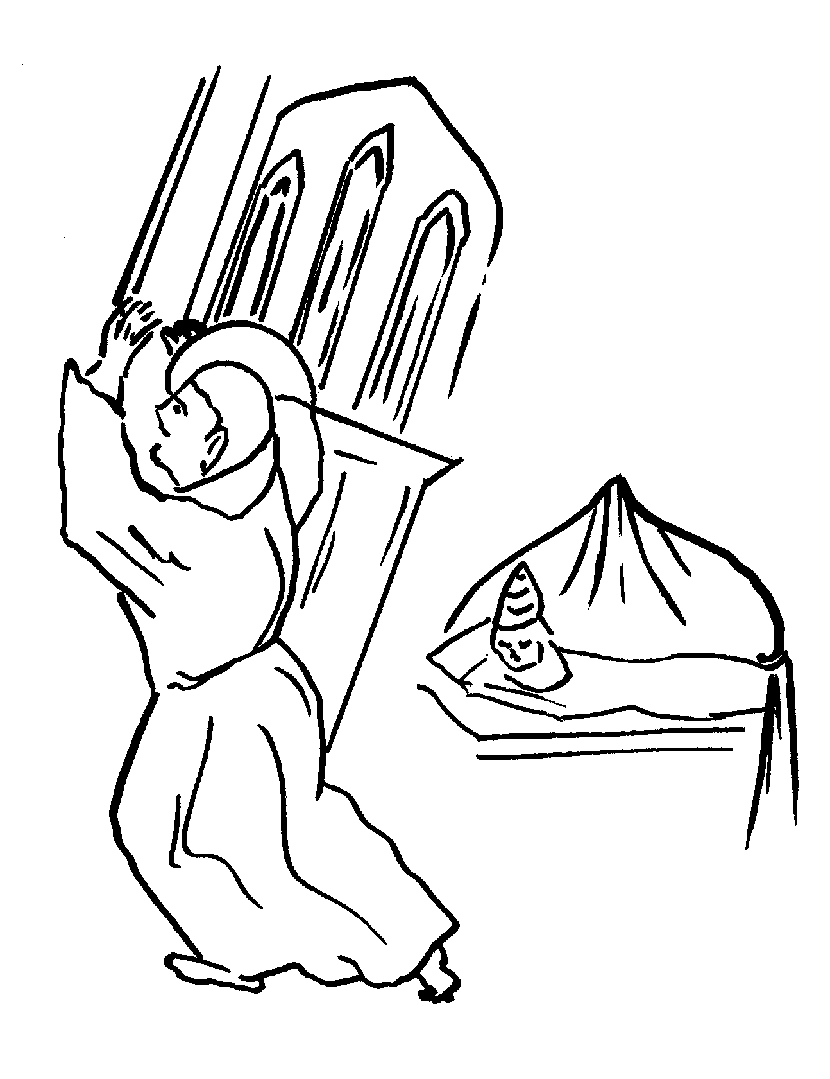
The story of how Francis had sought approval is well known. When Francis and his companions first approached Pope Innocent, he was suspicious of them, but after having had a dream where he saw Francis holding up the basilica of St John Lateran, he was convinced of Francis’ genuineness. He called for Francis and, he not only approved the new form of life, but invited Francis to preach the message and his understanding of it to everyone. “Though Innocent approved their way of life, he wanted them to experiment in shaping their life according to those texts while at the same time gaining experience so that they could write a more comprehensive rule of life.”

Francis returned joyfully with his companions to Assisi to carry out all that he had proposed. They placed themselves at the mercy of the people of Assisi, trusting that God would care for them. In fact, their way of life had impressed many people and there were many who wanted to follow them. It was from this time that the Order began to grow quickly.

Francis tells us he was inspired by God to work with this group of brothers. They would be different from the hermits, monks and canons of his time. Instead of imitating the monks who lived in their monasteries to “escape the world”, Francis’ brothers were to be “received into obedience” (RB 2) and wander from place to place and live amongst the people. Their monastery was to be a state of mind and heart. As it was said later, “the whole world was their cloister.” They were to commit themselves to the brothers and, with the brothers, discern God’s call. And that basically is what they did. An ordinary day might go something like this:

The brothers gather for the Eucharist in the morning and then go out to work, each one working at his trade. In the evening, they would come together for a simple meal and relate the incidents of their day, possibly interpreting them with the eyes of faith. The meal times were joyful times of sharing ideas.

Then, after the meal, they would read some passage of Scripture or tell stories. In this way, they would discern how God was calling them to live their lives or how they were to preach, or how to love and care for lepers and especially how they were to love and care for one another. It was at these times when problems were shared and discussed. In this way, their form of life began to take shape in the practical situations of their lives.

Reflection
- Consider how God worked in the life of Francis and his companions. When the time was right, God acted in creating a new movement in the Church.
- Consider the kind of life that the early friars lived in their communities. What similarities and differences do you notice from our lives today? Discuss this amongst yourselves.

5. FRANCIS AND THE WORD OF GOD

“Once when [Francis] was sick and full of pain all over, his companions said to him: ‘Father, you have always taken refuge in the Scriptures, and they have always offered you relief from pain. Please, have something from the prophets also read to you now, and maybe your spirit will rejoice in the Lord.’ The saint said to him: ‘It is good to read the testimonies of Scripture, and it is good to seek the Lord our God in them. But I have already taken in so much of Scripture that I have more than enough for meditating and reflecting. I do not need more, son: I know Christ poor and crucified.’ “
2 Cel, 105
This story indicates to us that reading the Scriptures was an important aspect of Francis’ life, and that this was one way in which he sought God and came to know the person of Jesus Christ. Right through his life from the time of his conversion it is clear that Scripture, the Word of God, was something he relied on as a guide for his life.

How Francis Used Scripture
Francis often referred to the Bible. He often quotes texts from the bible but he quotes freely as we can see in Admonition One, and he also draws out other thoughts from the reading. Cf. Admonition 1:10-11

Francis often adapts bible texts and assimilates their thought. In other words, he interprets the idea in his own way. For example, he takes the Golden Rule “Whatsoever you wish men to do to you, do so to them.” (Mt 7:12; Lk 6:13) The only literal quotation of this text is found in the Rule of 1221: “The friars should behave towards one another the way the Lord tells us: Therefore all that you wish men to do to you, even so do you also to them; and, What you do not want done to you, do not do to anyone else.” Francis applies the Golden Rule to a number of specific situations in the life of the friars.

Francis rarely uses the narrative stories in the Gospels, but rather he prefers the sayings of the Jesus tradition of the Gospels. But we must note that Francis always allowed a certain flexibility by interpreting the Gospel texts according to circumstances. The word of the Lord is, for Francis, an ideal, but it has to be applied to the existing needs of his time.

How would Francis have us Read and Study the Word of God?

- Francis had great reverence for Scripture even putting it on an equal basis with the Eucharist. We should love and reverence the Scriptures, not just what is contained there, but even the books and writings in which we find the Word of God. For Francis, these were to be treated on a par with the Eucharist.
- The Scriptures (and especially the reading from them in the Mass and Office) should become the basis of our meditation so that we can learn with God’s help to apply what we read and hear to our own lives and to our own times.

- We should, in the spirit of Francis, seek out ‘theologians’ and ministers of God’s word in order to have the Scriptures explained to us, whether this be by listening more attentively to sermons, reading about Scripture, listening to tapes, etc.

- Our reading of Scripture should always lead to prayer and meditation, and thence to action. The desire to follow the Spirit revealing himself through Scripture is the key to life. All temporal things must be subservient to the fostering of the spirit of prayer and devotion. “It is the spirit that gives life, the flesh is of no avail; the words that I have spoken to you are spirit and life.”

SHOW GREAT REVERENCE BASIS OF OUR MEDITATION

GOD’S WORD IN SCRIPTURE

UNDERSTAND WITH THE SHOULD LEAD US TO PRAYER,
HELP OF THEOLOGIANS MEDITATION AND ACTION
SERMONS, READING,
LISTENING

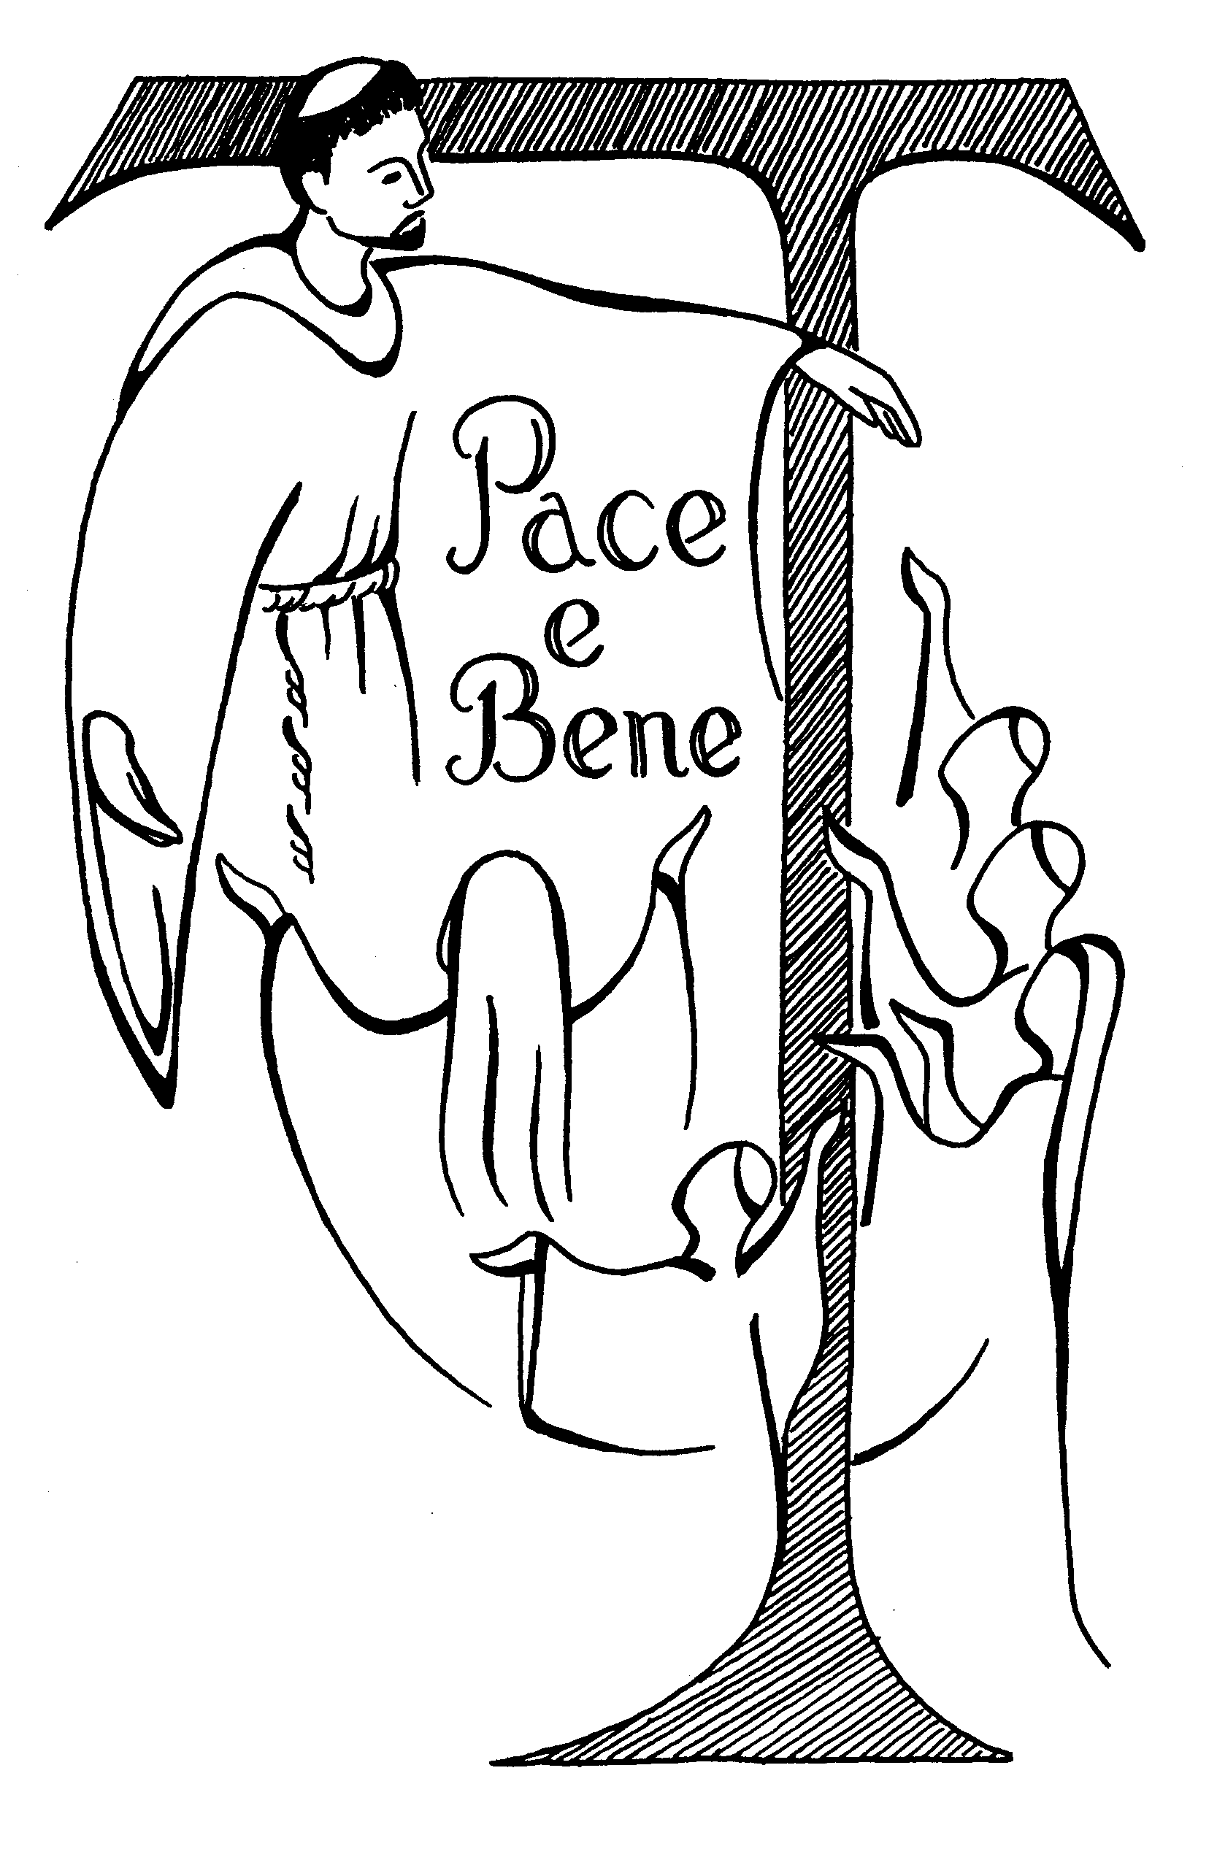
PAX ET BONUM !

This is the greeting that Francis gave everyone as they went along the road. It means “Peace and well-being!” Francis had probably borrowed this greeting from the Gospel passage Lk 10:5-6

“Whatever house you enter, first bless them saying, ‘Peace to this house.’ If a peaceful person lives thee, the peace shall rest upon him. But if not, the blessing will return to you.”

“What is striking about the friars’ Gospel life is that they were eager not only to preach peace but also to bring it about.”

CHAPTER TWO

THE FORMATION OF THE RULE

1. THE RULE OF THE FRIARS MINOR We can distinguish three distinct phases in the formation of the Rule:
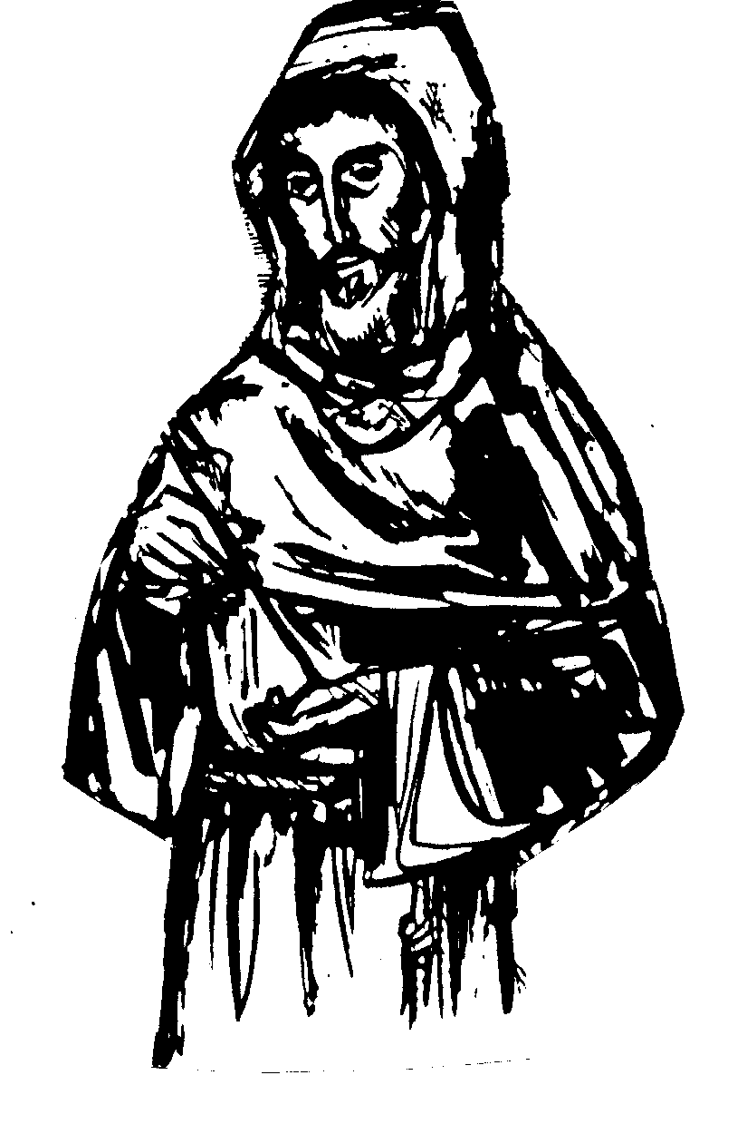
- The Primitive Rule approved by Innocent III orally in 1209/10;
- According to The Legend of the Three Companions, Francis composed other Rules where he experimented before the definitive Rule was written. Everyone agrees that there was an evolution in the formation of the Rule.
- The approved Rule of 1223 (Regula bullata).

It is impossible to say how long the early Form of Life remained in its original form. The increase in the number of friars and the spread of the Order into new areas brought about new problems especially concerning the forming of the brothers and in organization. The former Primitive Rule proved inadequate to deal with these new situations.

The very personality of Francis who, until then, had been the norm of living and the model of life and rule of the friars, could not meet the new demands of individuals in forming and uniting them. Defining structures was a felt need of urgency.

It is easy to see that the Rule had to develop over the years from 1209 until 1221 over a period of ten to twelve years with regular changes to suit changing conditions. But though changes were made, the basic ideas remained the same. What was central to Francis was the life of the brothers and its radical gospel demands and his reactions to concrete life situations and new conditions in the development of the Order.

Let us review how the Rule developed:
- We already saw how the friars gathered to discuss their lives and to share their experiences.
- On the basis of these experiences they made changes or set down rules or guidelines which would later form the Rule of life they were to follow. In this way the early rule was formed gradually over the years.
- Francis with his friars added many warnings and advice to the Form of Life as they were judged to be necessary before it was finally decided to place his ideas before all the friars for their decision during one of the gatherings of the friars.
Note that Francis and his brothers set down texts of the Rule in the setting of their own culture and in their own historical situation. In other words, we must situate the brothers in their times and conditions to understand their motives and purpose. The friars lived within the society which cared for them and at the same time were influenced by them. Yet the very way they lived was a challenge to the society and its values.

2. THE FOURTH LATERAN COUNCIL (1215)

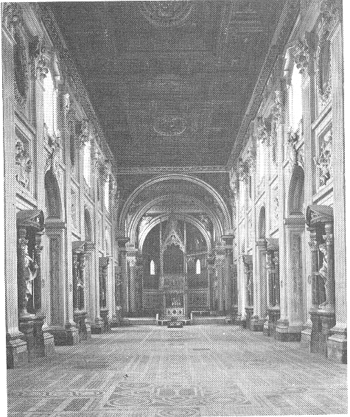
Basilica of St John Lateran
One great influence on Francis in the formation of the Rule was the Fourth Lateran Council. It was called by Pope Innocent III after careful planning and was one of the best attended and most important of the Lateran Councils. “It took up every major political and spiritual issue of the time: it promoted a new crusade; drew up procedures to deal with heretics, specifically the Albigenses and Waldenses…and restricted the establishment of new religious orders. Much of the legislation dealt with the sacramental life of the Church: it spoke of the Real Presence…and enjoined all Christians to receive the sacraments of penance and the Eucharist at least once a year.”

This Council had a great deal of influence on Francis and the Form of Life that he and the friars were developing: He attended this Council at which he had his Rule approved and at which the famous meeting of St Dominic with St Francis took place. However, one of the important moments in Francis’ spirituality also occurred at this Council. When Pope Innocent III gave the opening address, it had an effect on all who heard it.

It occurred on November 11, 1215, Pope Innocent III opened the Fourth Lateran Council with a sermon in which he commented on the passage from Ezekiel 9:4. The Pope quoted the words, “Sign the men on the forehead the sign of the Tau” And then he added: “The Tau is the last letter of the Hebrews alphabet and it has the shape of a cross such that the cross was presented first so that it would be placed as a signpost to Pilate. One carries the sign of the Tau on one’s forehead to express that in all one’s conduct one carries the splendour of the cross; one carried the Tau if one crucifies one’s flesh with its vices and sins; one bears the Tau if one affirms: “I want nothing else than to glory in the cross of our Lord, Jesus Christ… Whoever carries the cross (Tau) will find mercy, a sign of a penitent life, renewed in Christ. Therefore, be champions of the Tau and of the Cross!”
This concept of the Tau cross corresponded with the fervent cry of Francis and it profoundly influenced his spirituality. This was an appeal for a general movement of Christians for a Crusade of conversion and penance. Therefore, Francis wanted to obey the Pope and signed himself with the Tau of penance; he wished, by signing his brothers with the Tau, to remind his friars of their vocation, their life of penance. They were also to sign all Christians with this sign of penance. This became a favourite theme of Francis’ preaching and made it a constant theme of the Rule of 1221, and of his Letter to all the Faithful.
THE SPIRITUALITY OF THE TAU CROSS

It is generally recognized that this is why the Tau became such a characteristic symbol of Francis and Franciscans and towards which Francis always showed so much devotion. The Tau Cross expressed the deepest desires that Francis had to become like Christ.

Analysing the spiritual content of the Tau in the theology of St Francis, we can name four great themes essential to his faith and mysticism:

a) Tau is salvation
No one can be saved unless he is signed with the Tau. When Francis saw this sign, he received a new assurance of his salvation. The day that he understood that Br Leo was being assailed by doubts about his eternal destiny, Francis drew the letter Tau and restored his hope. The author of the Sacrum Commercium learnt a lot from this aspect of a Franciscan prospective when Lady Poverty is made to say: “When Jesus goes up to heaven, he left you with a symbol of the kingdom of heaven (the Tau) to sign the elect…because no one can enter the kingdom if he is not sealed with the Tau”.

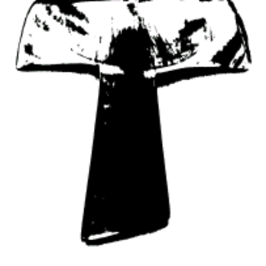b) The Tau is salvation through the cross
To be saved one must be baptized in the blood of Christ, spilt upon the Cross. This is the mystery that every cross and every sign of Tau reminded St Francis and his companions. For this reason they recited the prayer: “We adore you, O Christ and we bless you because by your holy cross, you have redeemed the world.” The brothers…would do the same whenever they happened to see a cross or a form of the cross on the ground, on the walls or among the trees, or in the hedges. (1 Cel 45)
Hence, the spirituality of the Tau is no other than the spirituality of the cross, that is, in the love of Christ who died for us on the cross. The Book of Exodus reminded Francis about the paschal lamb whose blood was painted on the door posts of the houses and for this reason, he painted the walls of his cell with the Tau.

c) The Tau: Salvation through Penance
If the cross achieved salvation for all once and for all, we should renew this mystery in ourselves daily. We should “carry the cross of our Lord Jesus Christ.” (Adm 4:8) This is the Crusade of the Tau preached by St Francis, a crusade not composed of armed soldiers to conquer Jerusalem, but a crusade of penitent men, who have come to Assisi to preach to all: “Do penance, bear fruits worthy of penance!” (Rnb 21:3) Here is where the spirituality of the Tau meets the spirituality of Disciples of Christ (Sequela Christi) Jesus said: “Whoever wants to follow me must carry the Tau.” St Francis understands this as “Whoever wants to follow me must be signed with the Tau which has the form of a cross. He would have liked to arrive as far as martyrdom in order to be signed with the Tau of blood. Francis would be signed with the stigmata.

d) The Tau is a sign of life and of victory.
There is a book in the New Testament that speaks of the Tau without mentioning the name: the Book of Revelation (Apocalypse). It presents the elect as those who are signed on the forehead with the seal of the Lamb. (Rev 7:2; 14:1-7). This seal is impressed by an angel who comes from the East.
Was Francis struck by these texts? Did he discover some insights for his mission, for his Crusade of the Tau and of penance from these texts? It’s possible but we can’t prove it from the written sources. Couldn’t we deduce it from the use that St John and St Francis make – 22 times in the Admonitions alone – of the expression “servants of God” to mean on one hand “penitents signed by the Tau,” and on the other hand, “Friars Minor”?

In any case, what is certain is that this text has frequently been applied, and sometimes in an abusive way, to St Francis, as if St John had St Francis in mind speaking personally of St Francis, while speaking at the same time about the angel who comes from the East. Such an interpretation gathered favour in the circle of the Joachimites.

3. SOME NOTES ON THE EARLY RULE

Let us note the following:

- At the beginning, Francis tried to form a small, mobile, self-supporting group who went out to preach to the people but would always gather again from time to time to share experiences.

- Francis had a great influence on the development of the Order and the friars always looked to him for leadership. However, as the years passed, many more men came to join the friars so that within ten years there were thousands of friars scattered all over Europe.

- Clearly, the same kind of rules that governed a small group was not enough for such a large group. It was necessary to have a written Rule that friars could carry with them even as a protection against being called ‘heretics’ by various bishops or priests who did not know them or the Order.

- At the start, Francis sent the brothers out to preach around Assisi, but later he decided to send them further away. This caused some complications because while they had permission to preach within the diocese of Assisi, when they went further away this permission no longer existed. There was a clear need for more guidelines.

- Again because of the great number of friars, the Rule needed to be adjusted to fit their various situations. Clearly, Francis needed help holding the movement to the paths he knew the brothers should tread.

It is important that we be aware of the historical situation of the Order at the time after the Fourth Lateran Council. Here is a brief outline of events:

In 1219, Francis went to the Holy Land with a dozen friars with him to convert the sultan leaving the government of the Order in the hands of two friars, friar Matteo da Narni and friar Gregorio da Napoli. However, these friars did not adhere to the ideals of St Francis and Francis was called back to Italy to deal with the situation in Spring 1220. A Chapter was called at which Francis abdicated. Francis saw the need for a new Rule to be written. He called on the help of Cardinal Hugolino, Protector of the Order, who advised him. Peter Catani was chosen as Vicar to take the place of Francis in the Order.
The next six years (1220 – 1226) of Francis’ life were very difficult for him. He had to endure many changes made by men who were in power – changes which went against his ideal of poverty. “Absolutely certain of his vocation and of the particular form which it had taken, and longing to get others to accept the same standards of humility and poverty, he was obliged to see more and more departures from the original Rule and intention of the Order, while strong-minded men who failed to share in his ideals got more and more power into their own hands. Francis bore it all with such patience and humility as he could command, but it was a very sore trial to him.”

THE RULE OF 1221
The main problem for him was the writing of a new Rule to address the present situation of the Order with five to ten thousand members. Francis spent the winter of 1220-1221 composing a new Rule. He offered this document to the General Chapter as a compromise measure and which remained the unofficial Rule of the Order for two years. This is known as the Rule of 1221 or non bullata (unapproved).

Let us look more closely at the Rule of 1221 as it contains all the ideas that were later expressed in a very much shortened, formal and legal Rule of 1223 which was accepted as the Franciscan Rule of the Friars Minor.

This Early Rule (1221) of St Francis is important because it helps us to see how the first community of brothers, through the test of experience, sought to hold and deepen their ambitious project which was to determine their way of life in detail. It is clear that the Pope (Innocent III) saw in the friar’s way of life – as well as the Friars Preachers (Dominicans) - useful tools that the Church could have at its disposal to renew the Church.

The Rule and Life of the Friars Minor is this:
To observe the holy Gospel of
Our Lord Jesus Christ…

Recent studies have shown that the first 17 chapters of the Rule give us a complete description of the life of the brothers. Here are some things to note:

- The word “rule and life” are to be understood as “guidelines” for those seeking to follow Christ. The evangelical counsels are a concrete manifestation of how the Gospel life takes shape.

- The friars will live “in obedience”. There is no mention of remaining in a monastery.

- “Divine inspiration” is named by Francis as the primary motive that must be present in a prospective candidate. The brothers are to explain the “tenor of our life” to candidates. The word “tenor” suggests the candidate must understand the meaning and tone of Franciscan community life. A man’s acceptance should be marked with kindness. “At first this may not seem to be an exceptional directive, yet it is in direct contrast with the Benedictine approach, which permitted a newcomer to enter only after a period of trial…to ‘test their spirits’ [1Jn 4:1]. Francis, in contrast, would have newcomers received with kindness…there was only one condition: selling their belongings and giving the money to the poor” if this was possible. In 1220, Honorius decreed that they had to have at least one year of probation.

- The prayer-life of the community and the discipline necessary for a healthy spiritual life are explained. It is quite simply the sanctification of each day binding all together in praising God and in centring their lives on the Word of God. Francis would have all do the same.”

- Fasting was an integral part of the life of the early community. It was part of their preparation for the liturgical seasons of Christmas and Easter as well as a communal discipline during Ordinary Time. Ascetical practices have long been regarded as necessary aids for growing spiritually.

- The prohibition of money went against the values of society of the time. Only in cases of extraordinary need did Francis permit begging for food and the necessities of life to meet the legitimate needs of the community.

- Friars were not to take on positions of authority over others. They were to use and develop their gifts.

4. THE ROLE OF THE GENERAL CHAPTER OF THE ORDER

It is important to note here the work of the General Chapters in the development of the Rule. The General Chapters became the place and instrument to complete periodically the law of life in the Franciscan Order. In those Chapters also the Order was organized into Provinces, electing Provincial Ministers and Custodes for various circumstances of the Order with the duty to protect the friars in their ideal of apostolic life so none would be lost; also to stimulate the group to action.

From these Chapters also arose the first “places” or “houses” or convents (friaries) of the Order as bases from which they could move out on apostolic work; also the first formation houses for the friars were established to form friars for the exercise of their mandate to preach penance.

The Rule was revised to 23 chapters and received the approval of the Pentecost Chapter in 1221 and was proposed for the observance of the whole Order. This Rule contained the Primitive Rule with its ideal of apostolic life, and the norms which St Francis and the friars, meeting in Chapter, had decided on. The Rule always remained faithful to the original intention of Francis, as well as adding some admonitions that St Francis had presented to the friars during the Chapter. Even with all these changes, this Rule re-proposes integrally the content of the Primitive Rule. The items vary in matters of organization of community life, but not in the fundamental option of apostolic life to which Francis and his companions were bound.

It is important to remember that the Rule grew out of the Franciscan fraternity and not from Francis alone.
5. THE LATER RULE OF 1223
Again, note that there is only one Rule of the Order of Friars Minor, but several “editions” with a number of amendments. However, the basic Rule is the same and the concepts are the same though expressed in more formal language.

With the publishing of the Rule of 1221, Francis had filled an urgent need for the Order. By this Rule, he provided the friars with steps to solve various problems which had arisen while he was away in the Holy Land. However, there is evidence to show that Francis did not regard the Rule of 1221 as the final word. He still wanted to make some changes to it before he put it in the hands of the Pope to confirm. He realized that it was important to have a definitive Rule for the Order.

Francis set out for the hermitage of Fonte Colombo in the Rieti Valley where he set to work to compose a new Rule to satisfy all the friars. There he called friars Leo and Bonizo (who was an expert in canon and civil law) to help him write the new Rule. After some difficulties were overcome, Francis presented the Rule to the General Chapter, and later approved by Pope Honorius III on 29th November, 1223. The bull of approval made clear reference to Innocent III and his approval in 1209/10. The Holy See regarded the Franciscan Rule as already approved but presented it as a new formulation of the same Rule. In fact, nothing of the original characteristics of the Primitive Rule was lost. It remained faithful to the original inspiration of St Francis: the following of Christ, following in the apostles’ footsteps and proclaiming the spiritual message of the Gospel, penance and a change of heart (metanoia).

The Rule of 1223 is a symbol of the end of a long process of assessment and legislation under the guidance of the Church. Although it contained all the original ideas, these were expressed differently. We must understand that “the Later Rule is not a spiritual document like that of 1221. It was a particular law of a religious Order. It had to be a concise, legal statement of the unique charism of a congregation. Though the word charism was not used that is indeed the criteria a Rule was to fulfil.” This was the Rule to be followed by all the friars.
Other aspects of the spirituality of the Rule will be considered in a later Unit.

THE IMPORTANCE AND CONTENT OF THE RULE (1223)
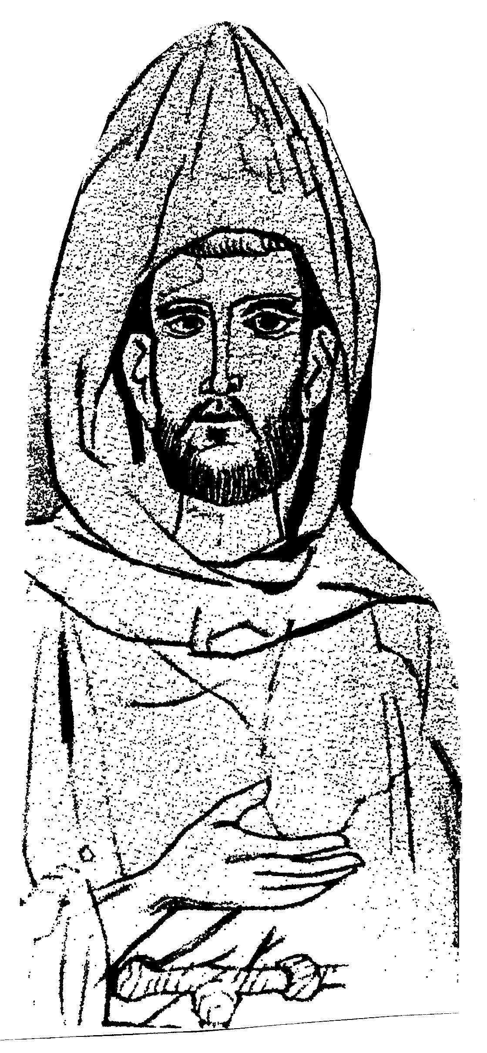
Francis’ Rule was revolutionary for his time. Religious life had never been imagined as he outlined it in his Rule. Francis proclaimed a new freedom for all his followers, to be like Christ in their apostolic work at home and when on mission to distant places. Later friars could proclaim: “The world is our cloister!” It is no wonder that writers at the time of Francis remarked at how different the friars were from the traditional monks in their monasteries! The friars were often looked upon with suspicion and wariness.

The Importance of the Rule
The Rule is important for us and the Order because in it Francis maps out the basic principles by which his disciples must follow to live the Gospel ideals. However, the Rule must be interpreted and understand for different times, places and conditions. For this reason, General Constitutions were written to complement the Rule, “in as much as they adapt the Gospel criteria which are fundamental and permanent, to the changing needs and demands of the times by means of norms, rules and regulations which assure and stimulate fidelity to the primitive charism.”

This explains why our understanding of the Rule needs to be reviewed from time to time, and up-dated to our present situation. What Francis says in the Rule must be interpreted in terms of modern living. That means our understanding of Franciscan spirituality must be based on the findings of modern research and studies.

The Content of the Rule
This will be dealt with here very briefly and in outline:
- Francis explains the friars’ loving relationship with God, the Church, each other, all people as well as all creation. Moreover, he proclaims a universal brotherhood or sisterhood for people and creation itself. Thus, he begins “In the name of the Lord!” In the Early Rule, he began with the sign of the cross. In other words, he expresses his thoughts in God’s name and God’s representative.
- Francis sums up the Rule and life of the Lesser Brothers “to observe the Holy Gospel of our Lord Jesus Christ, by living in obedience, without anything of one’s own, and in chastity.” In other words, the Lesser Brothers must live a Gospel life in complete obedience to the Church and to Francis himself, as Minister General of the Order, and all his successors.
- Francis then outlines how candidates were to be received and the requirements to join the Order, their religious clothing and their novitiate before being accepted as professed members of the Order.
- He then describes the daily life and practices of the members of the Order: prayer, fasting, living in harmony with each other and with the world. However, they were to be wary of the dangers: money, seeking riches or power. They were to go humbly throughout the world begging if necessary.
- Francis laid a lot of emphasis on brotherhood. The members of the Order belonged to a spiritual family much closer than a family of the flesh. Thus they were to treat each other as brothers, in trust and caring for each other as a mother cares for her child. So, with brothers who sin, they were to be treated kindly and mercifully.
- Francis then turns to the government of the Order: the election of a Minister General of the Order and the Fraternity Chapter held at Pentecost as a binding element for the Order and for the guidance of the Order. He also briefly describes what should be done if the Minister General is unsuitable for the task.
- Francis reminds the brothers of their preaching role in the Church and the kind of sermons they should use: short, simple, to the point.
- Francis comes back again to the importance of living in harmony, dealing with problems gently and with love, having the brothers make known their needs to each other in trust. He does not ignore the difficulties the brothers must face: they must beware of pride, vainglory, envy and greed and to keep their sights on the world to come and the reward promised them. He repeats they must love their enemies and do good to those who would harm them. He also warns them, according to the 4th Lateran Council, to avoid entering the monasteries of nuns without due permission.
- Then, he blesses those brothers who are inspired by the Holy Spirit to go to work amongst pagans (Saracens) and are sent by their Minister Provincial to such areas. Missionary efforts are blessed.
- Lastly, he requests a Cardinal Protector for the Order who can watch over the Order and as a safeguard against heresy. Then he commands that no one dare to change what has been written as their Rule of life.

Thus in twelve chapters, Francis sums up the life of the Friars Minor.

UNDERSTANDING THE RULE TODAY
Right from the beginning, the friars found that they needed to have the Rule explained and applied to their situation. This was done through what we now call “General Constitutions” of the Order. The words “General Constitutions” mean “Principles to follow for all the Friars”. These were not meant to replace the Rule but to explain it in a way all could understand it today in the different situations that we live in, and still remaining faithful to Francis’ ideal.

As was said earlier, “this explains that thirteen years after the death of St Francis, the General Chapter convened by Gregory IX in Rome, found it necessary to complete the Rule with certain Constitutions, with the purpose that it may always be observed in each historical situation. These first General Constitutions were followed by the famous Constitutions of Narbonne in 1260, when St Bonaventure was the Minister General of the Order. In this way almost from its beginning the Order has felt itself obliged to review its understanding of the Rule and apply it to changing conditions of our time.

Local adaptations of these Constitutions are made through General (that is, for all friars) and Particular Statutes for a region. These are updated more frequently than the General Constitutions which remain more stable. These days, the General Constitutions also present spiritual advice as well as particular guidelines in following the Rule

REFLECTION:
PSALM 118 (119)

¹Happy are those whose lives are faultless,
who live according to the law of the Lord.
²Happy are those who follow his commands,
who obey him with all their heart.
³They never do wrong; they walk in the Lord’s ways.

⁴Lord, you have given us your laws
and told us to obey them faithfully.
⁵How I hope that I shall be faithful
in keeping your instructions!
⁶If I pay attention to all your commands,
then I will not be put to shame.

⁷As I learn your righteous judgments,
I will praise you with a pure heart.
⁸I will obey your laws;
never abandon me!

⁹How can a young man keep his life pure?
By obeying your commands.
¹⁰ With all my heart I try to serve you;
keep me from disobeying your commandments.
¹¹Keep your law in my heart,
See that I will not sin against you.
¹²I praise you, O Lord;
Teach me your ways.
¹³I will repeat aloud
all the laws you have given.
¹⁴I delight in following your commands
More than in having great wealth.
¹⁵I study your instructions;
I examine your teachings.
¹⁶I take pleasure in your laws;
Your commands I will not forget.

6. THE TESTAMENT OF ST FRANCIS (1226) Those “who were with him,” the brothers who write in the Assisi Compilation, tell of a number of documents or “testaments” which Francis dictated as his health became worse and death was drawing near: that of Siena in which he outlined the basic principle of his Gospel vision; that concerning the Portiuncula in which he asked his brothers to care for this special symbol of their life; and another in which he provided guidelines for building new dwellings.

This document, which has come to be known as “The Testament,” has remained a primary expression of Francis’ profound wisdom and vision. While popular tradition maintains that it was written at the Portiuncula while he was dying, the document’s differing styles suggest that it was written at different moments of those final days and was prompted by different questions swirling around his simple Gospel vision.

Of all St Francis’ writings, his Testament has had the greatest impact on the history of the Order. Its purpose was to call friars to the original ideal. In 1230, the Holy See declared that the Testament was non-binding on the friars, but it became the ideal of those friars who wanted to follow the gospel radically as Francis had urged. It served as an inspiration for those friars who resisted the efforts of some to make the charism more institutional and who believed in the renewal of the Franciscan Order.

The Testament and the Rule of 1223
We must not think that the Testament was a “flag of freedom” as some may say. It certainly did not intend to free friars from the binding force of the Rule. Rather, it was written as a safeguard of the Rule, to help friars observe the Rule better and more faithfully.

We shall examine the topics raised in the Testament in another Unit of this course after we have examined the Franciscan charism more closely.

Exercises
- Read the Rule of 1221, the Early Rule, and compare it with the later Rule, the Rule of 1223.

- What would you count as important in your lived experience of Franciscan life?

- Be Francis, and set down these ideas in your own words.

- Is what you wrote different from the Primitive Rule?

Review of Unit Two
- Here are some questions to help you review your study of this section:
a) Why did St Francis want to write a Rule or Form of Life for his brothers?
- Why did he go to see the Pope about it?
- What part of the writings of St Francis tells us this?
- How many Rules did Francis actually write?
- Can you briefly explain how the Rule gradually developed over the years?

- Did the essential content of the Rule change as it developed? What are some of the changes that Francis made to the Early Rule (1221) and the Later Rule (1223)?

- What role did the Fourth Lateran Council play in the formation of the approved Rule (1223)?
- Why did St Francis have such great devotion towards the Tau cross?
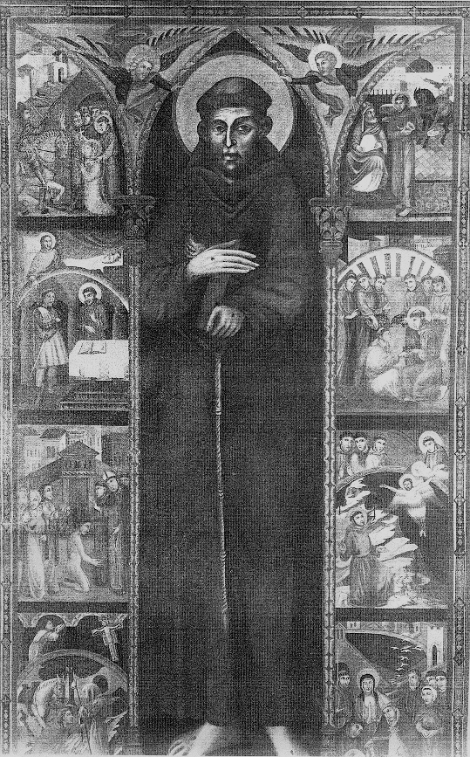
- Why is the Rule important for us?

- How did Francis understand Scripture? How should we follow his example in our reading and study of Scripture?
The picture here is that of an icon called the “Tavola of St Francis”. See if you can find out more about it The icon must be read from left bottom to top; and then right top to bottom right. Some pictures have a double message.

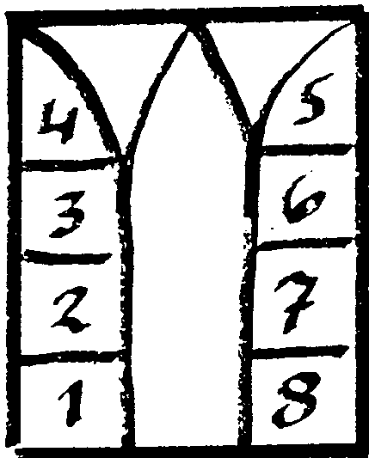

Each picture depicts something in the life of St Francis. There are eight significant events that you must identify.

  - The meeting with the leper & the San Damiano experience;
  - Francis’ before the bishop & his commitment;
  - Reading the Gospel at St Nicholas church & the Spoleto dream;
  - Francis cuts Clare’s hair- a sign of rejecting the world’s vanities;
  - Francis before the sultan & the crusaders;
  - The incident of the grape at Rivo Torto
  - Greccio crib & Francis is stigmatized
  - The transitus or death of Francis

Find each of these stories in the Early Documents; and then find out how they are related in the Tavola of St Francis.

SUMMARY:
Here are the main points of this Unit:-

FRANCIS DISCOVERS A NEW FORM OF LIFE

- Francis and his first followers sought courageously to follow the Gospel life in a new and radical way;

- Francis and his companions together devised the first Rule or Form of Life which they were to follow and sought the approval of the Church to follow it;

- Innocent III approved the Rule verbally and gave the friars permission to preach to the people;

- The Rule was approved in stages: verbally, developed by the friars in General Chapters and approved by them; and finally formally approved by the Church in a Papal Bull written by Pope Honorius III in 1223;

- There is only one Rule of the Friars Minor which was developed from the Primitive Rule in 1209/10; then the Early Rule of 1221 and the formal Rule of 1223;

- The approved Rule of 1223 outlined the form of life that the Friars Minor were to observe. It accepted the Rule as already approved by Innocent III and simply repeated the approval formally.

- The Rule of 1223 pertains to the First Order.

- Francis also wrote other writings, one of the most important of them is his Testament which comments on the Rule. This was later to cause great disputes amongst the friars and the interpretation of the Rule of 1223, but it also reveals much about Francis and his personality.

Mt 10:7 - 13
1 Cel IX 22
Legend of the Three Companions, VIII, Francis of Assisi – The Founder, p.84
“Portiuncula” means “little portion”
Legend of the Three Companions., p.89
ibid.
Wroblenski OFM& Karecki, SSJ-TOSF Madge, Franciscan Study Guide, 1998, n.2 p.13
Flood, OFM David, The Birth of a Movement(quoted by T. Murtagh OFM in his lecture notes on “The Development of the Rule of 1221)
GianMaria Poldoro, Francis of Assisi, edizione Porziuncula, 1998
Wroblewski OFM, Sergius & Karecki, SSJ-TOSF Madge, Franciscan Study Guide, 1998, n.2 p.13
Francis of Assisi, The Founder, vol. 2, p. 316
Fitzpatrick ofm Michael, lecture notes
Lapsanski, Duane, The First Franciscans and the Gospel, p.20
The Three Companions claim that Francis wrote three other ‘Rules which are not identified by modern critics. Celano claims the same but he is referring to the Rule of 1221. The Mirror of Perfection speaks of three Rules, the first being that of 1221; the second, the “lost” Rule; and the third, the Rule of 1223.
It would be better to call these early Rules “Forms of Life” because they were still developing. The Rule of 1221 refers to a Papal Bull of 22 September, 1220 which showed the concept of Rule was very ‘fluid’ as it was an on-going process without a fixed form. Cf Flood, D & Matura, T The Birth of a Movement, Chicago, Franciscan Herald Press, 1975
Flood & Matura, op. cit.
Cf. Encyclopedic Dictionary of Religion, ed. Paul Kevin Meagher, OP, S.T.M. and Thomas C. O’Brien and Sr Consuelo Maria Aherne, SSJ, Corpus Publications, Washington D.C. 1978 “Lateran Councils”, p.2047
Cf. Flood, D & Matura, op. cit., Introduction
Moorrman, J St Francis of Assisi, Franciscan Herald Press, Chicago, 1950, p. 95
Esser ofm, Kajetan in the Forward to the book by D. Flood & Matura The Birth of a Movement.
Armstrong, Regis J. ofm Cap, St Francis of Assisi – Writings for a Gospel Life,p.67
Karecki & Wronblewski, op. cit. 1998, no. 3
General Secretariate for Formation and Studies, Our Franciscan Identity,General Curia OFM, Rome, 1993, p. 11 (adapted)
From Francis of Assisi – the Saint, vol. I, pp.124ff. (adapted)
Vaughn, ofm, J. Our Franciscan Identity Kajetan Esser OFM, The Testament of St Francis, Franciscan Publishers, Pulaski, Wisconsin, 1981
ibid. Forward, p.5

