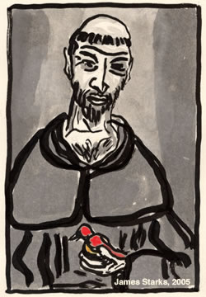
“Praised be you, My Lord, through all your creatures!”
Franciscan Readings for
Week Commencing
21 October, 2007
Twenty-Ninth Week of Ordinary Time - C

Sunday 21 October 2007
(A reading from “The Remembrance of the Desire of a Soul” by Thomas of Celano)
The power of love had made Francis a brother to other creatures; no wonder the charity of Christ made him even more a brother to those marked with the image of the Creator. He would not consider himself a friend of Christ unless he loved the souls that Christ loved. For him this was the principal cause for revering the doctors of theology: they are the helpers of Christ, who carry out with Christ this office. With all the unbounded affection of the depths of his heart, he embraced all the brothers themselves as fellow members in the household of the same faith, united by a share in an eternal inheritance.

Lord, you created us to be there amongst our brothers and sisters – may we always see them as those who carry us on the journey of life and love each other after the example of Christ.

Monday 22 October 2007
(A reading from 'The Assisi Compilation’)
Francis used to say that if a servant of God preserved himself internally and externally than the devil can do him no harm. One of the friars looked sad and depressed. Francis said, “Why, brother, do you persist in being sad and miserable? If it is a matter between you and God, pray to him, communicate with him, tell him your anger and frustration. That’s God – the one who loves and loves and loves.”

Lord, no one can love us as you do. Help us to bring ourselves freely and for your divine purpose.

Tuesday John of Capistrano 23 October 2007
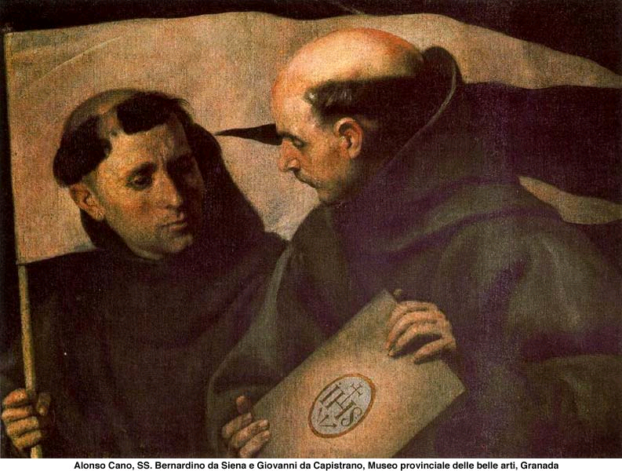
John studied law at the University of Perugia and was later appointed governor of that city. After spending some time in prison during the civil war, he became an observant Franciscan Friar. Together with James of the March he studied theology under Bernardine of Siena and went on to become a highly successful preacher throughout Europe, drawing many into the Order. He died in Austria in 1546.

(A reading from 'The Mirror of the Clergy’ by John of Capistrano)
You are the light of the world. Now a light does not illumine itself, but instead it diffuses its rays and shines all around upon everything that comes into view. So it must be with the glowing lives of upright and holy clerics. BY the brightness of their holiness they must bring light and security to all who gaze upon them. They have been placed here to care for others. Their own lives should be an example to others, showing how they must live in the house of the Lord.

Lord, may the light of our example shine out to all. Let us be leaders on the way and never parted from your guiding hand.

Wednesday Anthony Claret 24 October 2007
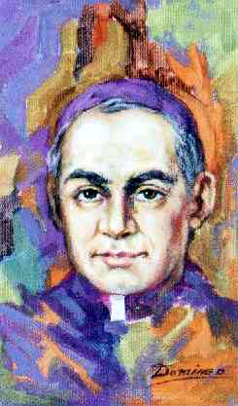
Anthony was born in Spain during Napolean’s invasion and was ordained in 1835. After a brief stint with Propagation he returned to rural Catalonia and established himself as an excellent preacher and giver of conferences to priests. His prolific writings resulted in about one hundred and fifty books on clerical spirituality – but, like all prophets, he was spurned by a section of the clergy and removed himself to the Canary Islands for a while. In 1849 Anthony gathered together five priests who formed the basis of the Missionary Sons of the Immaculate Heart of Mary (popularly known as Claretians). He preached against the slavery of the Negroes, and regularized numerous marriages. As a result of his activity he was frequently threatened with death and on one occasion an attempt was actually made on his life. In 1857 he was recalled to Spain as confessor to the queen. In this way he was able to exert some influence in the naming of bishops, set up a center of ecclesiastical studies at the Escorial, and work towards the recognition of religious orders in Spain. In 1869 he was in Rome, preparing for the First Vatican Council. He followed Isabella II into exile and at the insistence of the Spanish ambassador, was placed under house arrest in the Cistercian monastery at FontFroide, where he died at the age of 63.

(A reading from 'The Remembrance of the Desire of a Soul' by Thomas of Celano)
Francis had great compassion towards the sick and their needs. If people sent him medicines and tonics, he often passed them on to other sick people or those more in need. He had sympathy for all those who were ill and when he could not alleviate their pain, he spoke words of compassion to them. Francis would eat on days when people fasted so that the poor would not feel embarrassed about eating and he was not embarrassed to go and find meat for sick people to eat.
Francis encouraged the sick to bear their condition with patience and even wrote in the Rule for the sick brothers not to become demanding of the other friars. Rather Francis wished the sick to bear their condition as God's testing time and know that God would not let them suffer unnecessarily.

Lord, you are compassion and hope. May we not shrink away from our obligation to the sick and those in pain. With the joy of the risen Christ in our hearts, may we never be indifferent to the needs of others.

Thursday 25 October 2007
(A reading from the Assisi Compilation)
Francis was staying at Rivo Torto in a community where there was a very sick old friar. Francis was moved to pity when he saw him. In those days, friars accepted good and bad health in equal measure, often refusing medicines in the name of poverty. But Francis said to himself, “Some ripe grapes early in the morning may relieve his symptoms, I think.” So, rising early, Francis took the man outside and collected some grapes, sitting with him and eating them so that the old friar would not be embarrassed or ashamed. And while they were eating them, they praised the Lord.

Lord, kindness is a discipline of its own – may we be the first to show kindness to others and bend the rules when necessary.

Friday 26 October 2007
(A reading from 'The Assisi Compilation')
When he was in Collestrada, Francis met a poor man whom he had known a long time before. He said, "How are you doing?" The man began to complain about his landlord and how the landlord had taken everything he had. "Thanks to my landlord, may the Almighty God curse him, I am ruined!"
Francis felt sorry for the man's soul, so steeped in hatred. Francis said, "Brother, forgive your landlord for the love of God, so that you may set your soul free, it may be that he will return what he took from you. Otherwise, you will not only have lost your property, but your dignity and your soul too!" The man replied, "I cannot forgive him completely until he returns what he took from me."
Francis took off the mantle he was wearing and wrapped it around the man. "Here, I will give you this cloak and beg you to forgive your landlord for the love of God." The man's mood changed and, moved by Francis' generosity, he went and forgave the landlord all his wrongs.

Lord, it is easier to stay angry than to forgive. It is hard for people to back down for fear that they will be reduced or seem weaker than they wish to appear. May your loving forgiveness permeate our relationships, Lord, and, with hope in your mercy, may we be granted the gift of forgiveness for our own sins.

Saturday 27 October 2007
(A reading from ‘The Remembrance of the Desire of a Soul’ by Thomas of Celano)
Francis usually passed the whole day in his cell, returning to the brothers only for food. It happened this one day that two friars from Greccio came to see Francis and receive his blessing but, arriving at the friary around lunchtime, they were disappointed to learn that Francis had already gone to his cell. Unsure of how long they would have to wait for him to come again among them, they left consoled by the other friars. As they walked the path from the friary, they heard a loud voice call to them. Francis was standing in the friary garden waving to the two visitors and, silently, he made the sign of the cross for them in blessing. Francis had learned of their visit and broke his contemplation in order to give his brothers a blessing.

Lord, it is more important to be present to others than it is to delight in our solitude. May our lives be a living blessing to all.

