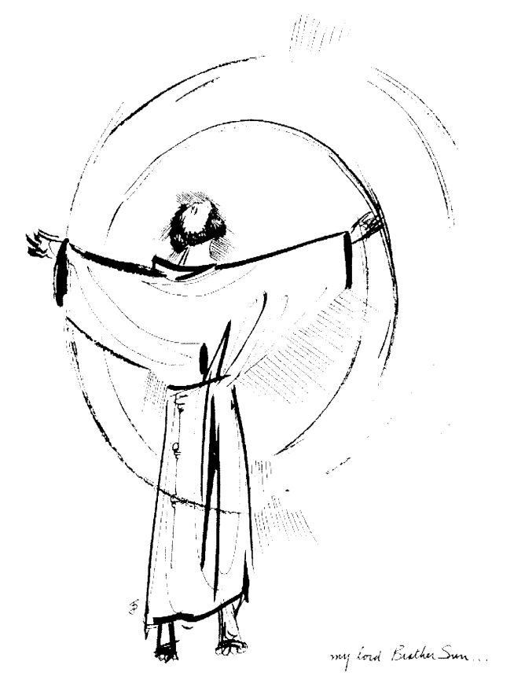
“Praised be you, My Lord, through all your creatures!”
Franciscan Readings for
Week Commencing
16 August, 2009
20th Week Ordinary Time

Sunday 16 August 2009
(A reading from the Assisi Compilation)
When Francis washed his hands, he chose a place where the water would not be trampled underfoot after the washing. Whenever he had to walk over rocks, he would walk with fear and reverence our of love for him who is called “The Rock”. He also told the brother who cut the wood for the fire not to cut down the whole tree, but to cut it in such a way that one part remained while another was cut. In the garden, part of it was left to grow only wild flowers and the growing of fragrant plants and beautiful flowers were always a feature of his garden. When everything was in bloom, Francis was overtaken with ecstasy and, shortly before his death, he composed the Praises of the Lord by his creatures to move the hearts of his listeners to the praise of God, and that in his creatures the Lord might be praised by everyone.

Lord, let us make a space for nature in our lives. Let your natural light infuse that place where we dwell.

Monday 17 August 2009
(A reading from the Life of St Francis by Thomas of Celano)
Francis was staying near Greccio when he found a rabbit caught in a trap. Releasing it, it ran to his lap for shelter. Placing it back on the ground, the rabbit again rushed to Francis’ lap until it was taken far away by the other friars for release in the wilderness. Likewise, Francis cared for fish. When he was offered a fish by the shore of the lake by some fishermen, he thanked them and then released the fish back into the water, exhorting them not to be caught again.

Lord, help us to offer impractical protection to our brothers and sisters in the wild. May we always see creation as your gift to us.

Tuesday 18 August 2008
(A reading from the “Life of St Francis” by Thomas of Celano)
On another occasion, Franc is was travelling through the Marches and Brother Paul was gladly accompanying him when he came across a man on his way to market. The man was carrying two lambs over his shoulder, bound and ready for sale. When Francis heard their bleating, he was filled with sadness – “Why are you torturing my brother lambs, binding them and hanging them in this way?” The man replied, “I am taking them to market because I need the money.” Knowing the fate of the two lambs, Francis took off his cloak and said, “Here – take this cloak. I will buy those lambs from you.” Handing them over, Francis was struck with a dilemma: he couldn’t think of what to do with them. Brother Paul suggested giving them back to the man under a solemn promise that he would never harm them but raise them and guide them from that day forward.

Lord, your lambs, the sheep of your pasture, struggle in this world without guidance and wisdom. Be our inspiration and our guide in times of doubt and darkness.

Wednesday 19 August 2009
A reading from ‘The Assisi Compilation’)
Francis was staying at St Mary of the Angels, the Portiuncola, in a small cell near the hedge of the garden – the place where Brother Ranieri, the gardener, had lived before his death. There was a cricket on the branch of a fig tree, so close to the window of his cell that Francis could touch it. ‘Sister Cricket, come to me,’ and the cricket obeyed, sitting in the palm of his handing and it began to chirp. Francis was overjoyed at this and sat with the cricket in his hand for more than an hour. Eight consecutive days were filled with the song of Sister Cricket until Francis commanded her to go, unless the friars may become distracted by her. The cricket left and was never seen there again. Francis found so much joy in creatures because of love of the Creator, to console him in his inner and outer self, that the Lord made even those that are wild to people become tame to him.

Lord, it is easy to judge those that are wild as dangerous and heartless. May we always remember that you are the Creator of all things, wild and tame, and that you exist in all things. Help us to love the wild and the free as much as the calm and the tame.

Thursday Bernard of Clairveaux 20 August 2009
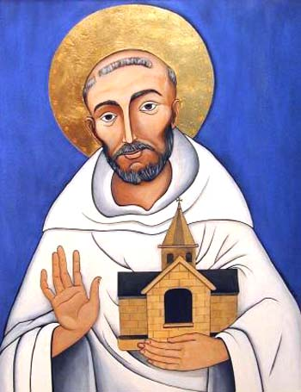
Born in 1090 near Dijon, Bernard’s legend is the stuff of hagiography – poor but pious parents and a desire form a young age to study the Scripture. This is a useless legend for a young person of any age to bear. The fact is that Bernard was a man deeply involved with his God, to the extent that this was an engrossing pursuit of his until his death. Bernard had a remarkable religious life. He joined an Abbey in France but, at this time, the Benedictine foundations were rediscovering their origins and, so, Bernard founded an abbey at Clairvaux. This simplifies the difficulties that Bernard went through. The valley was originally called the Valle de Absinthe – the Valley of Bitterness – and then Citeux. Bernard turned this valley into a place of the best fulfilment. He was the counsellor of the popes and it perhaps was the passing of his friend, Pope Eugenius, that precipitated his own death at the age of sixty-three.

(A reading from ‘The Little Flowers of St Francis’)
It was at the time when Francis was staying in Gubbio that there appeared a very big wolf, fearsome and ferocious, that had been devouring not only animals but also human beings so that all the townspeople were terrified. Against their pleadings, Francis decided to go out and meet this vicious beast, armed only with a foolhardy confidence in God. The wolf, panicked by the townspeople who had come – albeit at a greater distance – to follow Francis out of curiosity. It turned on the crowd and Francis called to it, ‘Come here, Brother Wolf, I command you to do no harm to anyone.’ Immediately, the fearsome wolf closed its mouth and came meekly as a lamb to lie at the feet of Francis who said, ‘Brother Wolf, you have done many terrible things in this area, killing the creatures of God without permission. You are worthy of the gallows like a common thief and the worst of murderers. But I want to make peace between you and these people so that you do not offend them anymore. In return for your good conduct, I promise that you will be fed by the people of this town for I know that what you did was out of hunger.’ The whole city poured into the piazza to see the fierce wolf with St Francis, who got up and preached to them saying that sin and the flames of hell were much more dangerous than the wolf, which could only kill the body. The same wolf lived in Gubbio for the next two years, tamely entering houses without harming anyone and being kindly fed by the people. When the wolf died, the townspeople were very upset because, through Brother Wolf, they recalled the holiness and virtue of St Francis.

Lord, help us to reconcile others in harmony and peace. May forgiveness abound in our homes, schools, communities and country. Together, let us walk the road of friendship with wolf and townsperson alike.

Friday St Pius 21 August 2009
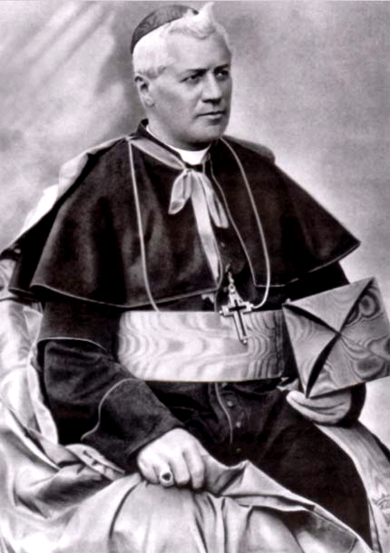
Giuseppe Sarto was ordained in 1858 and became a chaplain in the town of Tombolo for nine years. As the official chaplain was elderly and infirm, the young Fr Guiseppe (at only 23) assumed most of the duties of pastor in his place. He was keen to study more theology and was especially devoted to the works of St Thomas Aquinas and Canon Law. He was named arch-priest of Salzano and, in this role, restored the church and expanded the hospital – he was known for his care and attention during the cholera outbreak. He was dedicated to adult education and the proper formation of young priests. It was in this latter role that saw him named the Bishop of Mantua in 1884, a troubled diocese indeed. He revitalised the Church in Mantua becoming a lecturer to young seminarians and encouraging Gregorian chant and good liturgy. He was eventually elected Pope in 1903 following the death of Leo XIII. His first encyclical encouraged the reception of Communion by children. Pius’ unashamed defence of the Church and his upbuilding of the faith was respected by both Catholics and non-Catholic alike. .

(A reading from ‘The Little Flowers of St Francis’)
It was at the time when Francis was staying in Gubbio that there appeared a very big wolf, fearsome and ferocious, that had been devouring not only animals but also human beings so that all the townspeople were terrified. Against their pleadings, Francis decided to go out and meet this vicious beast, armed only with a foolhardy confidence in God. The wolf, panicked by the townspeople who had come – albeit at a greater distance – to follow Francis out of curiosity. It turned on the crowd and Francis called to it, ‘Come here, Brother Wolf, I command you to do no harm to anyone.’ Immediately, the fearsome wolf closed its mouth and came meekly as a lamb to lie at the feet of Francis who said, ‘Brother Wolf, you have done many terrible things in this area, killing the creatures of God without permission. You are worthy of the gallows like a common thief and the worst of murderers. But I want to make peace between you and these people so that you do not offend them anymore. In return for your good conduct, I promise that you will be fed by the people of this town for I know that what you did was out of hunger.’ The whole city poured into the piazza to see the fierce wolf with St Francis, who got up and preached to them saying that sin and the flames of hell were much more dangerous than the wolf, which could only kill the body. The same wolf lived in Gubbio for the next two years, tamely entering houses without harming anyone and being kindly fed by the people. When the wolf died, the townspeople were very upset because, through Brother Wolf, they recalled the holiness and virtue of St Francis.

Lord, help us to reconcile others in harmony and peace. May forgiveness abound in our homes, schools, communities and country. Together, let us walk the road of friendship with wolf and townsperson alike.

Saturday The Queenship of Mary 22 August 2009
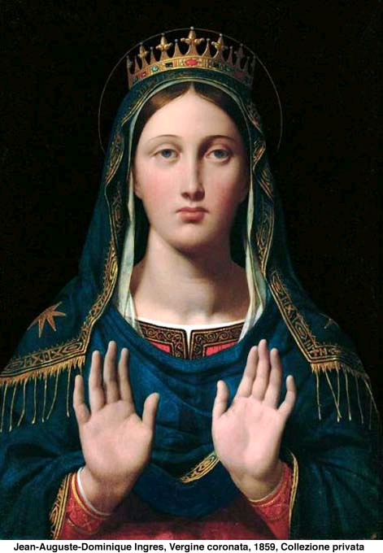
The Feast of the Queenship of Mary was first pronounced by Pope Pius XII in 1954 amid some criticism that the regal overtones made Mary something she was never intended to be. However, the idea of Mary as Queen was not a new one – in Scripture, particularly at the Annunciation, she is referred to as the mother of the one who would be seated on the throne of David, at the Visitation, Elizabeth refers to her as the Mother of my Lord. Throughout the ages, there have been many nominations of Mary as Queen rather than as mother. She is the Queen of All Nations, Queen of Heaven and Earth, crowned with the stars. In his defence, Pius XII wrote that Mary deserves the title “Queen” due to her role in Jesus’ redemptive work.

(A reading from a medieval Franciscan manuscript)
Masseo has said that he was with St Francis when he chose to preach to the birds. Rapt in devotion, Francis once found by the roadside a large flock of birds, to whom he turned aside to preach, as he had done before to another flock. But when the birds saw him approaching, they flew away. Francis began to reproach himself, “What impudence! You who expect birds to listen to you as if you, not God, were their creator!”

Lord, you are the master and Lord of all. May we take our place alongside your other created beings and sing forever to the praise of your name.

