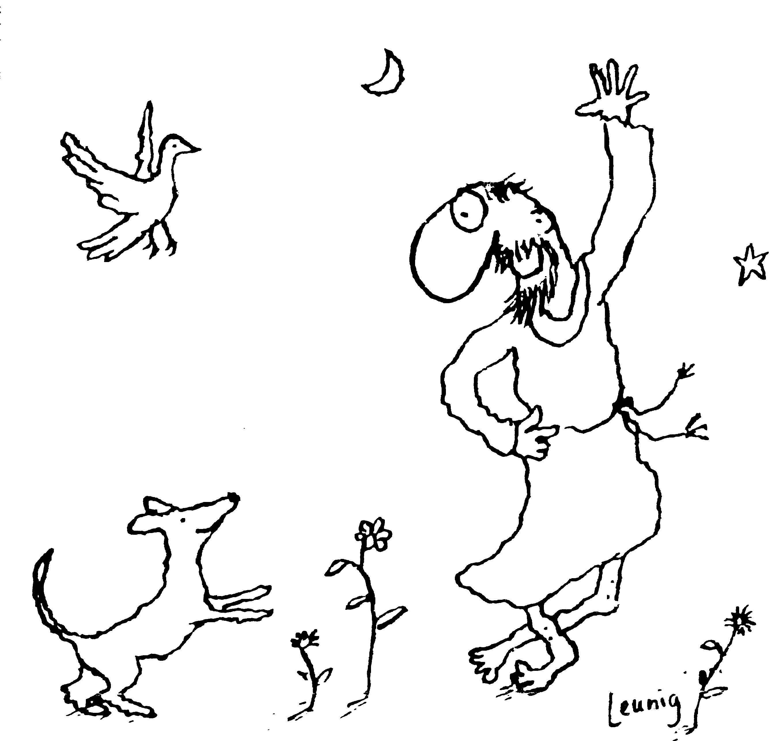
“Praised be you, My Lord, through all your creatures!”
Franciscan Readings for
the Week Commencing
10 June, 2007
10th Week Ordinary Time – C/1

Sunday CORPUS CHRISTI 10 June 2007

(A reading from “A Letter to the Entire Order” by St Francis)
The Lord of the Universe, God and the Son of God, so humbles himself that for our salvation he hides himself under an ordinary piece of bread! Brothers, look at the humility of God, and pour out your hearts before him! Humble yourselves that you may be exalted by him! Hold back nothing of yourselves, that he who gives himself totally to you may receive you totally!

Lord, the great mystery of the Eucharist gives us hope and calls us to be your servants and leaders. Help us to give ourselves totally to you and to be your Body of Christ.

Monday Barnabas 11 June 2007
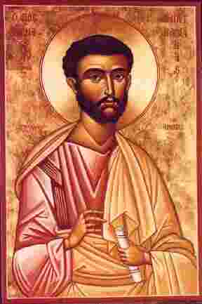
Barnabas was a Cypriot Jew, styled among the Apostles but not actually counted as one of them. He was the first to receive Paul after his conversion and was sent on the mission to Antioch. It was Barnabas who introduced his nephew, John Mark (the future evangelist) to the life of the early missionary. The debates about circumcision and membership of the new movement raged until more preachers arrived from Jerusalem. Paul fell out with Barnabas regarding his insistence that John Mark was a reformed character, following his defection from the first Mission. Staying most of his life in this region, Barnabas was eventually martyred in Cyprus in 54.

(A reading from The Mirror of Perfection)
Francis had a great devotion to the Eucharist – so much so that he had it written in the Rule that the friars would reverence always the Body of Christ. He wished that whenever the friars would see the Eucharist in the churches around Assisi that they would clean the altar linen and preserve always the elements of the sacrament, the bread and the wine. Francis encouraged the friars to carry pyxes with them containing the Eucharist that they may guard it carefully as was befitting the Christ of whose name we claim as Christians.

Lord, your ways are a mystery. Help us to be defenders of your Body and Blood and make us a sacramental people on the way to you.

Tuesday 12 June 2007
(A reading from ‘The First Letter to the Custodians’ by St Francis)
You should humbly beg the clergy to revere above all else the most holy Body and Blood of our Lord Jesus Christ and his holy name and the written words that sanctify his Body. Everything that pertains to the sacrifice ought to be held as precious. If the most holy Body of the Lord is very poorly reserved, it should be taken and placed and locked up in a precious place according to the rules of the Church. Likewise, the words of the Lord should be enthroned, not left lying in unkept places. In every sermon, remind people of penance and the saving power of the Body and Blood of Christ. Announce and preach his praises that all nations may adore him in every word and whenever the bells are tolled.

Lord, let us pick up the broken word and the dusty sacrament of the lives of those around us. May we keep them in a precious place, as is fitting the things of God.

Wednesday ST ANTHONY OF PADUA 13 June 2007
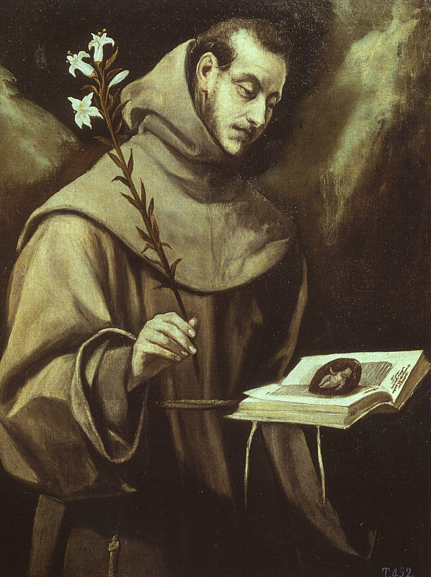
Antony was inspired to move from the Augustinians to the Franciscans by the first Franciscan Martyrs in 1220. He became a vigorous preacher and missionary and, because of his theological knowledge, began the process of education of the early friars. He died in Padua aged only thirty six. A life taken too soon, a man whose death broke the hearts of the Paduans due to his great love of Christ and his willingness to live the life of humility and poverty that Francis prescribed. The children of Padua missed him dearly and, to this day, we have recourse to him for that which is lost and for those who are ignorant.

(A reading from The Deeds of Francis and his Companions)
While Anthony was preaching before the Pope and the Cardinals, it became apparent that he could speak all languages and none for at the council were many Greeks and Italians and Slavs. Francis called him “his Bishop”. Anthony held the crowd in suspense and, though they all spoke different languages, everyone understood quite clearly Anthony’s message to them. “Is he not a Spaniard?” they enquired, “yet how do we all hear him in our own native language, Greeks and Latins, French and Germans, Slavs and English, Lombards and foreigners?” The Pope answered, “Truly, he is the Ark, the repository of the Holy Spirit.”

Lord, your spirit breaks down barriers. Help us to place our trust in your divine spirit that out actions may speak louder than words.

Thursday 14 June 2007
(A reading from The Tree of Life by St Bonaventure)
The most memorable event of Christ’s life is the Last Supper. Not only was the Paschal Lamb present but also the immaculate Lamb who takes away the sins of the world. The marvellous sweetness of Christ’s goodness shone forth when he dined at the table with the disciples and Judas. A marvellous example shone out when, girt with a towel, he washed the feet of the fishermen and his betrayer. The outpouring of his love shone forth when, loving his own to the end, he strengthened them with a gentle exhortation, forewarning Peter to be strong in faith and offering his beloved John a place of rest in his sacred heart.

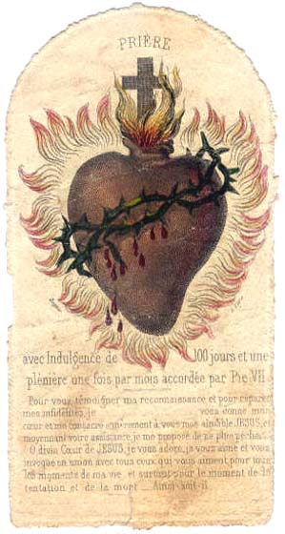
Lord, your heart is almighty. Is there room in our heart for the love of those who sit next to us? Let us love each other authentically, never sparing ourselves to the needs of those around us.

Friday The Sacred Heart of Jesus 15 June 2007
Sacro Cuore di Gesù, confido in Te!;
Dolce Cuore del mio Gesù, fa ch’io t’ami sempre più!;
O Gesù di amore acceso, non Ti avessi mai offeso!

The Sacred Heart has always been the source of scandal and a scene of confusion for the Church. The Heart of Jesus revealed to Margaret Mary Alazoque, the Visitandine nun who lived in the 17th Cenury in Paray-le-Monial, is not to taken literally but is a deeply challenging vision in its rawness – the Heart of Jesus, torn and in outrage, present in the life laid down in the Eucharist, driven through with the hatred of this world. We have a sense of the “heart” in our day – we set our heart on that which we love, we give with all our heart, we are pierced to the heart by the hurts that wound us. In the same way, we can talk, one heart to another, and this is the meaning of the devotion. We simply recognise the enormity of the love of Jesus and that we have the chance to make this love live again in our broken world. For it is in Jesus’ Sacred Heart that we are forever loved.

(A reading from ‘The Remembrance of the Desire of the Soul’ by Thomas of Celano)
Once there was a poor man who begged something of Francis ‘for the love of God’. Since he had nothing, Francis secretly found a cutting tool and hurried to cut his small tunic in two. But the firars stayed his hand and gave the poor man a different compensation. Francis said, “The love of him who loved us greatly is greatly to be loved!”

Lord, let us bring Christ’s love into our world by meditating on your Son’s Sacred Heart. Give us a special love for the poor and disenfranchised.

Saturday Immaculate Heart of Mary 16 June 2007

(A reading from the Book of Angela of Foligno)
If one looks and ponders with the utmost care the small piece of bread which the body eats, how much more should the soul not look and ponder before receiving this eternal and infinite good, created and uncreated, this sacramental food which is the sustenance, treasure, and fountain for the life of both soul and body. This is truly God which in himself contains every good.
Why bother going to a mystery when the real world is here around us? I will tell you what I think. Go – be received in order to be received, go pure in order to be purified, go alive in order to be enlivened, go just as you are to be more fully what you are.

Lord, let us know that you made us as we are. We are yours and attribute everything that we are to you with our weaknesses and successes. Keep our minds focussed on what is good.

