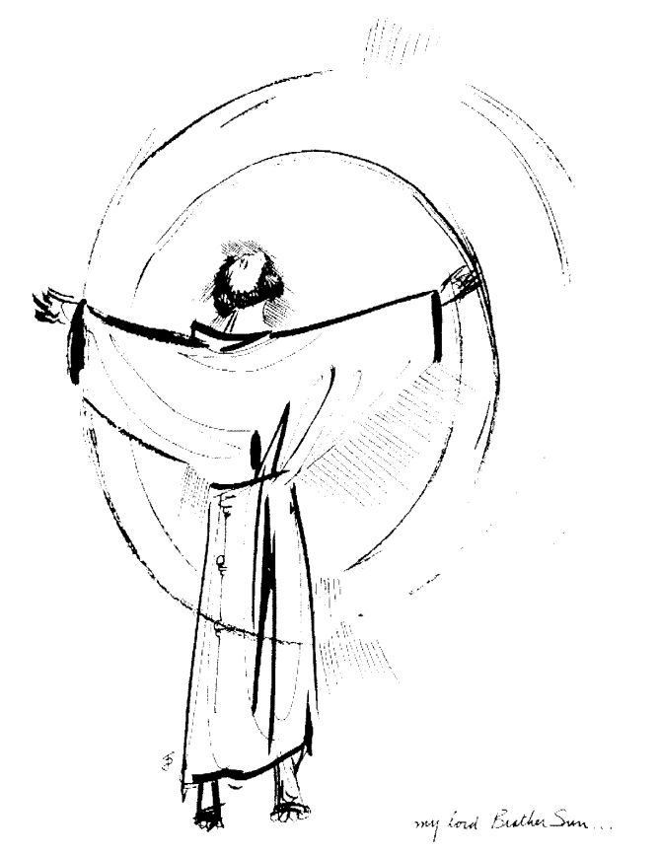
“Praised be you, My Lord, through all your creatures!”
Franciscan Readings for
Week Commencing
1 November, 2009
31st Week Ordinary Time

Saturday All Saints 1 November 2009
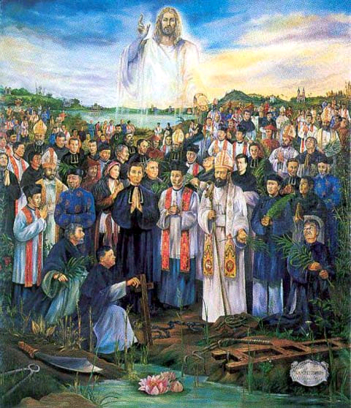
It was customary for the martyrs to be commemorated at the place of their martyrdom in the first century (they weren't necessarily all buried in catacombs but rather in large public cemeteries). St John the Baptist was the first "saint" added to the calendar of anniversaries - this gradually expanded until there were more saints than days. Gregory IV (827-844) declared that November 1 be designated as a feast day for all saints both known and unknown.

(A reading from 'The Fioretti')
Brother John of La Verna, seeing his fellow friar, Brother James of Fallerone, sick with illness at Mogliano, prayed for him, asking God devoutly in mental prayer to restore the health of his body. While he was praying in the woods, he saw a great army of angels and saints illuminating the entire area. Among them, he saw his sick brother, clothed in brilliant white clothes. He saw St Francis marked with the Stigmata. He saw the brothers he had loved in the past - Brother Lucido, Brother Masseo and many, many others. It was revealed to him that the sick brother would soon die of his illness but that he would go to paradise. He rushed to the bedside and told Brother James of Fallerone what he had seen and, saying "In peace in eternal life I will fall asleep and rest;" he passed with joy into the next life.

Lord, you surround us with examples of Christian valour. May we imitate the lives of holiness that we remember today and pray for the intercession of those whose lives were so conformed to Christ, your Son.

Monday All Souls Day 2 November 2009
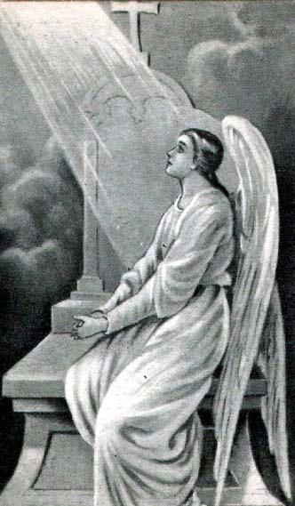
It was customary in the middle ages for the names of the dead to be entered in the diptychs. Monasteries would celebrate Masses for the dead, particularly for their release from purgatory - it was believed that the deceased had not fully atoned for sin and were debarred from the beatific vision. The only way to assist them was to offer a Mass or to pray for the deceased. We tend not to follow such a pessimistic view of God's mercy. A day for praying for all the dead was introduced around the ninth century and the current date was set to coincide with All Saints Day.

(A reading from “The Mirror of Perfection”)
Francis would say that a Lesser Brother is one who would possess the life and qualities of the following holy brothers: the faith and love of poverty of Brother Bernard; the simplicity and purity of Brother Leo; the courtly bearing of Brother Angelo; the friendly manner and common sense of Brother Masseo; the mind raised up in contemplation of Brother Giles; the virtuous and constant prayer of Brother Rufino; the patience of Brother Juniper; the bodily and spiritual strength of Brother John of Lauds; the charity of Brother Roger; the solicitude of Brother Lucidus who used to say, “We do not have a dwelling here on earth, but in heaven.”

Lord, let us look to our neighbour for good example – show us the way to imitate that which is good in those around us.

Tuesday All Deceased of the Franciscan Family 3 November 2009
(A reading from 'The Fioretti’)
Francis had become almost blind and went into the woods to speak to Brother Bernard. “Come and talk to me, brother,” Francis pleaded. But Bernard, a man of great contemplation, did not reply. After continuing to plead, Francis gave up and went away a little disconsolate. Throwing himself down in prayer, Francis felt rejected and sad. “Why are you sad, little man?” asked a voice from heaven. “Can’t you see that Brother Bernard is in prayer? Why would anyone leave the divine for a mere creature?”

Lord, you give us a keen sense of the divine. Keep our eye on the sparrow, keep our hand on our heart and pledge forever to be yours.

Wednesday Charles Borromeo 4 November 2009
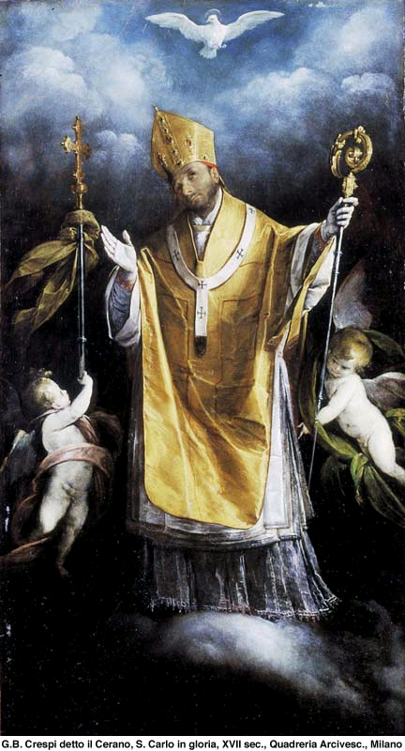
Charles Borrmeo was born at Castle of Arona on the Lago Maggiore in Northern Italy in 1538. He was fine noble stock, his father having married into the all-important de Medici line, marrying the sister of Pope Pius IV. Charles entered a monastery and was allowed to receive the tonsure at twelve and became a titular abbot soon after. His father died when Charles was only twenty and, although he was not the eldest son, huge responsibilities fell upon him. He was plunged into straitened circumstances and felt the humiliation of his deprivation most bitterly. At twenty-two, Charles was made a cardinal-deacon and then the secretary of state. Charles' positions and achievements are too numerous to mention - he was the man about town of the counter-revolution. He was instrumental at the resumption of the Council of Trent in 1562. Whatever about his responsibilities in the administration of the Church, Charles' was most well-known for his pastoral solicitude during the Plague. When the Plague hit Milani n 1576, Charles made his will and gave up his entire life to those suffering of the dreaded illness. Believing the Plague was sent for chastisement of sinners, Charles would take on the sins of the people by hanging a rope around his neck and walking the path of penance barefoot. He was afflicted with gout and died with the words "Ecce venio" on his lips in 1584, aged 54.

(A reading from 'The Fioretti')
Brother John of La Verna, seeing his fellow friar, Brother James of Fallerone, sick with illness at Mogliano, prayed for him, asking God devoutly in mental prayer to restore the health of his body. While he was praying in the woods, he saw a great army of angels and saints illuminating the entire area. Among them, he saw his sick brother, clothed in brilliant white clothes. He saw St Francis marked with the Stigmata. He saw the brothers he had loved in the past - Brother Lucido, Brother Masseo and many, many others. It was revealed to him that the sick brother would soon die of his illness but that he would go to paradise. He rushed to the bedside and told Brother James of Fallerone what he had seen and, saying "In peace in eternal life I will fall asleep and rest;" he passed with joy into the next life.

Lord, you surround us with examples of Christian valour. May we imitate the lives of holiness that we remember today and pray for the intercession of those whose lives were so conformed to Christ, your Son.

Thursday 5 November 2009
(A reading from 'A Letter in Response to an Unknown Master' by St Bonaventure)
What shall I say about those who take the professor's chair since the Rule declares that those who are illiterate should not be eager to learn? And who would be called 'Master' since the Gospel says that noone should be called so? I tell you that the gospel teaches us that all ambition and pretentiousness associated with the title 'Master' must be condemned and in no way sought after, but that the duty or office must be assumed. For who are better fit to teach the gospel than those who profess and observe it? I condemn the pretentious brother and maintain that he is entirely unworthy of the teaching office; but I praise the studious one, since I believe that the authority to teach the gospel of Christ belongs to him more than anyone else.

Lord, you created us with many gifts. May we share our gifts with others in quiet, humble ways. Let us not show ourselves up in our flashiness or pretence - may we be genuine signs of your grace.

Friday 6 November 2009

(A reading from 'The Fioretti')
The first companions of Francis strove to be poor in earthly things and rich in virtues. One day when they were sitting together, one of the friars gave this example: "There was someone who was a great friend of God and he had great grace in active humility that he thought himself the greatest of sinners. His humility helped him to grow in grace and to resist the temptation to sin." Brother Masseo was greatly impressed by this story about humility and vowed to never be happy in the world until he was perfectly humble. Brother Masseo went wandering in the woods and he heard a voice call out to him, "Brother Masseo! Brother Masseo!" Recognising the voice as the voice of Christ, Brother Masseo said, "What do you want, my Lord?" Christ replied, "I want to know what you would give for the gift of perfect humility." Brother Masseo answered, "I would give you the eyes in my head." Christ said, "I will give you what you most desire as well as the eyes in your head." Brother Masseo was known as the most humble and the happiest friar that lived.

Lord, you want us to be happy and humble. Nothing reflects your greatness more than those who quietly do your works on earth, accepting no praise for themselves. Help us to be happy in ourselves when we do what we know is right and not so much seek the approval of others.

Saturday 7 November 2009
(A reading from 'The Fioretti')
The first companions of Francis strove to be poor in earthly things and rich in virtues. One day when they were sitting together, one of the friars gave this example: "There was someone who was a great friend of God and he had great grace in active humility that he thought himself the greatest of sinners. His humility helped him to grow in grace and to resist the temptation to sin." Brother Masseo was greatly impressed by this story about humility and vowed to never be happy in the world until he was perfectly humble. Brother Masseo went wandering in the woods and he heard a voice call out to him, "Brother Masseo! Brother Masseo!" Recognising the voice as the voice of Christ, Brother Masseo said, "What do you want, my Lord?" Christ replied, "I want to know what you would give for the gift of perfect humility." Brother Masseo answered, "I would give you the eyes in my head." Christ said, "I will give you what you most desire as well as the eyes in your head." Brother Masseo was known as the most humble and the happiest friar that lived.

Lord, you want us to be happy and humble. Nothing reflects your greatness more than those who quietly do your works on earth, accepting no praise for themselves. Help us to be happy in ourselves when we do what we know is right and not so much seek the approval of others.

