Hooker's Lips
(Psychotria Elata)
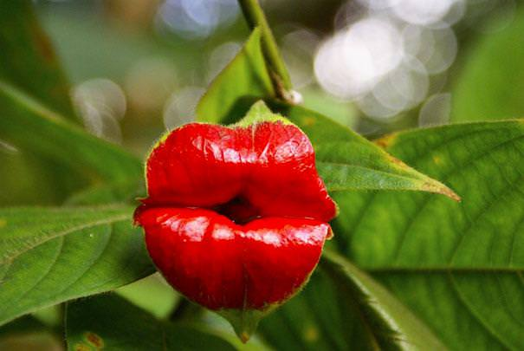

Dancing Girls
(Impatiens Bequaertii)
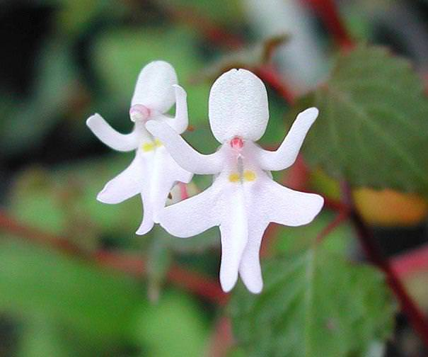

Laughing Bumble Bee Orchid
(Ophrysbbomyblifora)
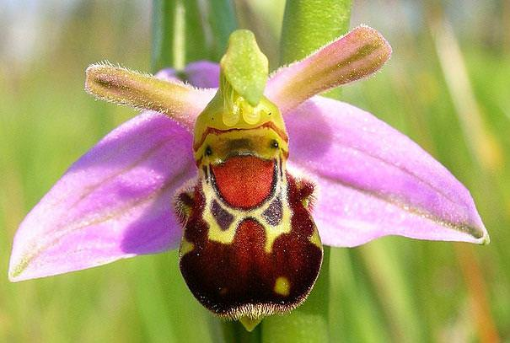

Swaddled Babies
(AnguloaUniflora)
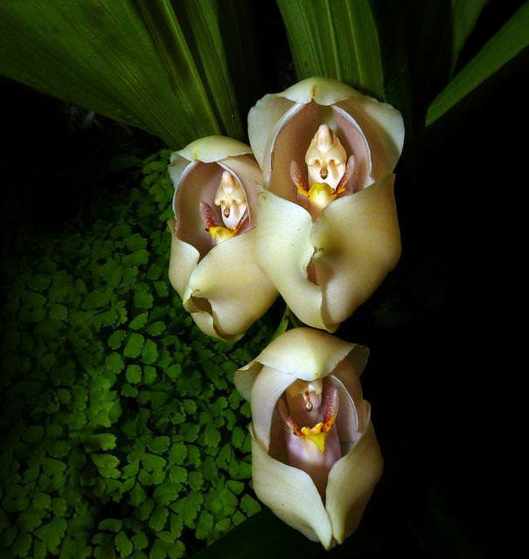

Parrot Flower
(Impatiens Psittacina)
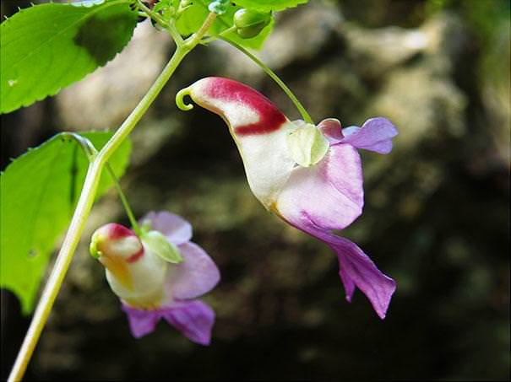

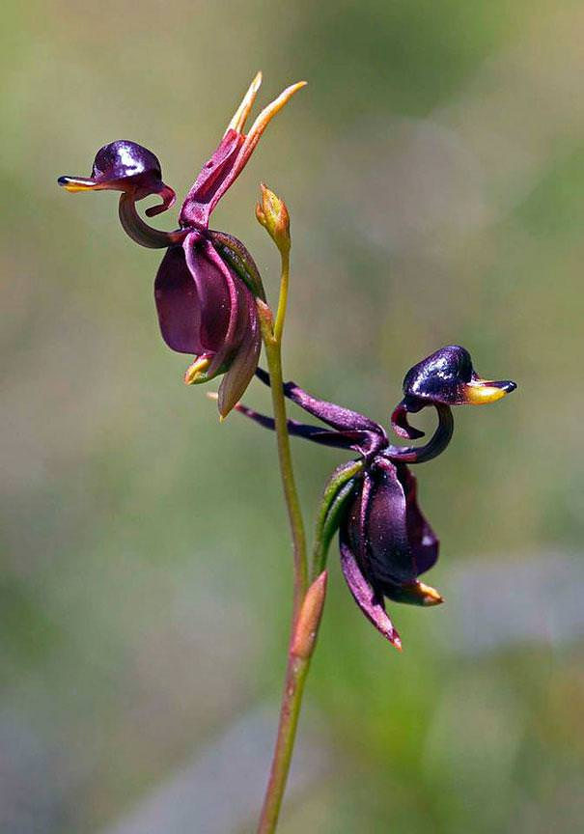

An orchid that looks remarkably
like a tiger
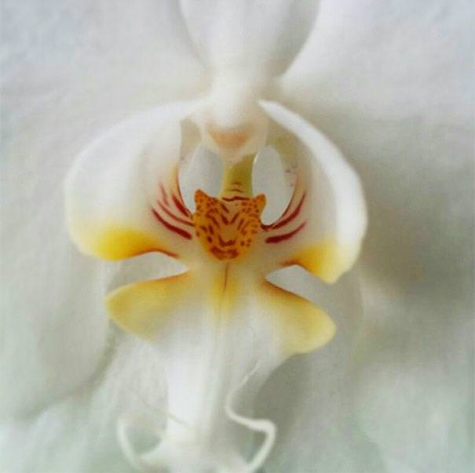

Happy Alien
(Calceolaria Uniflora)
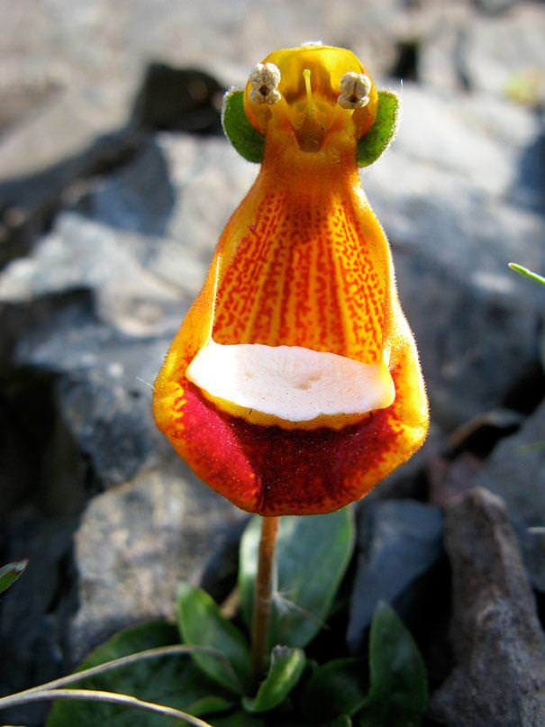

Just love the Logitec earphones
And his friends...

Angel Orchid
(Habenaria Grandifloriformis )
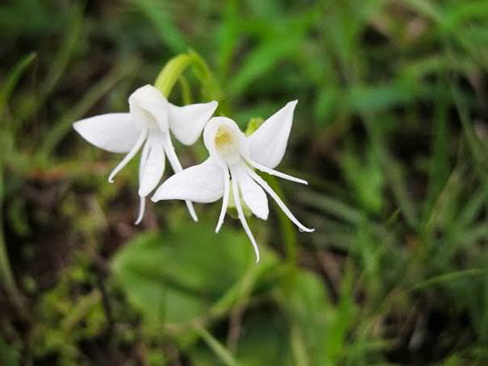

Dove Orchid Or Holy Ghost Orchid
(Peristeria Elata)
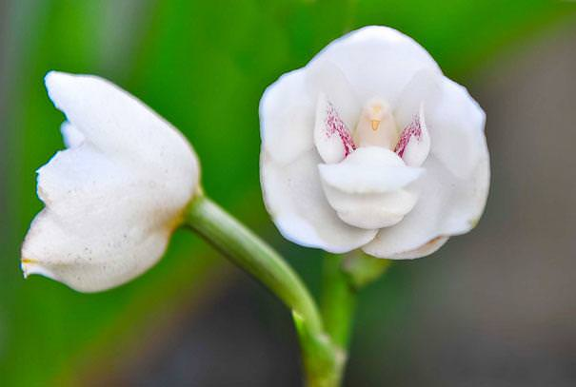

White Egret Orchid
(Habenaria Radiata)
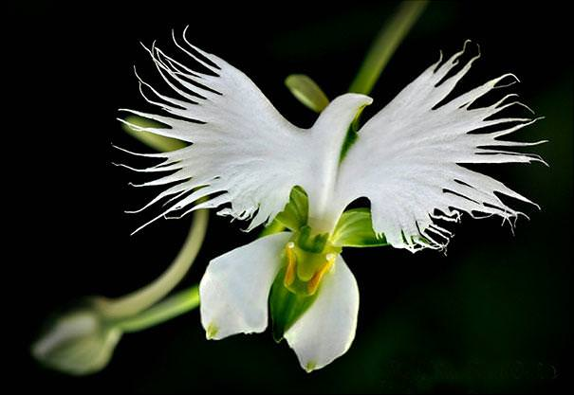

The Darth Vader
(Aristolochia Salvadorensis)
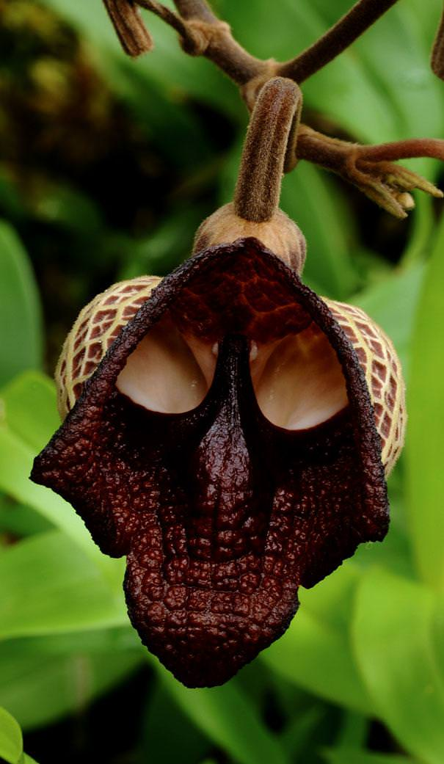
An Orchid That Looks Like A Ballerina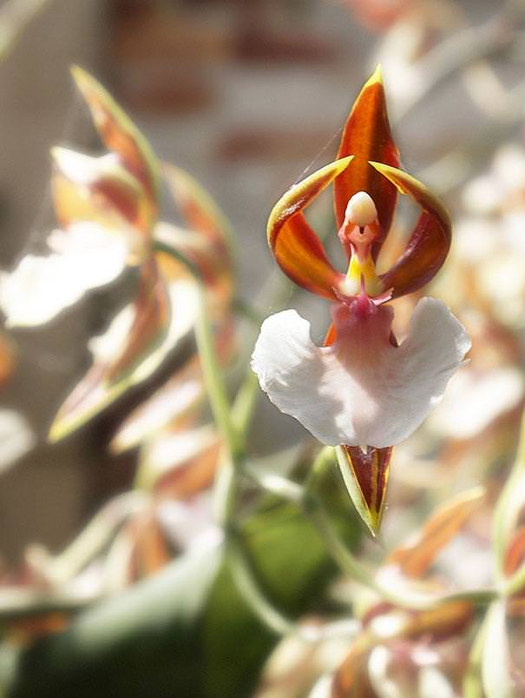

Monkey Face Orchid
(Dracula Simia)
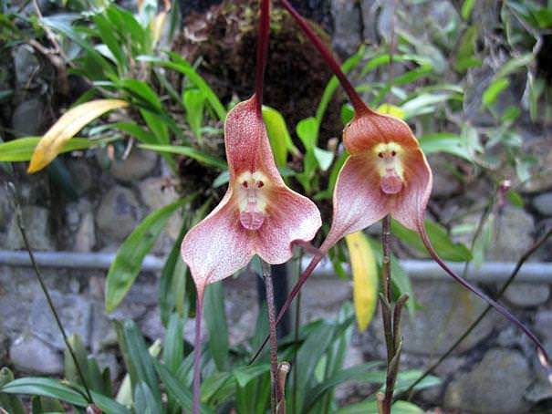

Moth Orchid
(Phalaenopsis)
