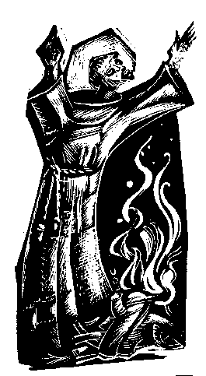
“Praised be you, My Lord, through all your creatures!”
Franciscan Readings for
Week Commencing
25 January, 2009
Third Week in Ordinary Time - B

Sunday 25 January 2009
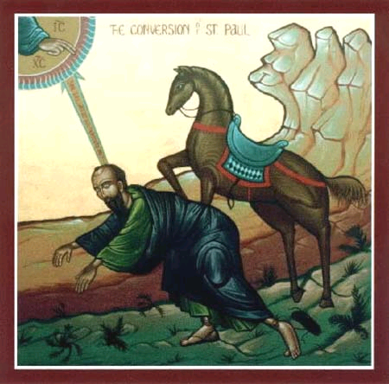
Paul (Saul) was from Tarsus, born around the year 20. His conversion story is legend. Paul was a Jew, a tentmaker and, it is said, a persecutor of the early followers of Jesus. He was not present at the stoning of Stephen as some believe. On his way to Damascus, Paul believed that Christ appeared to him. This occurred at a time when Paul was full of remorse, doubts, fears about his activities. "An excitable, nervous temperament; a soul that had been violently agitated and torn by the most terrible doubts; a most vivid phantasy, occupied with the awful scenes of persecution on the one hand and on the other by the ideal image of the celestial Christ; in addition the nearness of Damascus with the urgency of a decision, the lonely stillness, the scorching and blinding heat of the desert -- in fact everything combined to produce one of those ecstatic states in which the soul believes that it sees those images and conceptions which violently agitate it as if they were phenomena proceeding from the outward world" Pfleiderer wrote. Whatever about that, Paul’s faith in Christ drove him to change his life completely and he went on to become the most significant figure in the spreading of the Good News.

(A Reading from the Legend of the Three Companions)
Francis was staying in a small hut with the friars at Rivo Torto, near Assisi. It was very cramped, so much so that the friars could barely sit down to rest. Food was scarce and they lived on a few turnips growing in a nearby field. Francis scratched the names of the friars into the beams of wood so that each would know his place and not make excessive noise moving around. One day, the brothers were at prayer when a peasant came through the front door of the hut, pushing a donkey before him. He said to the donkey, “Go in, go in – we will do well in this place.”
Confronted with this spectacle and uproar, Francis turned to his brothers and said, “I know that God did not call us to prepare a lodging for a donkey, nor to have dealings with people. While we are preaching the way of salvation to people and are giving them wise counsel, we should dedicate ourselves most of all to prayer and thanksgiving.” They left the hut for the use of poor lepers and lived elsewhere.
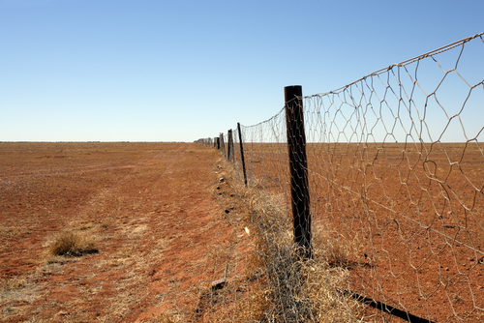
Lord, you send the noise and panic of our daily life to test our resolve. May we take all distractions as part of the rich tapestry of our life, your gift to us.

Monday AUSTRALIA DAY 26 January 2009
It is the day when we give thanks to God for the Great Southern Land of the Holy Spirit, Australia. We give thanks for our people, the spirit of sticking together through hardship and achieving beyond expectations. We give thanks for our land, fragile and enduring, harsh and extreme, ancient and self-renewing. We give thanks for diversity, for those who live in the city and the country, for those from different cultures and backgrounds – we give thanks that we can be one people, living together. We give thanks for our indigenous cultures, the resilient spirit, knowledge, art and history of Aboriginal and Torres Strait Islander people who define our identity and culture. We give thanks for freedom and democracy, for our fundamental rights and responsibilities, for participation and equality. We give thanks for the egalitarian ethos of our society, where everyone is given a fair go, our compassionate society where all are identified as friend.

.(A Reading from the Life of St Francis by Thomas of Celano)
When the friars were still at Rivo Torto, the Emperor, Otto, passed through that area with much pomp and ceremony to receive a crown of an earthly empire. Francis forbade the friars to join in the festival and to stay inside and remain silent – which they did, all but one who called out to the Emperor that his kingdom would be shortlived. Francis was not bothered by the Emperor, he had made a dwelling-place for God within himself. He refused to flatter kings and princes.

Lord, our compulsion to flatter and adulate can be strong. Help us to be genuine in our relationships and show the real face of Jesus in all that we do.

Tuesday 27 January 2009
(A Reading from the Legend of the Three Companions)
Francis obtained a church by divine inspiration from the abbot of the Benedictine monastery of Mt Subasio near Assisi. Francis commended the place to the Virgin Mary and ordered that this place be loved by the friars more than any other place in the world. One of the friars had a dream – all the people of the world were standing around the church, blind and calling to the Lord to restore their sight, which occurred in a bathing of light. The world with its seductions had disappeared and the people of the world saw the truth and beauty of this religion.

Lord, you call us to find a home on earth. May we find our true motherland on this earth, protect and defend its beauty, until we are called to our true home in you.

Wednesday St Thomas Aquinas 28 January 2009
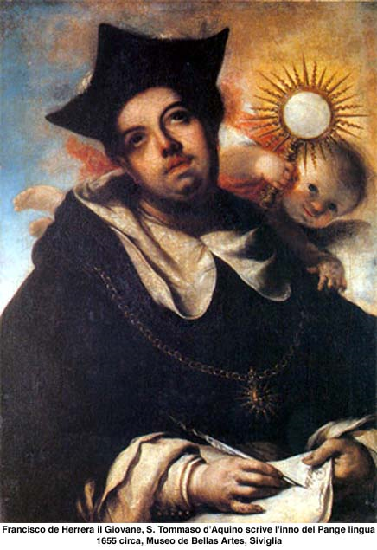
Thomas Aquinas was born at Rocca Secca, Napoli, in 1225. His parents, the Count and Countess of Aquino, were related to Emperors Henry VI and Frederick II, and to the kings of Castile, Aragon and France. His mother Theodora was told by Calo the Hermit that "He will enter the Order of Friars Preachers, and so great will be his learning and sanctity that in his day no one will be found to equal him". And it looked likely to be true as the little boy Tommy was sent off to the Benedictines to study, the child frequently heard to ask, “What is God?” The Abbot of Monte Cassino sent him then to the University of Naples to complete the Quadrivium and, despite the tempting corruption all around him, he took the Dominican habit in about 1243. His mother was the fretful type and hurried to see him in his novitiate at Naples but the friars, suspecting she might kidnap him, sent Thomas to Rome. Not to be outdone, Theodora sent a message to the soldiers of Frederick II who captured the novice Thomas and he was imprisoned by his family in the fortress of San Giovanni for two years. The Pope intervened and things were fairly smooth sailing from then on. His life could be summarised in a few words: praying, preaching, teaching, writing, journeying. His preaching was sought out by everyone, the Popes wanting him near to them. His principle work was the Summa Theologica on faith and reason – it is still used today. It took him eight long years to compose and, at the end, he said it was all just straw. Others disagreed. He died in 1274 on his way to a meeting with St Bonaventure, the monks at Fossa Nuova hassling him to dictate a treatise on the Canticle of Canticles at his deathbed. Thomas is now lying in Paris, the right arm at the University of Paris and the left in the Cathedral of Naples.

(A Reading from the Legend of the Three Companions)
Since they had promised to live according to the Gospel, Francis attempted all of his life to fulfil the Gospel to the letter. When the friars were cooking, he did not allow the cook to leave beans in the pot over night to soften them, for in the Gospel it says, “Do not worry about tomorrow, leave tomorrow to itself.” As such, the friars did not want to collect more alms than were needed for one day.

Lord, the temporary nature of the world around us reminds us of our true vocation. May we set our hearts on the higher things, acting always with the love that comes from you and into which we return.

Thursday 29 January 2009
(A Reading from A Mirror of Perfect of a Lesser Brother)
Once when Francis was at St Mary of the Portiuncola, a very poor man was coming back along the road from Assisi with a bag of alms. As he drew near the church, he was praising God at the top of his voice, so much so that Francis heard him. Francis ran out and, overjoyed, laughing and with great joy he kissed the man’s shoulder and took from him the bag of alms and the two men went together to the friary. Francis said to the brothers, “This is how I want a brother of mine to go for alms and to return happy and joyful praising God.”

Lord, you give us the light of truth. May we rejoice in the joy of the truth you have given to us: that your love for all creation is neverending.

Friday 30 January 2009
(A Reading from the Assisi Compilation)
Once when Francis had returned to St Mary of the Angels, he found there Brother James the Simple with a leper covered with sores who had come there that day. This leper had been entrusted to James who served as a doctor for in those days, friars lived in the leprosarium. Seeing James and the leper in the Church, he reproached James and said, “It is not right for you to take our Christian brothers around in this manner – it is not right for them nor for us.” People were afraid of lepers and Francis did not want them taken outside the hospital. Immediately Francis felt grieved that he had taken James to task and confessed his fault to the minister, Peter Catanio. As a penance, Francis said that he would share a meal with the leper. And so, Francis sat next to the leper and dipped his bread into the same bowl which was contaminated with the blood and sores that had fallen from the leper’s skin. All the friars who saw this grew very sad but dared not say anything.

Lord, give us the strength to meet the leper, to put aside revulsion and to only accuse ourselves.

Saturday Francis de Sales 31 January 2009
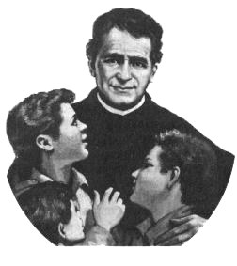
Giovanni Melchior Bosco was born in a little cabin in Castelnuovo in 1815. He founded the Salesian Order. His father died when he was two and he eked out a living as a hillside shepherd. He was given instruction by the local parish priest. He entered the seminary and ministered to prisoners on death row. Serving in a parish church, he befriended young urchins, founding the Oratory or rifugio for disenfranchised youth. He eventually founded the Salesians (the Society of Don Bosco) and, at his death, there was 250 houses. The Salesians are now found in every country throughout the world

(A Reading from the Fioretti)
There was a leper living in the friars’ leprosarium that was so ill-tempered and abusive that everyone was afraid to go near to him. This leper would scream out obscenities against the Church, our Blessed Mother and every friar that came near to him. Francis went to the leper and said, “My dear brother, may God give you peace.” But the leper responded, “What peace can I have from God? He has taken from me peace and every good thing, and has made me all decayed and stinking!” Francis said, “I want to serve you myself, since you cannot abide the others.” The leper replied, “What more can you do for me?”
“I will do whatever you want,” Francis said.
“Then,” said the leper, “I want you to wash me all over. I stink so badly from the infection that I can barely stand myself.” So Francis did, and the more he washed, the more the leprosy disappeared. The more the leper wept, the more his heart and soul were cleansed by contrition.

Lord, our power to heal is immense. Grant us the ability to heal the hearts, souls, bodies and minds of those who so desperately need it.

