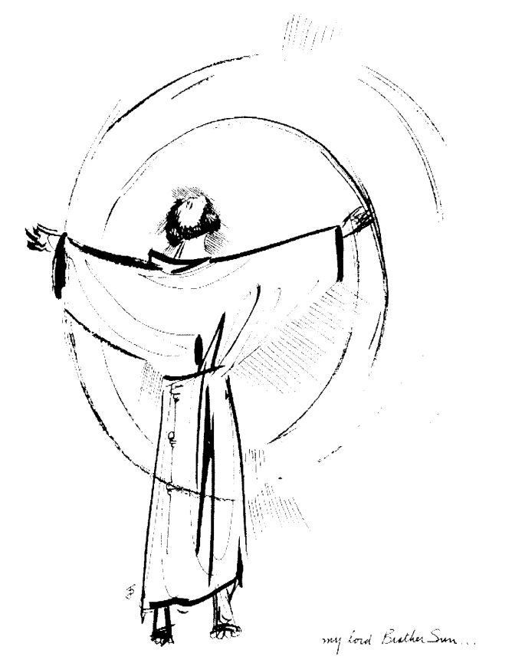
“Praised be you, My Lord, through all your creatures!”
Franciscan Readings for
Week Commencing
11 October, 2009
28th Week Ordinary Time

Sunday 11 October 2009
(A reading from “The Major Legend of St Francis” by St Bonaventure)
Humility – the guardian and embellishment of all the virtues. had filled Francis, the man of God, with abundance. In his own opinion he was nothing but a sinner, though in truth he was a mirror and splendour of every kind of holiness. As he had learned from Christ, he strove to build himself upon this like a wise architect laying a foundation. He used to say that it was for this reason that the Son of God came down from the height of the Father’s bosom to our lowly estate so that our Lord and Teacher might teach humility in both example and word.

Lord, help us to be examples of humility, placing ourselves second to our neighbour that we might be instruments of peace.

Monday 12 October 2009
(A reading from 'The Admonitions’ of St Francis)
‘Blessed are the peacemakers, for they will be called the children of God.’ Servants of God will never realise how much patience and humility they have within themselves while they are content and everything is going well. It is when people displease or disturb us that we realise how much patience and humility we really possess. This is how much they have and no more. Those true peacemakers preserve peace of spirit and body out love of Christ regardless of what suffering may be inflicted on them. Blessed are they who do not consider themselves any better when they are praised and exalted than when they are thought worthless and simple – for what we are before God, that we are and nothing more.

Lord, you make us with our gifts and talents. You have not spared us weakness and failure, such is the beauty of life. Help us to be happy with who were as we stand exposed and vulnerable before your crucified Son.

Tuesday 13 October 2009
(A reading from 'The Remebrance of the Desire of a Soul,' by Thomas of Celano)
Francis, the man of God, not only showed himself humble to the great but also to his peers and to the lowly, more willing to be admonished and corrected than to admonish others. One day he was riding a donkey, as he was quite sick at the time. Passing a field, one of the peasants working the land ran up to Francis and asked him, “Are you Francesco, Bernardone’s son, from Assisi?” When Francis replied that he was, the peasant said, “Try hard to be as good as everyone says you are for many place their trust in you. Never be different from what people expect.” Francis got down and knelt before the peasant thanking him for his kindness in admonishing him.

Lord, we would love to be immune from criticism. Help us to humbly accept the advice of wise people and be the last to find fault with others. Give us the grace of gentleness and honesty.

Wednesday 14 October 2009
(A reading from 'The Remembrance of the Desire of a Soul,' by Thomas of Celano)
Francis came to Imola, a city of the Romagna, and presented himself to the Bishop, asking for permission to preach among the people. “Brother,” said the Bishop, “I preach to the people and that is enough for them.” Francis hung his head and kind of slid out of the room. An hour later, he came back. The Bishop said, “What do you want, Brother?’ Francis said, “If a father throws his son out by one door, he should come in by another!” The Bishop was moved by his simplicity and embraced him saying that he and his friars could preach anywhere in the diocese.

Lord, when a door slams in our face, help us to find the window through which to climb back in. May we never tire of preaching your word to others.
heart.

Thursday St Teresa 15 October 2009
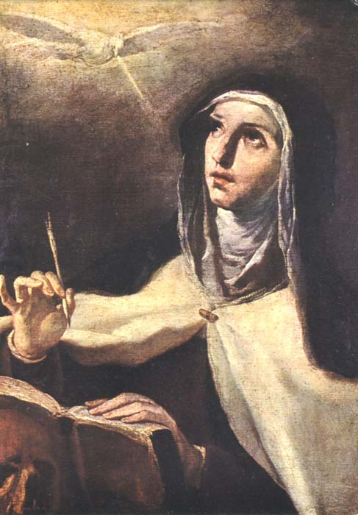
St Teresa of Avila was born in Spain in 1515 and died in 1582. She was a remarkable woman in that she had an astonishing spiritual life but also reformed the Carmelite order which had calcified over those many years since its foundation. The details of her hardships are noted as well as her experiences of Christ and the writing of her Interior Castles. She was a strong woman of reform in an age of narrowness. We ask for her strength and knowledge.

(A reading from 'The Legend of St Clare’)
This woman, the cornerstone and foundation of her Order, from the very beginning sought to place the building of all virtues on the foundation of holy humility. For she promised holy obedience to Francis and never deviated from her promise. She never shirked any familial chores, to the extent that she would wash the hands of her sisters and serve them at table. She would never give an order without preferring to do it herself first. She herself washed the mattresses of the sick and, even when they would reject her charity, she tried even harder to offer it with love and affection.

Lord, help us to be like St Clare in her selfless service of her sisters. May we never shirk our responsibilities within our lives as brothers and sisters of Francis and Clare.

Friday 16 October 2009
(A reading from a letter of St Peter of Alcantara to St Teresa of Avila)
If any wish to follow Christ’s counsel concerning greater perfection let them follow it, because it was not given more for men than for women, and Christ himself will grant success as he has to many others who have followed him. I place my confidence in Christ and firmly believe his counsels to be the best because they are divine. I consider the poor in spirit are blessed, those voluntarily poor in spirit as I myself have experienced. Do not believe those who from a lack of light or from disbelief affirm the contrary because they have never tasted how sweet God is. Instead believe those who serve him and love him and for love of him renounce all things of the world that are unnecessary.

Lord, let us rise to the heights of perfection. You are most praised when we are fulfilling our potential – give us the strength and zeal to do wonders in our day.

Saturday 17 October 2009
(A reading from The Fioretti)
St Francis wanted to teach Brother Masseo a lesson about humility and, while he was with all of his companions, Francis said to Masseo, “O Brother, all those companions of yours have the gift of contemplation and prayer; but you have the gift of preaching the word of God to content the people. So I want you to have charge of the door and alms and cooking so that these brothers can be left to contemplation. You shall eat your meals outside on the doorstep so that you may say a few words from scripture to those who come to the door before they knock thus disturbing the others.” Masseo went and did as he was bid. After many days, the other brothers became upset as the whole running of the house had been assigned to Brother Masseo. Finally, they went to Francis and asked if the tasks could be distributed evenly amongst the friars. Francis asked Masseo, “The other brothers want to do some of the tasks I assigned to you, so I want these jobs divided.” Masseo said, “Whatever you assign me, part or all of it, I will consider it all God’s doing.” Francis was overjoyed at his humility and the charity of the others.

Lord, help us to refrain from being compulsive helpers who feel beset upon for no good reason. Let us see all of the mundane tasks that we must perform as all part of God’s greater work in the world.

