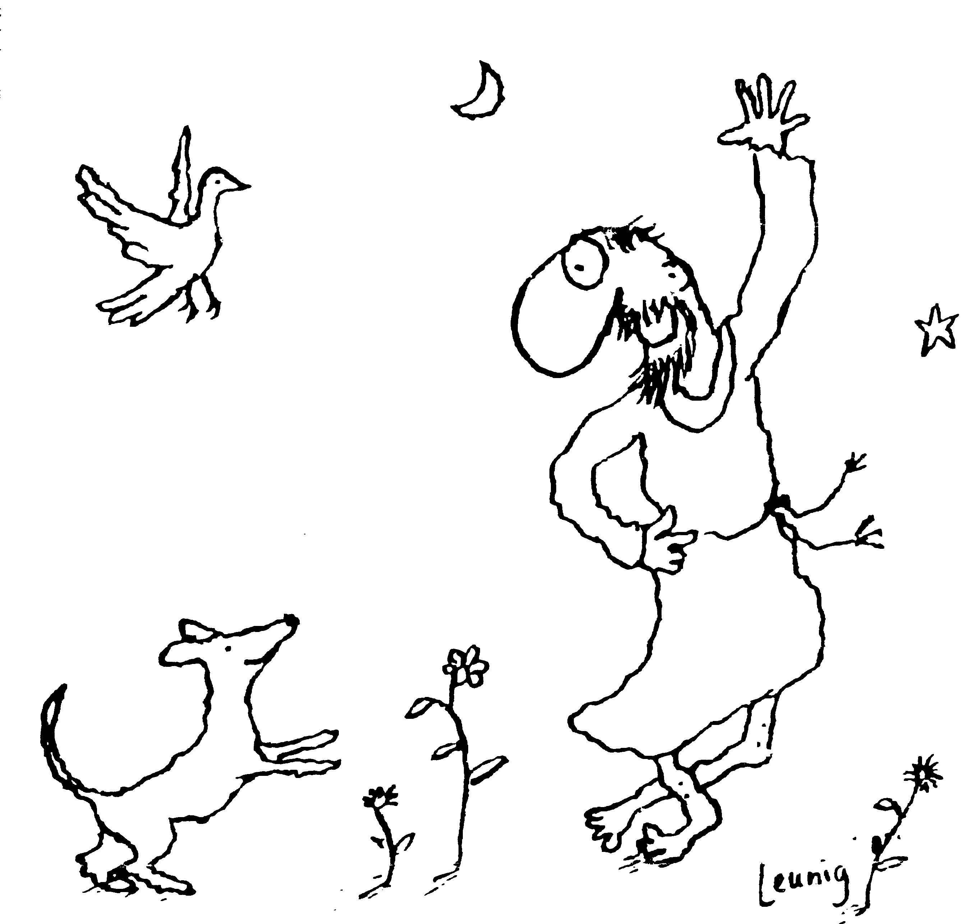
“Praised be you, My Lord, through all your creatures!”
Franciscan Readings for
the Week Commencing
8th March, 2009
2nd Week in Lent – A

Sunday 8 March
(A reading from ‘The Life of St Francis’ by Thomas of Celano)
More than anything else he desired to be set free to be with Christ. His chief concern was to live free from al things that are in the world, so that his inner serenity would not be disturbed even for a moment. He made himself invisible to all outside noise, gathering his external senses into his inner spirit – he emptied himself for God alone. In the clefts of the rocks he would build his nest and in the hollow of the wall his dwelling. But he was not reluctant yo involve himself in the affairs of his neighbour when the time was right. Yet prayer remained his safest harbour.

Lord, help us to be involved in the affairs of others in a healthy manner. May our disinterested charity be an example of generosity to others.

Monday Frances of Rome 9 March

Billed as one of the greatest mystics of the fifteenth century, Frances had always wished to be a religious but was made by her father to marry Lorenzo di Ponziani at the age of twelve. She had at least four children and was known for her charitable works and patience. She was committed as an oblate of the White Benedictines and live din continence with her husband’s permission. She was, despite perhaps her religious fervour, a loving mother and a wonderfully social woman in her dealings with the poor and unwanted. Upon her husband’s death, she was admitted to the Benedictines and became superior. She died in 1440 whilst visiting her son (just as she had foretold). She is buried near the Roman forum.

(A reading from ‘The Remembrance of the Desire of a Soul’ by Thomas of Celano)
Francis always prayed the prayers of the Church wherever he was. Even though he was suffering from a condition of the eyes, stomach, spleen and liver, he didn’t lean against a partition during the office but stood upright and recited the psalms with incredible devotion. One day, he dismounted his horse to say the Office and became soaked through from the rain – “If the body calmly eats food, which along with itself will be food for the worms, the soul should receive its food, which is its God, in great peace and tranquillity.”

Lord, let us be people of prayer. May we not be embarrassed or put off praying in public but embrace prayer as part of our life in you.

Tuesday 10 March
(A reading from ‘The Remembrance of the Desire of a Soul’ by Thomas of Celano)
‘When a servant of God is praying, and is visited by the Lord in some new consolation, he should life up his eyes to heaven, fold his hands and say, “Lord, you have sent me this sweetness and consolation from heaven and I send it back to you so that you may save it for me, because I am a thief of your treasure.” And also, “Lord, take away your gift from me in this world and keep it for me in the next.” This is the way it should be – a man who prays should come away from prayer looking as though he was the most worthless of sinners. Remember – it happens that one loses something priceless for the sake of a small reward and may easily provoke the giver not to give again.’ Francis would rise early and in secret in order to pray. At night, he would pray privately but would make a loud noise before going to bed so that the other friars knew he was at rest.

Lord, you shower us with many gifts. May we return our gifts to you tenfold by admitting our unworthiness and sharing them with others.

Wednesday 11 March

(A reading from ‘The Remembrance of the Desire of a Soul’ by Thomas of Celano)
The abbot of San Giustino was coming along the road when he met Francis. Talking for a while, the abbot asked Francis to pray for him. Moving on, Francis called out, “Wait a while, brother, and I will pay my debt to you,” for Francis never through promises behind his back but rather fulfilled them quickly. The little man of Assisi prayed earnestly for the abbot who was filled with a lightness and a great humility. These small gifts are the kind that servants of God should give to each other: to help and be helped in spiritual welfare, to commend and be commended.

Lord, we don’t need to have a million dollars to show our appreciation of others. Help us to remember those we love as well as those who remote from us in our prayers offered to you.

Thursday 12 March
(A reading from the Legend of St Clare)
Clare would pray with the sisters for long periods of time after compline and torrents of tears would flow down her face. Even after the sisters had retired to bed, Clare would remain behind to spend even longer with the Lord. She imagined that she held Jesus in her hands, impressing kisses on his feet and washing them with her tears. One night, she thought she saw a small child approaching her, saying, “You should not cry so much or will go blind.” “Noone who sees God can become blind.” And then again the child taunted her saying, “You should not cry so much or your brain will dissolve in the salty water, flowing out through your nose which will become crooked.” “Noone who knows the suffering of our Lord can ever become crooked.” And the little child disappeared.

Lord, dare we weep at your sufferings and know the pain of your Passion? Can we become so full of love that we feel agony inside us? Let us be genuine in our faith, Lord, and may we draw closer to you each day.

Friday 13 March
(A reading from the Assisi Compilation)
One day, the bishop came to visit Francis and entered the friary freely, as he had before. But going to Francis’ cell, having always been treated with friendliness and respect, he found he couldn’t open the door. When he did, the door flew shut, knocking the bishop backwards. Francis was in conversation with God and would not be disturbed. The bishop went away sorry for the intrusion.

Lord, when do we find time to give to you alone? Help us to be remarkable in our consistency with you. May we hold to thinking of you a little each day, and then to gradually give ourselves to you totally as we know and love you more and more.

Saturday 14 March
(A reading from the book of the Blessed Angela of Foligno)
The soul grants hospitality to God in prayer – God is the Pilgrim. Would that when you go to preach you could understand, as I understood when I knew I had given hospitality to the Pilgrim. For then you would be absolutely unable to say anything about God, and neither could anyone else. Then I would like to come to you and tell you, “Brother, say something to me about God now,” and you would not be able to say a thing, nothing about God’s goodness or God’s infinite love. What you need to attain is complete oneness with God in prayer – and then you would say to the people with complete self-assurance, “Go with God, because about God I can say nothing.”

Lord, we can make the words of prayers sound wonderfully holy and pious. Help us to come close to you in the silence and the stillness where words are unimportant. Draw us to you always.

