UNIT ONE

CALLED BY GOD IN FAITH
In Unit One, we aim to show firstly, the concept and the normal pattern of a religious vocation. Our response to God’s call is what we call ‘conversion’. We briefly look at the process of conversion and how it operated in the life of Francis and all those who follow him.

CHAPTER ONE: WHAT IS A VOCATION?

- Jesus calls four fishermen – a life experience Reflect and Discuss
- The Pattern of a Vocation God calls Moses Ex 3:7 – 9 Activity A Story to think about
- Cultural elements that could influence a vocation Scripture Reflection
- Some Legal Aspects of Vocation Signs of a Vocation

CHAPTER TWO: CHRISTIAN DISCIPLESHIP

1. Reflection on Jn 1:35-42 A Commentary Discussion Questions 2. Discipleship in the New Testament
Two Kinds of Discipleship
3. Some Characteristics of Franciscan Discipleship

CHAPTER THREE: GOD CALLS FRANCIS

Meet Francis Bernadone
God calls Francis to Serve Him
Reflection Questions

CHAPTER FOUR: CONVERSION: A RESPONSE TO GOD’S CALL

What do we mean by “conversion”?
Vocation and Conversion
Summary
Bartimaeus – A Story of Conversion Questions for Discussion

CHAPTER FIVE: STAGES OR SIGNS IN FRANCIS’ CONVERSION

Activity
The Story of Francis’ Conversion
Francis’ conversion experiences: Francis’ Dream at Spoleto; the Francis’ Cave experience, Meeting with the Leper; Roman Experience; Francis before the Bishop; San Damiano experience; Jesus reveals himself to Francis.
Reflection: How did Francis see his Conversion?
Review of Unit One
Summary of Main Points of this Unit

UNIT ONE: CALLED BY GOD IN FAITH

CHAPTER ONE

WHAT IS A VOCATION?

Here we reflect on what a vocation or call from God is. How can we recognize a true religious vocation?

Read or listen to the following story from the Gospel of Mark:

Jesus calls four fishermen
After John had been put in prison, Jesus went to Galilee and preached the Good News from God. “The right time has come,” he said, “and the Kingdom of God is near! Turn away from your sins and believe the Good News!”

As Jesus walked along the shore of Lake Galilee, he saw two fishermen, Simon and his brother, Andrew, catching fish with a net. Jesus said to them, “Come with me and I will teach you to catch people.” At once they left their nets and went with him.

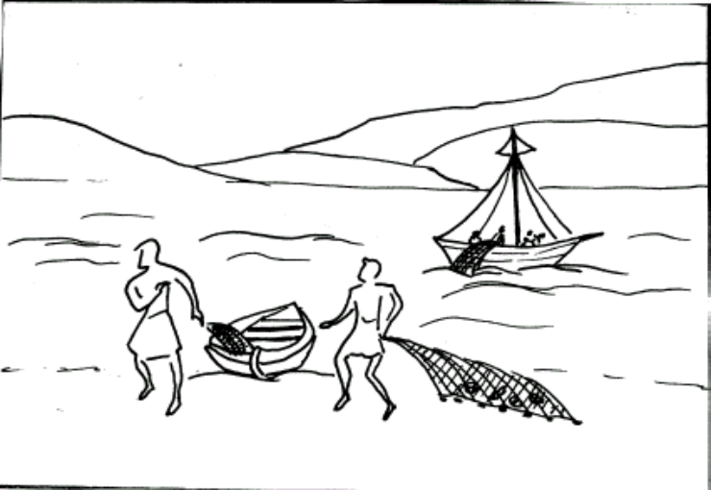 At once they left their nets (Mk 1:18)
He went a little further on and saw two other brothers, James and John, the sons of Zebedee. They were in their boat getting their nets ready. As soon as Jesus saw them, he called them, they left their father Zebedee in the boat with the hired men and went with Jesus.

At once they left their nets
Mk 1:14 – 19

1. LIFE EXPERIENCE
God calls people in the situation they are in:
- The society they live in;
- Whether they are rich or poor;
- At a particular time;
- In a political and religious situation; and
- In a particular culture

All these things shape our lives. They also affect the way we hear and answer God’s call. God may call us at any time and any place. Sometimes his call can be clear and certain, but usually it starts as an inclination or a movement within us towards a certain way of living. This develops into a strong feeling, an impulse to move in a certain direction towards a way of life which later develops into a firm resolution. It is a gradual process that takes time – short or long - to develop. This is what we call a “vocation” which comes from God.
Consider the situation that the four disciples were in when Jesus called them.

These disciples were simple fishermen. They were not what we would have expected leaders of the Church to be. They would have had very little schooling, but they knew their trade as fishermen. They were poor, simple men, Jews from the nearby village of Capernaum. They were certainly God-fearing men who were obedient to their parents and respectful to everyone. That was a Jewish custom.

The disciples were at their normal work catching fish when Jesus called them to follow him. Just imagine the situation. These men see this stranger, Jesus, whom they recognize as a ‘teacher’ (rabbi). There must have been something very attractive about Jesus. Instinctively, they trusted Jesus even though they did not know him. They were guided by an inspiration they could not explain, but they knew that what they were doing was the right thing to do. But this was only the beginning of their vocation. It took some time before they understood it.

Reflection
Take some time to reflect on your own situation and how God has worked in your life. Jot down some points that you may like to share with others. When you are ready, go into a group and discuss your reflections.

Some things you could discuss could be:
- When did you first feel God acting in your life?
- Where were you?
- What or who influenced you?
- How did you respond to God?
- Where did God lead you?
- What did you feel about it?
- How did you and your family and friends react?
- Who or what urged you to follow the call?

Note: A “vocation” can refer to any way of life, but here we are restricting the meaning to
a religious call by God to live the Franciscan vocation.

Share and Discuss these first experiences among yourselves.

2. THE PATTERN OF A VOCATION
A vocation comes from God. It is a mystery to us. Yet, there are many examples of God calling people to carry out his work in the bible. If we examine these we would find that each story follows a pattern. Many can find the same pattern in their own vocation. Let us take an example from the bible:
Read the story of Moses’ vocation in Exodus 3:7 – 9. And note the pattern. Here it is:

GOD CALLS MOSES TO WORK FOR HIM

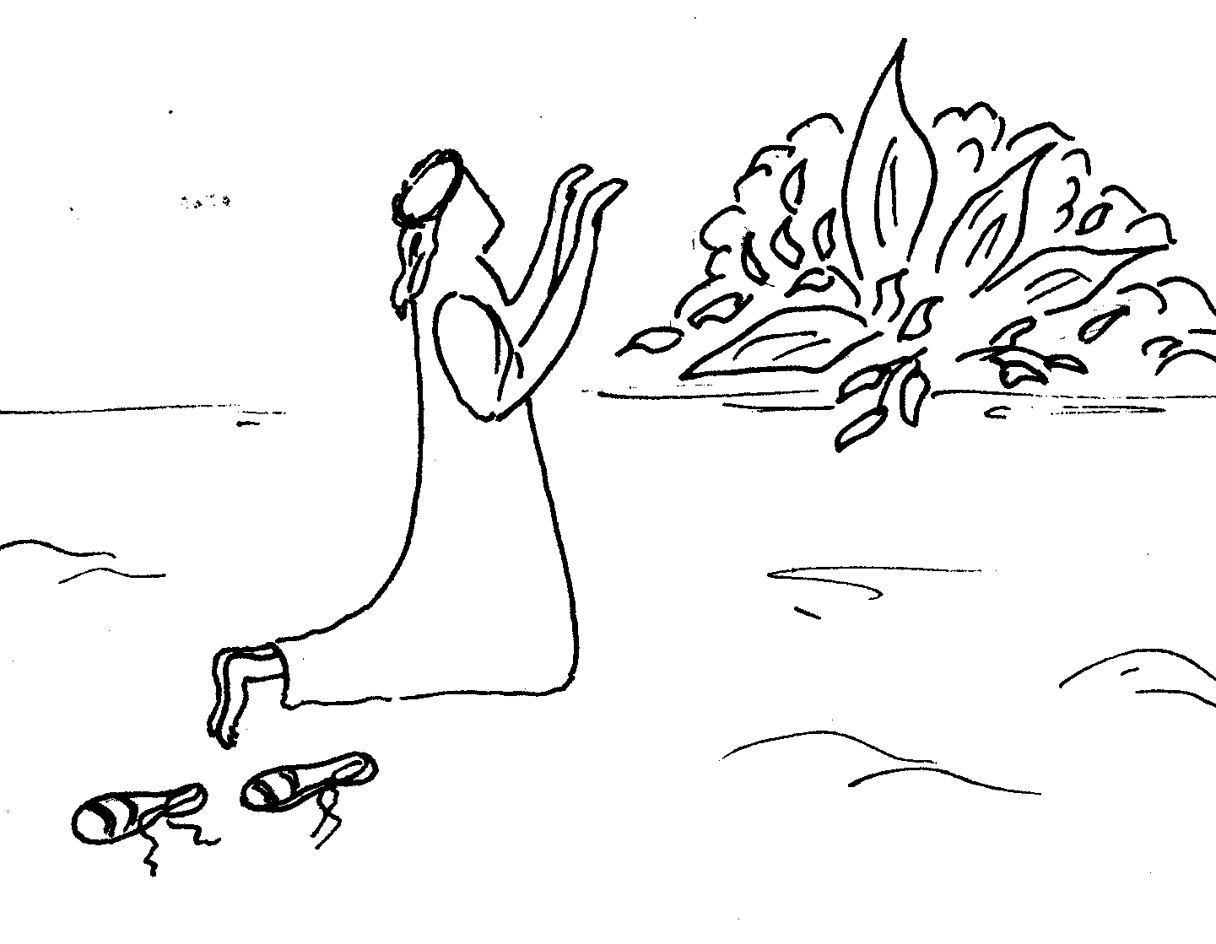

A CALL
IN RESPONSE
TO A NEED Then the Lord said, “I have seen how cruelly my people are being treated in Egypt; I have heard them cry to be rescued from their slave-drivers. I know all about their sufferings, and so I have come down to rescue them from the Egyptians and to bring them out of Egypt to a spacious land, one which is rich and fertile…I have indeed heard the cry of my people, and I see how the Egyptians are oppressing them…”

Now, I am sending you to the king of Egypt
So that you can lead my people out of this
country (Ex 3:10)

God freely CHOOSES people as his representatives to do the ‘work’ for him. To carry out his promise God chose Moses, one of the oppressed, to be his agent to bring freedom for the Israelites.

God CHALLENGES Moses to carry out his work: A MISSION

In calling a person, God asks, “Are you willing to give me your body, all your gifts and your whole person so that through you, I can be present in the world and can accomplish my plan?”

Just as in the story of the call of the apostles, Jesus says, “Come, follow me,” And immediately they left everything and followed him.
But that is not always the case for most people. The usual reaction is FEAR. A person is afraid when he or she sees what the call implies. That is what happened to Moses. He was afraid so he looks for excuses to get out of the task asked of him. Moses objects four times, but God insists. Moses tries to pass on the job to his brother, Aaron, but God tells Moses, “If I wanted Aaron, I would have asked him. I am asking YOU!”
Then God gives Moses the reassurance: “I WILL BE WITH YOU” to help you. TRUST ME and HAVE CONFIDENCE IN ME.

This tells us that it is not by our own strength that we will accomplish God’s work but by God’s help. This is an important thing to remember when we are faced with difficulties and we don’t see success, as we would judge a situation.

GOD INVITES US and ENCOURAGES us (“I will be with you”)

And he AWAITS OUR CONSENT TO FOLLOW HIM,

AND OUR COMMITMENT TO BE WITH HIM.

There is still one more element we should consider in the concept of a vocation: There must be A GOAL TO ACHIEVE, A DREAM TO FULFILL that draws us on and gives us energy.
All these elements go to make a vocation (not necessarily in this order):

A CALL – AN INVITATION FROM GOD

A CHALLENGE – TO FACE UP TO

A MISSION – TO ACHIEVE

A GOAL – TO INSPIRE US TO ACT

A TRIAL – TO OVERCOME

Activity:
- Look up the following texts and see if you can pick up the aspects of a vocation in each one. What reaction is there to the call? Note down the differences from one example to another.
Gen 12:1 – 4: God calls Abraham
1 Sam 3:1 – 12 God calls Samuel
Jer 1:4 – 10 God calls Jeremiah

- Can you name some other examples of vocations in the Bible?

A STORY TO THINK ABOUT

This is a story about a camel called “Horace”. He lived in the great Sahara Desert in Africa. One day, Horace was looking up to the sky and he said to his friends: “Look at that fantastic star! I think it’s calling us and asking us to follow it.”

These camels all lived near an oasis, where their lives were peaceful, simple and secure. They always had plenty grass and dates to eat and plenty water to drink. Nothing seemed to disturb the peaceful living of these camels but they now sensed their friend was certainly fascinated by the strange bright new star. It puzzled them and they wondered what it could mean.
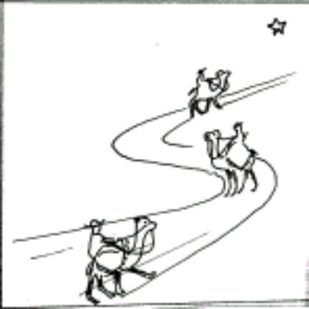
“I remember one of my dreams as a child,” continued Horace, “I saw a star over the horizon and clearly heard it inviting everyone to follow in search of a new life, a new country, a new fatherland...I wonder if this could be the same one.”

Some of his friends now laughed at him. Those who hadn’t seen the star called him a mad visionary, a foolish dreamer. Those who had seen it called him crazy.

“What? Follow that star? Nobody’s ever thought of that before! Where? How? For how long? Why follow it at all?”

“Where? Wherever it may lead!” he answered, “and forever, if we need to. Because it’s inviting us! I feel drawn towards it, helplessly....I’ll follow it, whatever it may cost. I’ve made up my mind and nobody can ever stop me!”

Most of the other camels left him alone and went back to eating, drinking and sleeping. Only a few stayed behind. They were filled with wonder, both by the new shining star and by the way it seemed to have completely taken over their friend. One of them asked, “Do you mean to go out into the desert, Horace, and leave all the comfort and security of the beautiful oasis?”

“Yes, I’ve decided to give everything up! If anyone wants to join me, you’re welcome! But delay is dangerous. Come on! One minute more and the star could pass us by. It might disappear and never come back. It’s now or never, the chance of a life-time!”

A few camels were certainly impressed with Horace’s eagerness and determination. They made up their minds, there and then, to join him.
“We’ll come as well! But give us time to get some things together for the journey. We need plenty of grass, lots of water, dates and grain. We need....”

“Look, time’s running out! The star’s moving away. We can’t wait a minute longer! The one who’s calling us to follow him surely won’t do so without seeing to our wants. He’ll look after us during the journey. I’m leaving at once! Anyone who wants to join me, come along. If not, stay behind and fend for yourselves!”

He started walking away from the oasis and into the empty, friendless and never-ending desert. His eyes were glued to the little shining star as it steadily vanished from the horizon over the oasis.

Only two camels ran and joined him before it was too late. All the others shook their heads in disapproval and muttered, “They’re crazy! They’re bound to die of hunger, thirst and exposure. And to think they could have stayed here with us, in the oasis enjoying all the good things life can offer!”

Discuss the story amongst yourselves.
- What do you think is the main point of the story?
- What does the story say to you about the idea of a “vocation”?
- Can you think of any other stories like this one in the Bible?
- What lessons do you think we can learn from it?

3. SOME CULTURAL ELEMENTS THAT COULD INFLUENCE A VOCATION

Question: What influence does your culture have in the way you respond to God?
Here are some cultural reasons why people avoid a vocation to the priesthood or religious life:
e.g. - Marriage is expected in his culture because there must be someone to carry on the line.
- Some must feel that they have to work and earn money to repay parents for schooling, etc.
- Some are moved by pressure from their peers to ignore a vocation;
- Some are influenced by bad propaganda and scandals in the Church;
- Some feel they would be “going against the tide”. It’s too hard for them.

Discuss these or other cultural elements that you may know that may affect a vocation.

Scripture Reflection
The Sound of the Sea
There are many sounds in the world today which did not exist at the time of Christ, but there is one sound which has existed since the dawn of creation and which will continue to exist as long as this earth lasts. It is the sound of waves breaking on a shore. Peter heard that sound by the Sea of Galilee just as you or I might hear it when we go to the beach. To us, most likely, it would speak of holidays, of a break in the year’s work, of bathing and splashing and the laughter of children. But to Peter it meant long nights of work; it meant his livelihood; often it meant frustration and cold and buffeting by storms. At least, it meant all that until the great day when he heard the voice of the Master mingling with the sounds of the sea, “Come, and I will make you fishers of men.” There was magic in those words that day; a magic that somehow changed the whole of the world about him. The silvery fish swimming about in the sea-depths suddenly took on human shape; the very sea opened out into a great world ocean; the fishing-tackle took on a new and mysterious significance and the sound of the sea mixed with the noises of towns and strange peoples.
“Come,” the voice was compelling – yet the sound of the sea still beat in his ears urging him to stay; that sound so familiar since his childhood tugged at his heart. It was hard to leave it all, to grow accustomed to new sounds and sights. But the Master’s voice prevailed: “and leaving all things, they followed him.” There are times in the lives of all of us when we must leave familiar sounds and sights which we have grown to love. It may be that the Master calls and bids us follow him in some special vocation; it may be simply the call of duty or the Providence of God at work in our lives. If we are good Christians, we will try to do as Peter did: respond quickly and follow without vain regrets.

4. SOME LEGAL ASPECTS OF A VOCATION

We have seen that a vocation is understood traditionally as an attraction, an urge that draws a person to a particular way of life. A religious vocation is a special grace that leads a person to act. It is a gift freely given by God that inspires a person to follow Christ in a particular way of life. The Fathers of the Church affirm that “without an interior call, no one should attempt to enter religious life.” Popes Pius XI and Pius XII said that a vocation has two essential elements:

- a divine element – God’s call; and

- an ecclesiastical element – The Church or the Order’s confirmation of this call after the vocation has been tested, directed and approved.

Religious life and priestly life demand a total consecration of oneself to God. One must be willing to give oneself totally and dedicate one’s efforts to the service of God and neighbour and especially to one’s community.

There is something mysterious about religious or priestly vocation. We do not understand why God chooses some and not others. This is part of God’s plan and we can only wonder and the gift that is offered to those whom God freely chooses. St Francis himself understood that a call from God was a marvellous grace that was given only to some, and that each vocation had to be tested and tried before a candidate could be accepted into the Order.

What are the signs of a vocation?

All theologians agree that there positive and negative signs of a vocation being present in a person. Each one that is listed is an indicator that points to a genuine vocation or the lack of a genuine vocation. This is a very large topic that we can only touch on here and will be discussed again in Unit 4 under the section on “Commitment”.

Here is a table that might be of some help in recognizing the signs of a vocation or lack of vocation:

SIGNS OF A VOCATION
POSITIVE SIGNS | NEGATIVE SIGNS
- The laws of the Church and the Order are being followed.  - The person shows that he or she is able to live religious life which includes: health, emotional stability, intellectual capacity, morality, honesty, etc.  - Most important: He or she must have the right motivation or intention. This is essential to a religious vocation.  - The person must have the proper and adequate knowledge of the religious vocation that he or she intends to follow. | - A person experience extreme difficulty in remaining sexually in control;  - The person cannot control his temper so as to make community life and obedience very difficult;  - A habitual lack of docility; or a person has a ‘bossy’ disposition; deep-rooted jealousy.  - A person lacks the ability to make a right judgment in order to carry out one’s duties or pursue his or her vocation.

The signs of a vocation are very closely bound to the signs of conversion, as we shall see in the next section. The two go hand in hand. We cannot consider a vocation without also considering the effects that vocation has had on a person. Thus, in judging a vocation, the candidate must manifest signs of a new and profound identity which we might call a “gospel identity” in the Franciscan life. In other words, the candidate must come to feel “at home” in his or her new environment and acquire that aspect of “belonging” and “being accepted” which is essential to the family spirit of the Franciscan Order or Institute.

Francis often referred to this “family atmosphere” that must be present in the Order. Note, in his writings, the number of times he speaks of “mothers”, “brothers”, “children of the one Father”, etc. This was and remains an essential element of the Franciscan vocation. Francis himself says in the Later Rule:

“And wherever the brothers may be together or meet [other] brothers, let them give witness that they are members of one family. And let each one confidently make known his need to the other, for, if a mother has such care and love for her son born according to the flesh, should not someone love and care for his brother according to the Spirit even more diligently? And if any of them become sick, the other brothers should serve him as they would wish to be served themselves.”

Discuss some of these legal requirements amongst yourselves. Why do you think it is important to consider them when we are dealing with Franciscan Spirituality?

CHAPTER TWO

CHRISTIAN DISCIPLESHIP

Let us begin by reflecting on the following story at the beginning of the Gospel of St John:

“The next day John was standing there again with two of his disciples when he saw Jesus walking by. “There is the Lamb of God!” he said. The two disciples heard him say this and went with Jesus. Jesus turned, saw them following him and asked, ‘What are you looking for?’ They answered, ‘Where do you live, Rabbi?’ (This word means ‘Teacher’) ‘Come and see’, he answered. (It was then about 4 o’clock in the afternoon.) So they went with him and saw where he lived, and spent the rest of that day with him.”
“One of them was Andrew, Simon Peter’s brother. At once he found his brother, Simon and told him, ‘We have found the Messiah.’ (This word means ‘Christ’) Then he took Simon to Jesus. Jesus looked at him and said, ‘Your name is Simon son of John, but you will be called Cephas.’ (This is the same as Peter and means ‘a rock’.) ”

Reflect on this story.
- What differences do you notice in St John’s approach to the vocation story of the disciples to that of the Synoptics, Matthew, Mark and Luke?
- What does this story say to you about discipleship?

When you have spent some time thinking about these questions, reflect on the following comments from Scripture commentaries:

1. A Commentary
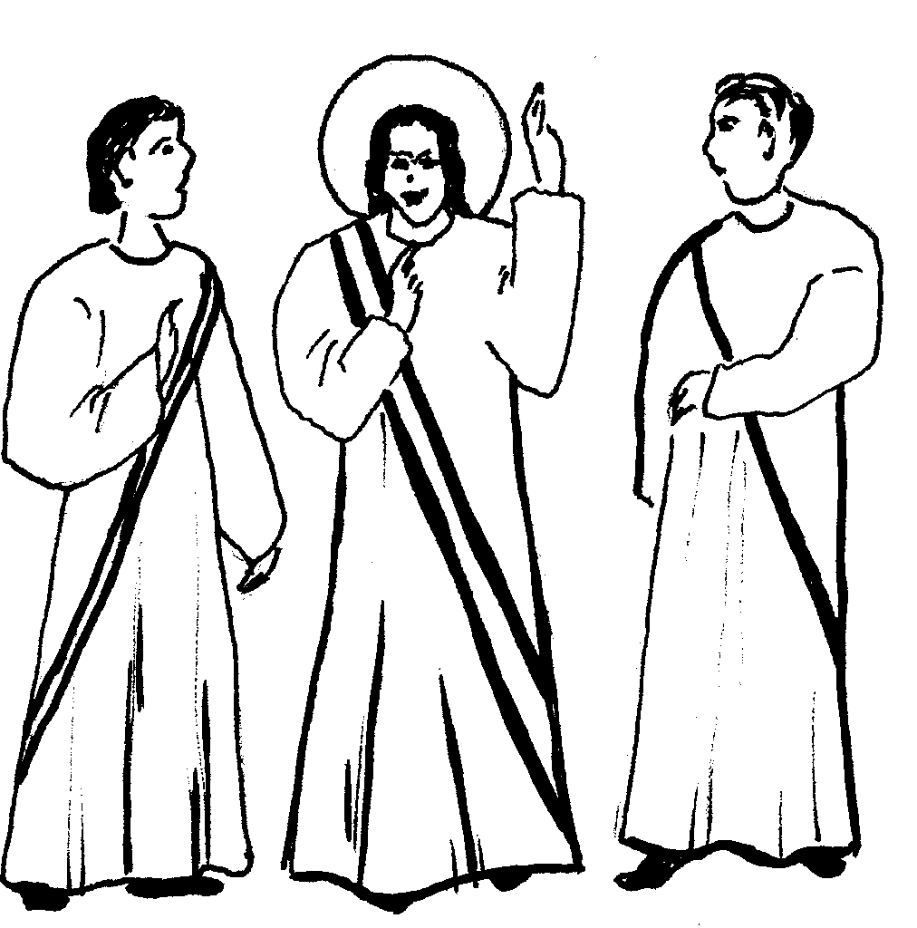
“What are you looking for?” John did not forget these first words Jesus spoke to them. We want to know who Jesus is, but the Lord asks us what our inner dispositions are: because we will gain nothing through finding him unless we are disposed to submit ourselves to him.

These two disciples began to live with Jesus. With time, they would discover that he is the Teacher, the Messiah, the Son of God; so, too, with us. We progress in this knowledge of Jesus Christ as we go on our journey through life.

John the Baptist was without jealousy; he had encouraged his disciples to follow Jesus, and later these first two brought the others. Likewise, we come to Jesus because of another person who spoke to us of him, or involved us in an apostolic task.

These two disciples recognized Jesus. It would be more exact to say that Jesus recognized those whom the Father had entrusted to him…

The account of the call of the first disciples in John is very different from Matthew, Mark and Luke. He does not mention boats, fish or nets. He considers discipleship on another level. He looks at the event with Easter faith and stresses the meaning of being a follower of Jesus. The mention of John the Baptist is only a stepping-stone to introduce Jesus to the disciples. These two disciples of John hear John point out Jesus and so leave John to follow Jesus. The images that John uses to describe Jesus are “the suffering servant” or “the Passover lamb.”

The conversation between Jesus and the two men touches the heart of discipleship. Note that there are two levels of meaning here that St John often uses in his Gospel. When the disciples of John the Baptist ask Jesus, “Where do you live, Teacher?” Jesus replied, “Come and see.” This is more than just a friendly invitation that Jesus makes. “Live” or “stay” here recalls Jesus “living or staying with the Father and the Father with him, just as true believers “stay” or “live” in Jesus and his love. Here the meaning of “live” with Jesus means they must enter into a new relationship, a new communion of life with the Son and the Father through the work of the Holy Spirit. So this is more than a visit that the disciples make. It is a homecoming.

To do this, one must “come and see.” This “seeing” is the recognizing of who Jesus is. Discipleship is not something casual. It is a process that requires a growth in understanding, a deeper knowledge of the Master, a growth in Christian awareness. To know Jesus is to know the Father (Jn 14:9), but this is possible only when we “stay” or “live” with Christ. To be really Christian is to realize that we belong to a new household, living in and with the Triune God.

Note the way John the Evangelist has us see how Jesus begins the process in the disciples that also happens to us.
  - First, the disciples recognize Jesus as the Rabbi (Teacher);
  - later, they recognize him as the Messiah; then
  - the Son of God and King of Israel.

It is a deepening of faith and understanding of Jesus. This is how Jesus invites us “to come and see” him just as the disciples of John did so many years ago.

Discussion Questions

- This story calls us to examine how Jesus is inviting us to a closer relationship with him, to “come and see.” What are some of the things that attract you to follow Jesus?

- When Andrew and his companion went to spend the whole day with Jesus, they were convinced that they had found the Messiah. What do you think might have happened when they were with Jesus that day?

- Examine what the disciples did when they left Jesus. They were so excited that they had to let others know what they had discovered. What message do you think is contained in that action for you?

- What does “discipleship” or being “a disciple of Jesus” mean for you?

2. Discipleship in the New Testament
In the table below is a brief comparison of some of the main characteristics of Jesus’ style of discipleship and that of the Rabbis. This may help us see how different Jesus’ disciples were from those of the Rabbis. The following table outlines those differences:

A Comparison of Two Kinds of Discipleship
 | Disciples of the Rabbis |  | The Disciples of Jesus
1  2  3.  4  5 | The initiative of being a disciple came from the disciple himself. The young man approached the rabbi to be a disciple; and the rabbi accepted or rejected his request.  The disciple stayed close to his master with the objective that he would be a rabbi like his master. They called themselves ‘disciples of Moses’. The disciples had to learn the Law and apply it.  The rabbis defined a disciple as “a person who freely puts himself in the service of a teacher and shares his views.”  The rabbis demanded faithfulness to the Law and their interpretation of the Law. They did not demand devotion to themselves.  The rabbis chose men who were capable and best suited to carry on their work and who obeyed the Law. Good students who would carry on their name. Women were never chosen to be their disciples.  The rabbis were taught to take the first places in the synagogue and to be leaders; to show their external belief in God and the Law. Many did not look to the interior dispositions. | 1  2  3  4  5 | The initiative of being a disciple came from Jesus. He went out and chose disciples himself. E.g. the call of the disciples  Jesus’ disciples remained close to him, learning from him. There was no rote learning but they were to be witnesses and give a true account of Jesus. Their task was to become better disciples and witnesses of Jesus. Their whole life was one of discipleship.  They are called by God to have a person attachment to Jesus who gives them the destiny and dignity to carry the cross.  Jesus demanded complete surrender to himself. E.g. they were to abandon their father and mother, sisters and brothers, etc. and come follow him. Cf. Mt 10:37f; Lk 14:26ff. Jesus claimed his own authority as the Son of God.  Jesus chose those he wanted even though they were rough fishermen or tax collectors, zealots or even women to be his disciples, that is, even the most unlikely candidates to be his witnesses.  Jesus taught his disciples the path of humility, to take the last places, to learn the way of suffering, charity to the poor and marginalized, and not to lord it over others as the pagans did. They were to follow the Suffering Servant to victory.

This comparison can help us understand Christian commitment in our own lives as disciples of Jesus and Francis’ approach to his followers. Discipleship for us is a kind of faith experience and dominant in our Christian life.

One aspect we can see in our understanding of discipleship is this: The way we shape our following of Christ depends on the way we see Jesus and our understanding of him. In other words, the way we understand Jesus will have a profound effect on the quality of our discipleship. That is why it is so important for us, as Franciscans, to have the understanding of Jesus that Francis and Clare had.
Discipleship is not just an idea we follow, but an encounter with the person of Jesus Christ. The Friar Minor puts his discipleship into action in the light of the life experience of Francis of Assisi. We contemplate the face of Christ in the pages of the Gospel and we recognize the face of Francis in his writings. But what we want to discover here is: What is the nature of this discipleship?

3. Some Characteristics of Franciscan Discipleship

1) Discipleship is a Response to a Call

We saw that all Christians have responded to a call from God to follow Christ. In the same way, a Franciscan responds to a call to follow Christ in a more intimate way in the steps of St Francis. We also saw that every vocation implies the process of conversion, of change in the style of life we were leading to one that will bring us closer to God. This implies Christian discipleship – following Christ and being in the company of Christ as his daily companion, to enter into a closer relationship with him and share our lives with him. It also means we are ready to learn from Christ and walk in his footsteps.
If you have love for one another, then everyone will know that
you are my disciples. Jn 13:35

2) Discipleship means Complete Surrender to Christ

What does this “surrender” mean to us as Franciscans? In other words, what is the nature of our commitment to Jesus and to Francis? In answering these questions, let us turn to the encyclical on Consecrated Life (Vita Consecrata) by Pope John Paul II. The Pope states:

“The evangelical basis of consecrated life is to be sought in the special relationship
which Jesus, in his earthly life, established with some of his disciples. He called them
not only to welcome the Kingdom of God into their own lives, but also to put their lives at
its service, leaving everything behind and closely imitating his own way of life.”

Let us take an example from the story of the rich, young man in the Gospels:

“As Jesus was starting on his way again, a man ran up, knelt before him, and asked him, ‘Good Teacher, what must I do to receive eternal life?’ ‘Why do you call me good?’ Jesus asked him. ‘No one is good except God alone. You know the commandments: Do not commit murder; do not commit adultery; do not steal; do not accuse anyone falsely; do not cheat; respect your father and your mother.’ ‘Teacher,’ the man said, ‘I have obeyed all these commandments.’ Jesus looked straight at him with love and said, ‘You need only one thing. Go and sell all you have and give the money to the poor, and you will have riches in heaven; then come and follow me.’ When the man heard this, gloom spread over his face, and he went away sad, because he was very rich.

Jesus looked around at his disciples and said to them, ‘How hard it will be for rich people to enter the Kingdom of God!’ “ (Mk 10:17 – 23)

What is the point of this story? Where does the emphasis lie? Is Jesus talking about poverty or something else? It seems that the young man occupied a place of importance. He had many riches and wanted to do what was right to be saved. His approach to Jesus was sincere as Jesus looked at him and loved him. Jesus invites him to discipleship. The young man must have realized all that this implied, but he was too attached to his riches and his position and so he was sad and turned away. The commitment that Jesus was asking of him was too much for him. To abandon everything, to leave his wealth, his position of honour, his status and follow the poor Jesus was a demand that he could not face. It must have come as a shock to him especially, being a Jew where money and riches were signs of God’s blessing, according to popular belief. But Jesus wants total commitment to him if we are to be his genuine disciples. I believe, that is the point of the story.

Note that in Matthew’s gospel, Jesus’ reply is, “If you wish to be perfect, go, sell all you have, give the money to the poor… and come follow me.” (Mt 19:20) The word for “perfect” in Greek is “taleos” which means “complete” or “arrive at the goal your heavenly Father holds out for you” cf. (Mt 5:48). This is a reference also about taking on the “burden” of discipleship, i.e. a mission or task required by becoming a disciple. Jesus goes on to emphasize this by giving the example of letting no obstacle stop you to achieve this objective. Cf. Mt 5:29-30

Surrender to Christ also implies obedience to Him and his Church. Christ’s desire was to do the will of the Father and so this also was the driving force that led Francis in his following of Christ. Also remember that no one surrenders his life’s direction to another without knowing, trusting and loving the other completely.

3) Discipleship means Brotherhood / Sisterhood

The concept of “brotherhood” or “sisterhood” is one of the main characteristics that mark us as true followers of St Francis. There is a deep bond that Francis and Clare often reminded us about in their Rules.

There are different levels of relationship to be considered. We can think of brotherhood on two levels: the natural and a spiritual level; or on a Christian and Franciscan level.

Natural Brothers and Sisters
As people, we talk about “brothers” or “sisters” meaning a blood relationship, that is, they have the same parents. We can say the same about animals. They have brothers and sisters like we do.

Natural brotherhood or sisterhood is not a matter of choice, but of acceptance. We choose friends, but brothers or sisters are accepted or refused. For example, we hear stories about some families where a member or more may be rejected. Such rejection could be because a girl in the family gets pregnant outside of marriage – especially in some cultures; or because a boy contracts AIDS; or because of a crime committed…

There are numberless ways that we could describe where a boy or girl is rejected by his or her family or by the community. Psychologists tell us that being accepted is an essential part of normal growth. During World War II it was shown again and again how important it is that we need love to reach adult maturity.

Relationship is opposed to the idea of a “stranger.” A stranger is not related by blood or homeland. So a “wantok” in Papua New Guinea (a person from the same village or area) can claim relationship because he or she comes from the same place, or has the same language. This can be the basis of their friendship and even duty to help the other. It’s interesting that Francis tells us to go though the world like “pilgrims and strangers.” That is part of the idea of Franciscan poverty.

The strong bond of relationship between brothers and sisters is one that can never be broken. Even after death, one cannot truthfully deny the fact that a certain person is your brother or sister if that is the case.

A Story
This bond of love was shown in an incident reported in a newspaper recently. A boy’s sister was taken ill. She was found to have a diseased liver and the only way that she could live was to have a liver replacement. The boy heard this and offered half of his liver to save his sister. They were both operated on and both survived. It was such a remarkable act of love that many people were amazed at such great love between brother and sister.

Spiritual Brothers and Sisters
Approaching this from another viewpoint, we could speak about spiritual brothers or sisters as Christians. We are spiritual brothers and sisters when we give witness to the world that God is Father of all. We read in John’s First Letter, “If we say we love God, but hate others, we are liars; for we cannot love God, whom we have not seen, if we do not love others, whom we have seen. The command that Christ has given us is this: whoever loves God must love others also.”(1 Jn 4:19 – 20) In other words, the love we show each other proves the love we have for God. Christian brotherhood is a revelation of the community love that exists in the Blessed Trinity. It is the revelation of the origin of every fatherhood in heaven and on earth. The community of love in God is the revelation of community of love amongst men. God is honoured by man and man is honoured by God. The Christian community is the acceptance of God as Father and the acceptance of every man or woman as brother or sister. It is a witness that reveals that the disciples of Christ are reborn to a new and common life with Christ.

Franciscan brotherhood or sisterhood
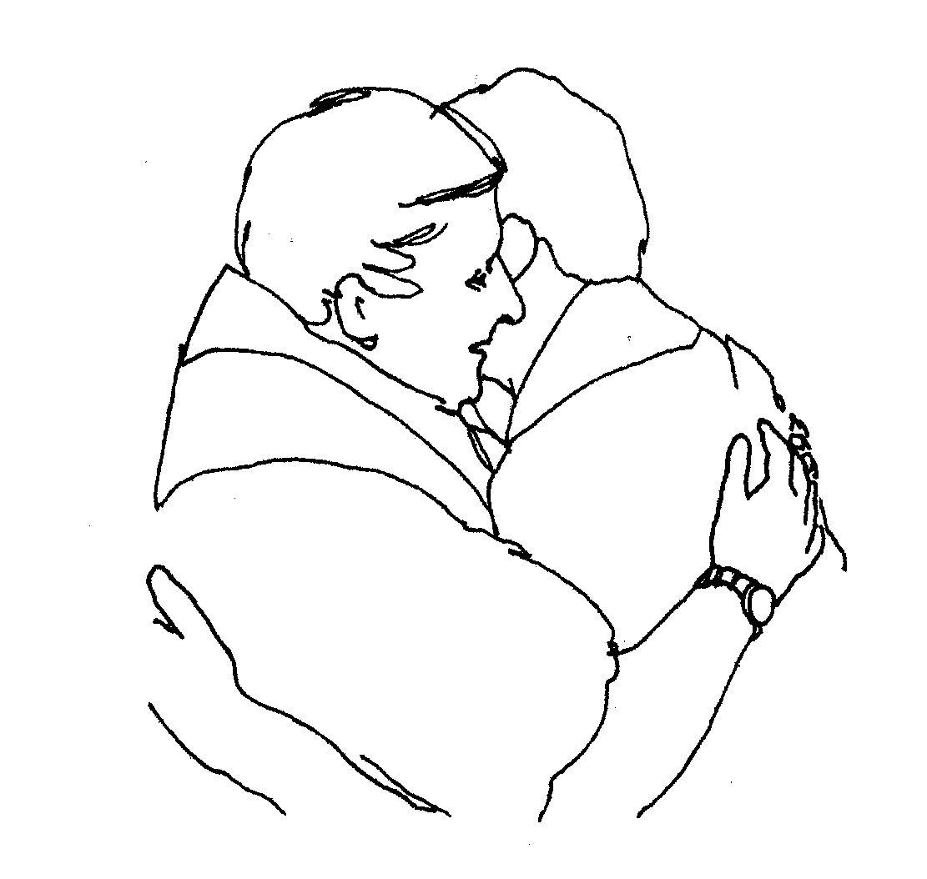
Christian life is based on baptism which is the natural basis of Franciscan brother/ sisterhood. Franciscan brotherhood or sisterhood offers a witness to the Church and to the world. This is clear from Francis saying he “measures himself with Christ and the Gospel.” But it also flows from the universal fatherhood of God and the Universal Brotherhood of Man.

Raised up by God for the restoration of the Church, St Francis leaves us the involvement and the responsibility to build the kingdom of God with all the capabilities of our hearts and minds. As the Word of God became man to restore the gift of divine life to all, so Francis made “fraternity” to restore to every creature the love for the fatherhood of God and the joy of many brothers and sisters. The Gospel experience of France is put before us as the “Rule of life” and the statement or plan of a sure observance of the Gospel.

“For Francis, brotherhood is the first witness of the apostolate. For him, our relationship with our brothers and, of course, with God is the foundation of our way of life.

4. Discipleship also means Minority and Service

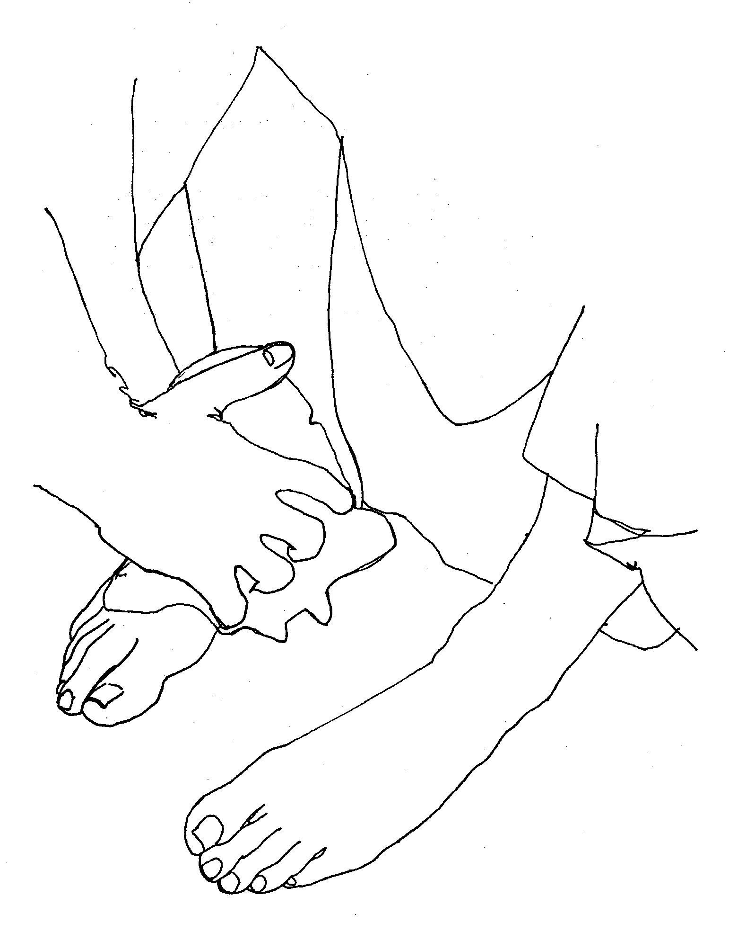
This is brought out clearly on that last Passover feast when Jesus washed the feet of his disciples when he said, “Do you understand what I have just done to you?” he asked. “You call me Teacher and Lord, and it is right that you do so, because that is what I am. I, your Lord and Teacher, have just washed your feet. You, then, should wash one another’s feet. I have set an example for you, so that you will do just what I have done for you. I am telling you the truth: no slave is greater than his master, and no messenger is greater than the one who sent him. Now that you know this truth, how happy you will be if you put it into practice!” (Jn 13:12 – 17)
The poor among the Jews walked barefoot while the rest wore sandals. Jesus uses a traditional gesture of welcome among the Jews. This washing the feet of the traveller was usually done by a servant. The apostles did not have servants, but that night Jesus wanted to become their servant. Jesus did not intend merely to make the apostles clean and comfortable. His washing of their feet was a sacred act which symbolized purifying them just as baptism does. However, the apostles needed to be prepared for sharing the “Bread of Life” at the table of the Lord. It also pointed out that the way of a disciple was through service of each other and of others. This also implied being lesser ones (minority).

The Pope, in his encyclical, explains this as “a radical response in the following of Christ through acceptance of the evangelical counsels”, that is, accepting the three vows of poverty, chastity and obedience. So, we need to examine each of these in the light of the Gospels together with the particular view that Francis had of them, but in the light of modern research of theologians.

5. Discipleship means loyalty and Perseverance

Francis frequently taught his followers that they were to be loyal. He says in the later Rule: “No one having put his hand to the plough and looking back is fit for the kingdom of God.” (RB 2)

SUMMARY:

Responding to Christ’s Call Complete Surrender to Christ

Brotherhood / Sisterhood Minority

FRANCISCAN

DISCIPLESHIP

Service Loyalty

Perseverance

CHAPTER THREE

GOD CALLS FRANCIS

Meet Francis Bernadone
To understand Franciscan spirituality it is important to understand Francis, the man, his background and way of thinking. Here are some ideas to help:

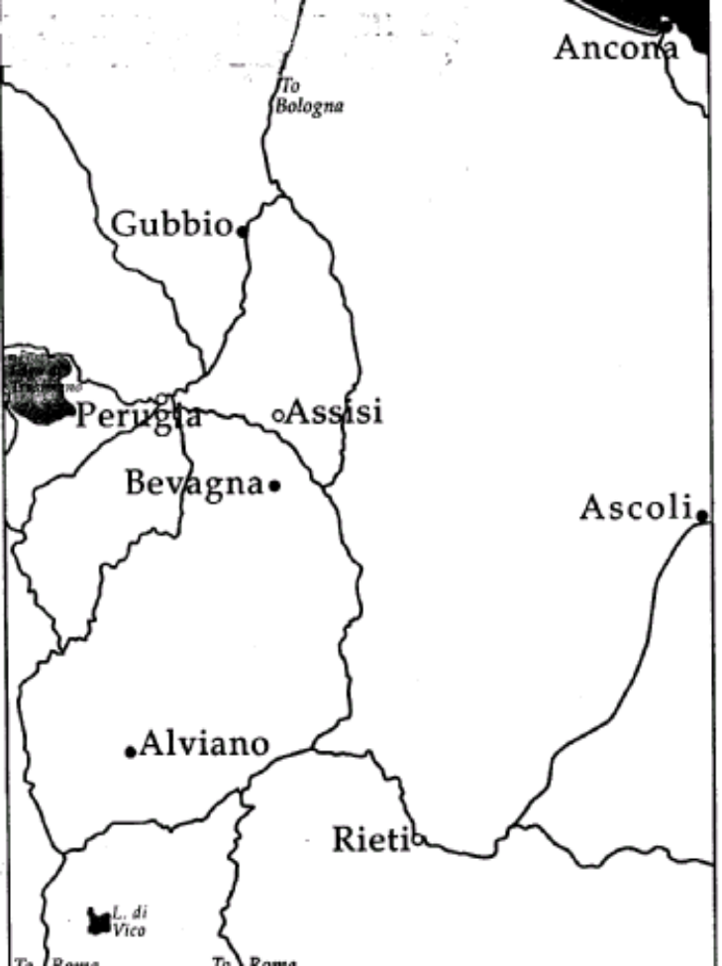Francis Bernadone was born of Pietro and Pica Bernadone, in Assisi in Umbria, Italy in 1181 or 1182. His father was a merchant and a respected man. He often carried out a lot of his business in France. In fact, it was while he was away in France that Pica had her child whom she named Giovanni (John), but his father called him “Francesco”, the Frenchman. As Francis grew up his outgoing personality made him popular amongst his peers. Francis enjoyed parties and loved to sing and enjoy himself just as many young people of his time.
Assisi and the surrounding district
His father had great hopes for him to follow him in his trade as a merchant.

However, there was another side to Francis’ character that became clearer later in his life as he responded to God’s call. Francis was naturally a generous and caring person. He loved things that were beautiful. He also used to dream about becoming a knight like his heroes. And that is why, in 1202, when a local war broke out between Assisi and their neighbour, Perugia, Francis joined the fight on the side of Assisi. But things did not turn out as he had hoped. Francis was taken prisoner and cast into a dungeon where he remained for about a year.

In prison, Francis accepted his condition and began to cheer up his companions who were with him. His father paid the ransom for his release. But Francis was a very sick man and depressed when he returned home. He did not know what he should do; but this was when he began to understand how God had entered into his life. God led him in another direction – one that he had never expected. We could say that Francis’ prison experience was the beginning of his conversion. In fact, Francis’ experience did not make him bitter but made him more sensitive to the poor.

God Calls Francis to Serve Him

Friar Thomas Celano was one of the first Franciscan writers to describe the life of Francis Bernadone. Here is how he describes Francis’ vocation in words like this:

Francis had led a rather worldly life wanting to be popular with his friends. He dreamt of becoming a knight, a hero. However, he became very sick and he began to reflect upon the past and over the life he had been leading. As he recovered a little from his illness, he used a cane to walk around the house in order to regain his strength. He wandered out into the fields and looked around himself at God’s creation but he gained no consolation from what he saw: the flowers, the vineyards and everything around him seemed as emptiness and vain.

From this time on, Francis began to see himself as worthless and everything that he admired before as contemptible. He was not ready yet to follow a new style of life. He was torn between the life he knew before and a new mysterious path that he didn’t understand. He sought some means of escape so that when a nobleman from Assisi invited him to go to Apulia and seek the glory of a knight; he impulsively accepted. But that night he had a strange dream. He saw his house filled with soldiers’ weapons, saddles, shields, spears and other equipment. Francis wondered what all this could mean?

In the morning, Francis awoke and thought to himself: ”This dream must mean that I will be successful in Apulia.” And yet he was not as enthusiastic as he had been before. Somehow, this was not the answer. He changed his mind about going to Apulia with the nobleman. Instead he hid himself in a cave in a lonely spot and began to pray to discover God’s will for him. He spent entire days in prayer until God led him to understand what he wanted of him.

Now, Francis was filled with such joy that people asked him if he was thinking of marrying? “Yes,” Francis replied. “I will take a bride nobler and more beautiful than you have ever seen. She is more noble and wise than anyone else.”

Reflection: Reflect on the story of Francis. Consider these questions:

- Did God’s call change Francis? What changes did you notice?

- What changes took place in you at your “conversion”?

- Did you seek excuses or postpone your “conversion”? Is this tendency still active in you now?

- What can we learn from this experience of Francis?

CHAPTER FOUR

CONVERSION: A RESPONSE TO GOD’S CALL

WHAT DO WE MEAN BY “CONVERSION”?

In the bible “Conversion” means a complete change of heart, a change in behaviour that takes place in a person’s life.

The word that is used in the Gospels is metanoia which means “repentance” or “penance”. But Jesus gave the word a meaning it had in the Hebrew “shub” which means “a spiritual movement of the whole person returning to God”. We can see this meaning in the famous story of Saul who had a mysterious experience on the road to Damascus. You may like to read this in Acts 9:1 – 19.

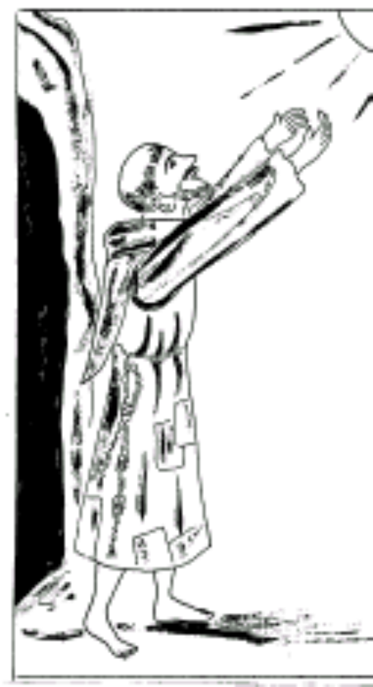 Duane Lapsanski points out “Conversion is not a once-and-for-all experience but an on-going process that is never completed until we arrive at our destination in heaven. It is a life-long process that needs to be deepened as we respond to God’s inspiration. Francis used to say that we need to be converted every day, to turn towards the Lord more and more. Each day is a challenge to be faced and an opportunity to come closer to our goal.

Francis used to say to his companions, “My brothers, we must begin to serve our Lord and God. Until now we have done very little. Holy as he was, Francis realized that he still had many kilometres to go in his growth in the Lord. And he had the humility and courage to keep on beginning.”

Conversion involves a struggle, a challenge we must face. During the whole process of conversion, the Lord was with Francis helping him to overcome his ‘old self’. At times, Francis tried to flee the hand of God, ‘but slowly he came to be filled with a new and special spirit which he received from the Lord.’ This new spirit set him afire with a divine fire and he was not able to hide outwardly the feeling he felt in his heart and mind.

Again, “conversion” is another way of looking at the concept of “vocation,” or call from God. Some elements are the same except that “conversion” means the person decides in turning to God that he or she will follow Christ totally.

Conversion is a response to God’s call. This chart that may help to make this clearer:

VOCATION : GOD CALLS | CONVERSION : THE RESPONSE
- God freely invites a person to follow Christ.  - God challenges a person  - God gives a mission and a goal to be achieved.  - God tests a person to strengthen his or her vocation. | - A change of attitude and behaviour.  viz. unselfish love of neighbour.  - The challenge is accepted: a basic decision to follow Christ in faith and trust.  - The person responds and allows God to lead him or her.  - Endurance is proved

Let us see how this applies in the life of Francis of Assisi in the next section which will examine the process or signs of conversion in the life of Francis of Assisi.

Summary:
RESPONSE TO GOD’S CALL

↓

CONVERSION
Greek: metanoia: change of heart and attitude
Hebrew: shub: a spiritual movement of the whole person to God

↓ ↓

A CHALLENGE A PROCESS

God helps us if we cooperate “Brothers, let us begin for until now we with him have done little.” - St Francis
This process is on-going until we die.

BARTIMAEUS – A STORY OF CONVERSION

“They came to Jericho. As Jesus was leaving Jericho with his disciples and a large crowd, a blind beggar, Bartimaeus, the son of Timaeus, was sitting by the roadside. On hearing that it was Jesus of Nazareth passing by, he began to call out, ‘Son of David, Jesus, have mercy on me!’ Many people scolded him and told him to keep quiet, but he shouted all the louder, ‘Son of David, have mercy on me!’

Jesus stopped and said, ‘Call him.’ So they called the blind man, saying, ‘Take heart. Get up, he is calling you.’ He immediately threw aside his cloak, jumped up and went to Jesus.
Then Jesus asked him, ‘What do you want me to do for you?’ The blind man said, ‘Master, let me see again!’ And Jesus said to him, ‘Go your way, your faith has made you well.’ And immediately he could see, and he followed Jesus along the road.”
Mk 10:46 – 52

This simple story can teach us a great deal about conversion. The simplicity of the narrative could have us miss the symbolism and the deeper meaning of the story. Behind the words and the actions, we find a lesson that expresses a deep faith and trust in Jesus on behalf of a simple blind man.
Just imagine Bartimaeus. He was sitting by the side of the road to Jericho as usual begging from those passing by. He cannot see. It is dark all around him. He had been blinded in some way, perhaps an accident of his childhood days, but he could scarcely remember what it was like to see any more. He had resigned himself to a life of darkness. But then, one day he heard a commotion amongst the people. When he asked what it was all about, he was told that the prophet, Jesus, was approaching along the road. Bartimaeus had heard about Jesus and many of the things that he had done. He felt a glimmer of hope and began to cry out in a loud voice, “Jesus, Son of David, have mercy on me! Feel my misery and help me!” The people around him were shocked and felt ashamed of him. They did not understand that Jesus had come for people like Bartimaeus. “Be quiet! Don’t bother the Master,” they said to him. “He has no time for you!” But Bartimaeus was determined. He cried out all the louder, “Jesus, Son of David, have mercy on me!”

Jesus came closer and heard Bartimaeus. He said to those around him, “Call him to me.” Those standing near Bartimaeus immediately said to him, “Take heart, Bartimaeus! Get up and go to Jesus. He wants you to come to him.” Immediately, Bartimaeus threw aside his cloak, jumped up and went to Jesus. This simple action of throwing aside his cloak could easily be overlooked, but it has symbolic meaning. Throwing aside his only possession, his cloak which served to keep him warm, to protect him against the cold was an action that indicated a change of heart. It showed his complete trust in Jesus and an act of gratitude that Jesus had stopped to listen to him.

As he stood before Jesus, he heard Jesus ask him, “What do you want of me?” Bartimaeus’ replied: “Master, let me see again.” And Jesus recognizes a deep trust and answers, “Go your way; your faith has made you well.” At this Bartimaeus regains his sight and he followed Jesus along the road. He not only gained physical sight but had gained a spiritual renewal. He became a disciple of Jesus and began to follow him. His life had gained a new meaning and purpose.

Note the triple repetition of ‘calling,’ (“Call him – they called – he is calling”) in the story. In this way, Mark shifts his attention from the cure of the blind man to that of calling or vocation. Here the blindness of the beggar is the image of the blindness of those who do not, or do not yet recognize Jesus as Messiah who leads the way. Jesus is the way to our communion with God. That is why the first Christians called themselves “the people of the way.” Those who follow Jesus on this way will see the light for Jesus is the Light.

This story describes the experience of someone who joins the movement of the first Christians. He is moved by the Spirit to follow Jesus.

Questions for discussion

- What do you think the vocation of Bartimaeus could teach us about conversion?

- What are the “signs of conversion” in the Bartimaeus story?

- What is the significance of the following phrases in the story: “casting aside his cloak”? “followed him along the road to Jerusalem”?

- Compare this story with the ‘rich, young man’ in Mk 10:17-23. What are the similarities and differences?

- What do you think “conversion” meant to Bartimaeus?

CHAPTER FIVE

THE PROCESS OR SIGNS OF FRANCIS’ CONVERSION

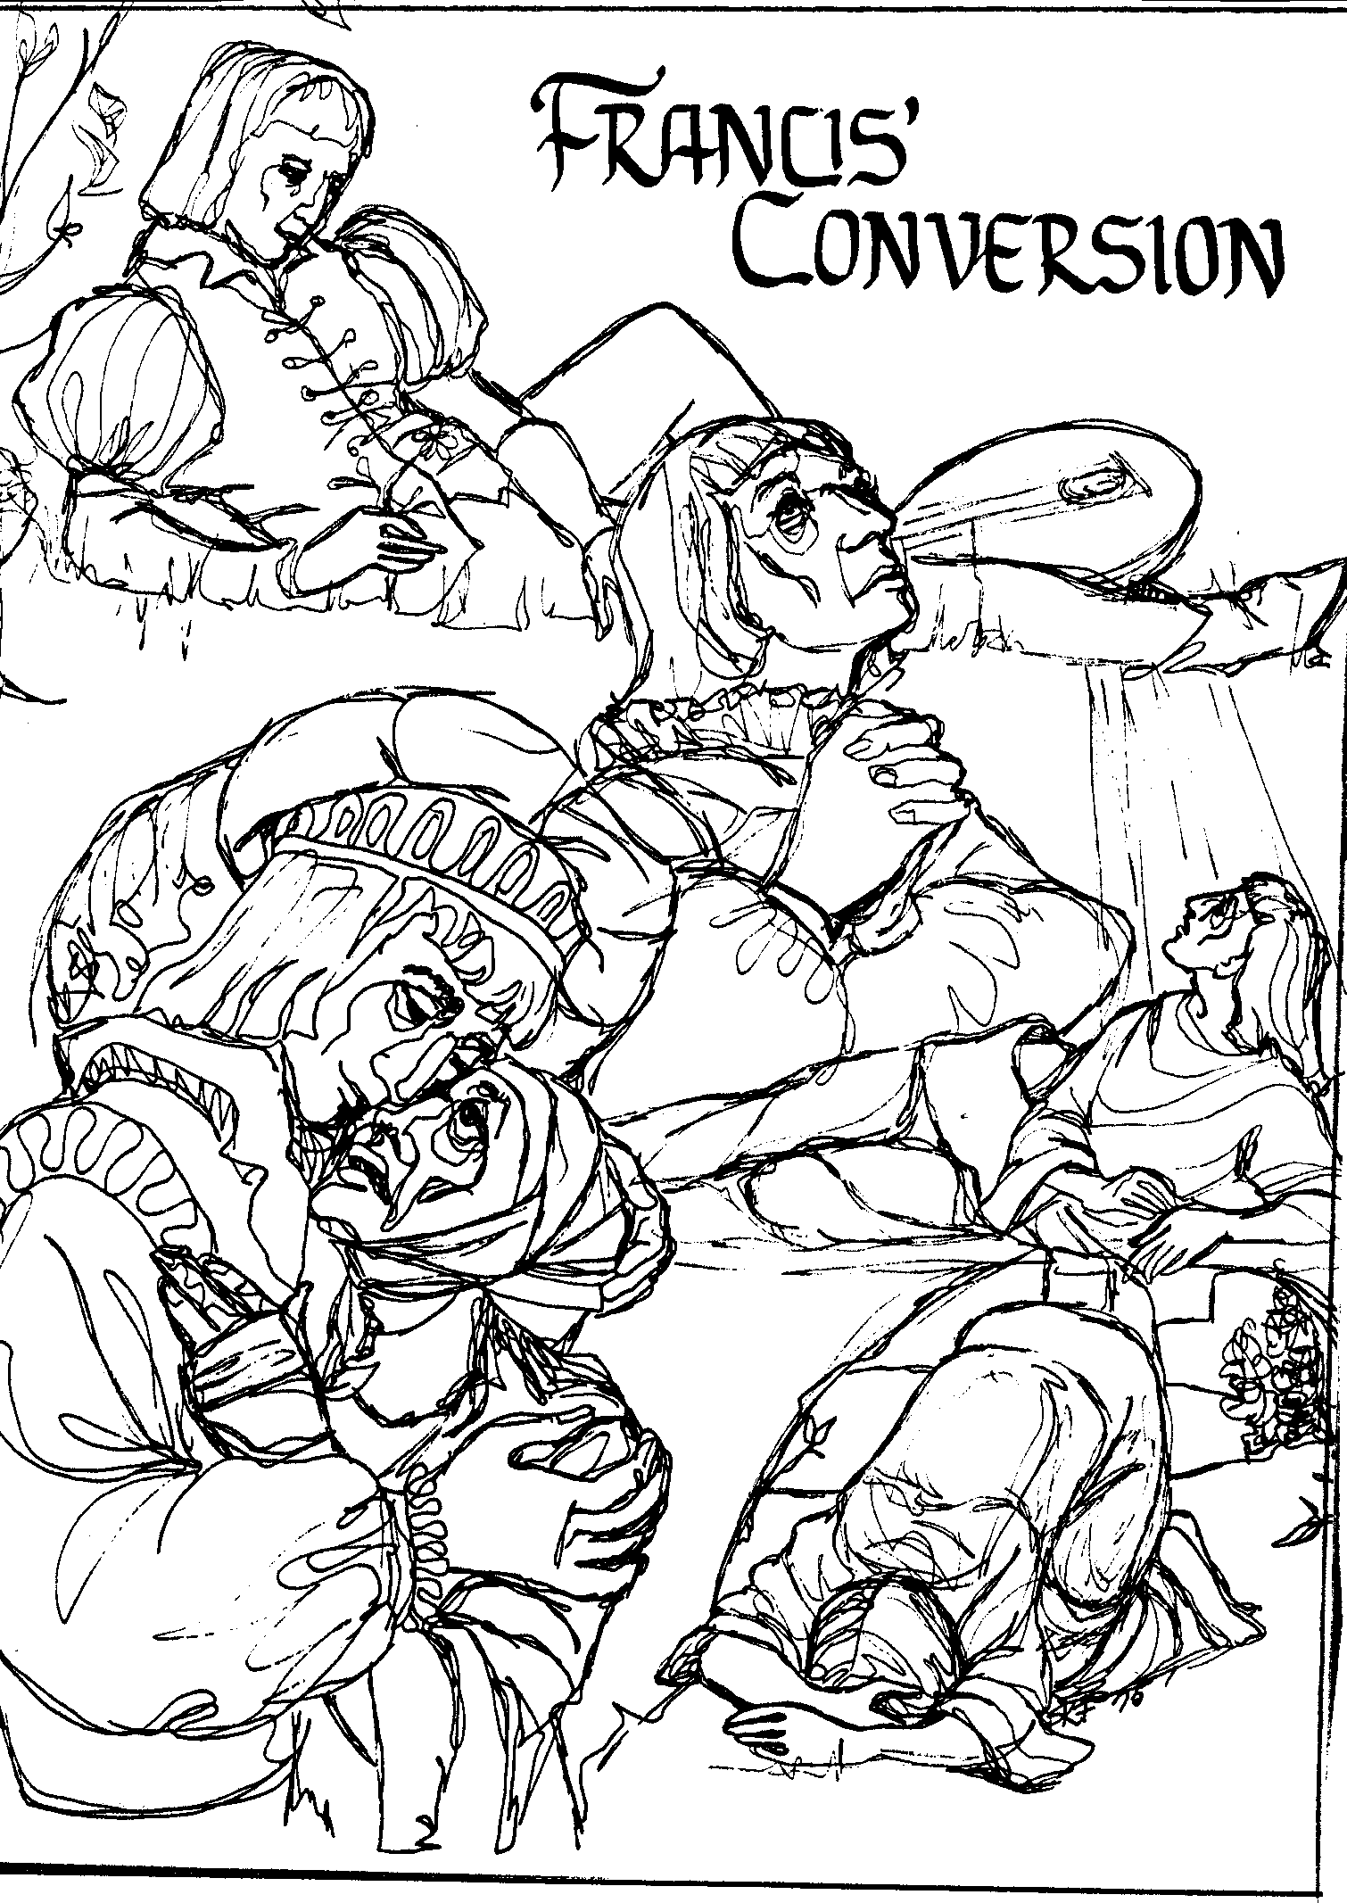

This picture is taken from Damien Isabell’s “Workbook for Franciscan Studies. If you examine it carefully you can see a number of instances from the life of St Francis which mark the stages of his Conversion experiences.

Activity:

- Do you think you can name the experiences expressed in the picture?

- Discuss the picture among yourselves for a few moments.

The Story of Francis’ Conversion

The conversion experience began for Francis when he was 25 years old between 1204 and 1208. We see this in the change that took place in his behaviour. Here we are trying to see how this mysterious process took place – to follow Francis’ difficult journey until he discovered a new way of seeing things and which later led to his total giving of himself to Christ.

Firstly, note that it was God’s initiative that started the conversion process. God made the first move. Francis himself says, “The Lord granted to me, Brother Francis, thus to begin to do penance”. What was Francis like at 25 years of age? Francis was mature for his age, generous and courteous. Once he had roughly rejected a beggar, but soon after he repented, and, there and then made up his mind to never deny anyone who asked him for anything in the name of the Lord. He had enough education to act as a clever merchant and to support his ambition to become a knight. Since he did not belong to the nobles, he had to make up for it by his spirit. He was able to create his own distinct style of nobility wasting his parents’ goods and wearing the best clothes so that he gained the name “King of the youth of Assisi”.

Francis had joined the people of Assisi to fight against Perugia but he was captured and imprisoned. However, he did not become sad and upset but rather he set about cheering up his fellow prisoners. We could regard this as the beginning of the conversion process but I think his conversion began in earnest at Spoleto.

When Francis returned to Assisi he had a dream about a room full of weapons. He took it as a sign that he was to continue his efforts to be a knight. He set out to join the army of Gautier of Brienne to fight against Apulia until God intervened in Spoleto. His conversion had begun. The Lord acted through the events of Francis’ life to bring him closer to God and to make him his instrument in influencing the world not only of his time but of many men and women to come. As we think about Francis’ journey of conversion, we need to hold our minds open. The people who lived in Francis’ time were struck with wonder at the events they witnessed.

For Francis, these events were like a conversation between God and his servant which can only be understood by faith. Here are some of the events that appear to be important steps in the conversion process for Francis: We need to consider each one of them.

- Francis’ Dream at Spoleto

- Francis’ Cave Experience

- Francis’ Meeting with a Leper

- Francis’ Roman experience with a beggar

- Francis’ Decision before the Bishop of Assisi

- Christ speaks to Francis: the San Damiano Experience

- Jesus reveals himself to Francis: 1) Through his Word at San Damiano 2) Through his Word at St Nicholas

1. FRANCIS’ DREAM AT SPOLETO

We saw how God entered the life of Francis when he had made up his mind to gain glory in Apulia but it was revealed to him in a dream that God had other things in mind for him.

We can find this story in The Legend of the Three Companions

The day before the vision occurred, the promise of great glory and nobility was so strong in him that he gave away all his expensive knight’s clothing to another poor knight. He set out for Apulia and got as far as Spoleto where he began to feel a bit sick so he went to bed. He was half-asleep, half-awake when he heard someone asking him where he wanted to go. Francis told him his plan to go to Apulia. The other said, “Who can do more good for you - the lord or the servant? Francis answered, “The Lord.”

“Then why are you abandoning the Lord for the servant, the patron for the client?” he was asked. Francis replied, “Lord, what do you want me to do?”

“Go back to your land,” he said, “and you will be told what to do. You must understand in another way the vision which you saw.”

When Francis woke up he began to think very carefully about this vision. Just as the first vision made him very joyful in the hope of great worldly glory, this vision made him turn in on himself and to marvel at what it might be saying. He stayed awake all night wondering about it.

When he got up in the morning, he was so happy that he quickly returned to Assisi to await the Lord’s directions and refused to go to Apulia as he felt this was what God wanted of him. We could regard this as the first stage of Francis’ conversion where he began to look for spiritual values rather than worldly ones.

Reflection
This scene is placed in a typically feudal setting and brings out the change in values which God brought about in Francis. Up until this time Francis had only one aim in his life and that was to achieve knighthood on the field of honour. But now all his thoughts were turned towards his Lord who had given him his life and for whom he would now offer everything he had.

It is in this scene that we see the change of values taking place in Francis. Julio Micó describes this change in the following way: “The God of Francis’ conventional background, who had remained unchanged and perfectly compatible with his other values, now gave place to the living and life-giving God who conquers and takes over, who broadens and even tears apart the accustomed horizons of one’s life. Francis’ consent to the evidence of God’s lordship would mean that from then on he would live in a kind of continual ecstasy, a permanent leaving of self behind to go out to the God of fulfilment. After this experience, he would no longer be able to go on cultivating his own personality but would set forth along new roads as a pilgrim of the Absolute, searching for the wellspring at which he could quench his thirst for God.”

To experience of the awareness of one’s imperfections as a calling to renew oneself and change requires one to have faith. One has to believe that one is able to change, to shake off one’s lack of action. One has also to believe it is worthwhile and that there is meaning to life. This faith which preceded an explicit voice of God calling, was already there in the young Francis when he was imprisoned in Perugia. “When his fellow prisoners were depressed, he who was naturally cheerful and jovial, not only was not dejected but actually seemed to be happy. One of the prisoners rebuked him as insane for being cheerful in prison. Francis replied vigorously: ‘What do you think will become of me? Rest assured, I will be worshipped throughout the whole world’.”

Thus, the believer was born, who like Abraham, left his family, his father and everything for a destination only God would show him. All this, we encounter in Francis’ conversion to God in faith.

Activity:
  - Find the town of Spoleto on a map. How far do you think it might be from Assisi? See if you can find out more about it from any books you may have.

  - Discuss the story of Francis’ dream. Does it bring to mind any experience in your life similar to this one?

- FRANCIS’ CAVE EXPERIENCE

Celano describes Francis’ cave experience as follows:

“Now there was in the city of Assisi a man Francis loved more than all the rest. They were the same age and very close friends. Francis wanted to share his secrets with him. He often brought him to remote places suitable for talking, telling him that he had discovered a great and valuable treasure. His friend was overjoyed when he heard this and was excited and willing to go with Francis.

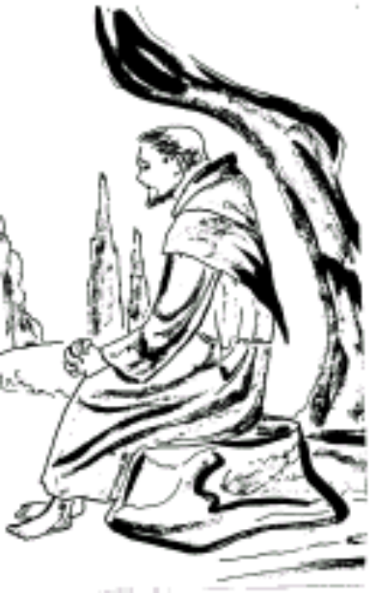There was a cave near the city where they often went and talked together about the treasure. Francis used to go into the cave while his friend waited outside. In the cave, Francis was inspired by a new and extraordinary spirit and he would pray to his Father in secret. He begged God to let him know what was wanted of him. Francis endured great suffering in his soul and was unable to rest until he had done what he had in his heart. He was stormed by different thoughts. He was burning inwardly with a divine fire that he was unable to hide. He felt great repentance for his past sinful life and distrusted himself for the future. When he came out of the cave and rejoined his companion he was so exhausted from his struggle that he appeared to be another person.

One day when he invoked the Lord’s mercy with his whole heart, the Lord showed him what he must do. At this Francis was filled with such joy that he found it impossible not to say something to others. He spoke of a great treasure to his friend and in riddles to others. They teased him and asked if he wanted to get married. He answered, “Yes. I will take a bride, more noble and more beautiful than you have ever seen, and who would be wiser than anyone else.”

You can see in this story the change of attitude that took place in Francis. Before he would seek the company of his companions to celebrate at parties and live a life of enjoyment and material happiness. Now, he begins to realize that such a life was wasteful and lacking in true holiness. Before, God was left out; now, he saw his need for God and so he spent long periods in personal prayer.

Francis felt this call to change, this metanoia or penance-conversion, in himself. He experienced it as a call that invited him not to turn to himself, nor to the world but to Heaven. It was something drawing him towards invisible things, so much so that he remained apparently unaware and completely deaf to the voices of his companions feasting. But in his heart he sang to the Lord. Little by little, he drew away from his companions. Then he tells us, he was flooded with such divine sweetness that he was unable to move or speak. It pervaded his being and he felt such an interior feeling of emotion that it drew his soul to things invisible, judging things of this earth as of absolutely no importance.

Reflection and Discussion on Francis’ Cave Experience

- Francis discovered a tender, loving God by allowing himself to enter the pain and darkness of the cave.
- Francis was afraid to leave the cave – afraid of what he would have to face in the light of day
- Francis asked God for the help he needed – until he was filled with a new strength and courage and a new sense of freedom.
- Francis experienced being held by God. He realized that before he only acted from the motive of pleasing others.
- In the cave, Francis symbolically entered the womb and was born again.
- Francis remained in the cave – the cave changed from being a hiding place to a safe, secure place where he no longer feared himself.
- Francis became open to receive the Gift of God – Francis met darkness and did not run away from pain. He was now ready to listen to what God wanted him to be.

Murray Bodo notes “Francis…continually returns to the cave. He seeks out lonely places in order to burrow into the earth in search of the treasure which lies hidden from those who live only on the surface. What is this gospel treasure that Francis keeps looking for throughout his life? I believe that it is not so much something hidden in the earth as it is something hidden in the self that you discover in the process of burrowing in the ground, something you discover about yourself.”

Conversion brings about a change in oneself. The experience of being aware of one’s imperfections as a calling to renew oneself and change requires one to have faith, to believe in the possibility of change, to shake off one’s unwillingness to act – It is necessary to believe it is worthwhile and that there is meaning in life. This faith which went before a clear voice of God who calls, was already alive in the young Francis when he was imprisoned in Perugia. ‘When his fellow prisoners were depressed, he was naturally cheerful and joking with them. He was not dejected but actually seemed to be happy. One of the prisoners rebuked him as insane for being cheerful in prison. Francis replied strongly, “What do you think will become of me? Rest assured, I will be honoured throughout the world!”

Thus, the believer in him was born, who, like Abraham, left his family, his father and everything for a destination only God would show him. All this, we encounter in Francis’ conversion to God in faith.

- From what we have considered already, what changes do you think you had to make at your “conversion” to follow Christ?

Scripture Reflection

Psalm 139

Lord, you have examined me and you know me.
You know everything I do;
from far away you understand all my thoughts.
You see me, whether I am working or resting;
you know all my actions.
Even before I speak,
you already know what I will say.
You are all around me on every side
You protect me with your power.
Your knowledge of me is too deep;
It is beyond my understanding.

Where could I go to escape from you?
Where could I get away from your presence?
If I went up to heaven, you would be there;
If I lay down in the world of the dead, you would be there.
If I flew away beyond the east
Or lived in the furthest place in the west,
you would be there to lead me,
you would be there to help me.
I could ask the darkness to hide me
or the light around me to turn into night,
but darkness is not dark for you,
and the night is as bright as the day.
Darkness and light are the same to you.
You created every part of me;
You put me together in my mother’s womb.
I praise you because you are to be feared;
All you do is strange and wonderful.
I know it with all my heart.
When my bones were being formed
carefully put together in my mother’s womb,
when I was growing there in secret
you knew that I was there –
you saw me before I was born.

The days allotted to me
had all been recorded in your book,
before any of them ever began.
O God, how difficult I find your thoughts;
how many of them there are!
If I counted them, they would be
more than the grains of sand.
When I awake I am still with you.

- FRANCIS’ MEETING WITH A LEPER

Of all the experiences concerning his Conversion, this one seems to be the one that struck Francis most strongly. Many have said that this incident in Francis’ life was the central issue that the whole of his spirituality. Let us see how Francis speaks of it in his Testament like this:
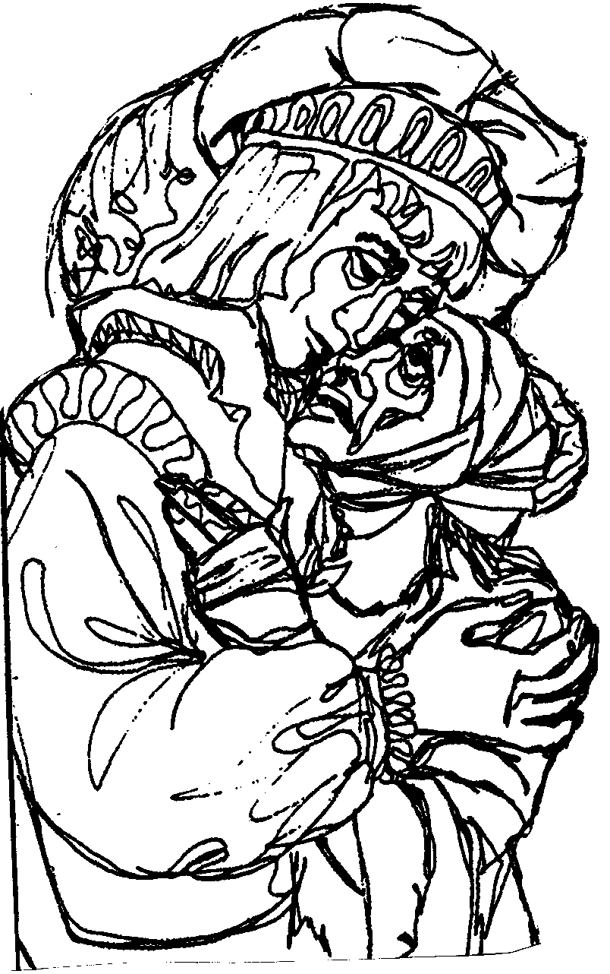
“The Lord granted me, Brother Francis, to begin to do penance in this way: While I was in sin, it seemed very bitter to me to see lepers. And the Lord Himself led me among them and I had mercy upon them. And when I left them that which seemed bitter to me was changed into sweetness of soul and body; and afterwards I lingered a little and left the world.”

After an evening meal with his companions, Francis went away from his friends to be alone. He did not know where to go but he knew where he should not go. He had renounced money and worldly glory to the wonderment of his friends…but he needed to go further.

When he was riding his horse, he met a leper – one of those unfortunates he could not bear to see. The sight and smell of them sickened him – but, faithful to his promise, he dismounted and ran to meet the leper. The leper extended his hand for an alms. He received not only money but a kiss as well.

This is one of the decisive events in Francis’ life. It appears to be so simple yet it marks the beginning of a long, painful time of interior struggle for Francis and which was only a stage on the way to his making a final decision for Christ.

REFLECT AND DISCUSS:

This experience that Francis had in his conversion raises many questions for Franciscans today.
- Francis’ meeting with the leper brought him face to face with his natural dislike of lepers. He overcame his weakness by embracing the leper and kissing him. Who are the “lepers” in our life?
- Who are the marginalized or “lepers” in our community or society today?
- What can we do to overcome these challenges? How should we “embrace the lepers” in our life?

A Story about Embracing the Leper
Here is a story told by a Franciscan nun, Sister Jose Hobday, one she tells that happened at Thanksgiving when she was a child.

Sister Jose tells how her mother loved old people and made it her duty to serve them. One day she sent Jose to bring biscuits and fresh bread to an old lady called Mrs Casey. The terrible fact was that Mrs Casey had a bad cancer and her face was all bandaged. What was more, her disease gave out a terrible smell that Jose could not bear. She did not want to go to visit her so she tried to get her brother to take her place; but when her mother heard about it, she made sure that Jose went to see Mrs Casey every time. Her mother also expected her to sit with Mrs Casey and talk to her. Every visit to see Mrs Casey became a terrible trial.

One day, her mother announced that she had invited Mrs Casey to come and have Thanksgiving meal with them. Of course, Jose objected and said that the smell would spoil her day. Her mother replied that she would have to adjust as Mrs Casey had nowhere else to go.

When the day came, Jose decided that she would sit at the opposite end of the table away from Mrs Casey, but her mother put her right opposite her. All the food there was Jose’s favourite. When the baked potatoes were passed around, her brother took two of them. That was against the rules in their house, but her brother knew Jose would have to keep quiet as they had Mrs Casey there as their guest. When the dish was passed to Mrs Casey, she saw that if she took a potato there would not be any left for Jose, so she passed the plate on without taking any. Jose felt very embarrassed about it when the plate came to her with only one potato left on it. She took it and put it on her plate. Then she cut it in two and offered half to Mrs Casey who graciously accepted it. From that moment, it seemed that the smell disappeared and Jose really enjoyed the meal.

Later, when she read about St Francis and how his meeting with the leper had turned to sweetness for him and her situation which was exactly the same! She said, “I learnt to let outside appearances blind me from seeing the goodness in others”.

4. FRANCIS’ ROMAN EXPERIENCE

The leper event made a great impression on Francis. It represented a victory over his former ways and over himself so much so that he recalls it in his Testament twenty years later. It is also one of many actions that showed his changed attitude, such as the following story:

“Francis had changed in his behaviour. He wanted to go to another city where he was not known. He would take off his clothes and exchange them with the rags of a poor man, and he would try begging alms for the love of God.

At this time, he happened to go to Rome on pilgrimage. As he was entering the church of St Peter, he noticed the mean offerings made by some and he said to himself, ‘Since the Prince of the Apostles should be greatly honoured, why do they make such mean offerings in the church where his body rests?’ Then with great eagerness he took a handful of coins from his money pouch, and threw them through a grating of the altar, making such a loud noise that all the bystanders were amazed at his generosity.

As he was leaving and passed the doors of the church, where there were many poor people begging alms, he secretly exchanged clothes with one of those poor people and put them on. Standing on the steps of the church with the other poor, he begged for alms in French, which he did not speak very well but he liked to do so.”

Activity

Draw or discuss one of the scenes just described and discuss in a group what it means to you in living a Franciscan life.

Reflection

- What do you think the ‘Roman Experience” showed us in Francis?

- How do you think it affected his future? What lesson did he learn from it?
5. THE DECISION: FRANCIS BEFORE THE BISHOP OF ASSISI

The Spirit led Francis to a greater generosity. He sought to follow the signs that would lead him to know what God wanted of him. Filled with a desire to help the poor, Francis gathered bolts of cloth from his father’s shop and sold them as well as his horse at the town of Foligno and gave the money to the priest who was caring for the church of San Damiano. The priest was suspicious of Francis and refused to accept the money. Francis did not want the money so he threw it up into a window sill and left if there.

When Francis’ father, Pietro Bernadone, discovered what Francis had done, he was furious. Francis, knowing how angry his father could become, ran away into a secret cave and remained there for a whole month praying that God would help him. After a month, Francis felt himself strong and fearless to face his father. He returned to Assisi amid the mocking crowds who had heard what he had done. When Francis’ father found Francis, he took him home, beat him in an effort to change his mind. Failing that, he locked him in a dark cellar and left him there. Pietro had to go away on urgent business so he left his mother to watch Francis. Since she did not approve of what her husband had done and unable to dissuade Francis, she let him go free.

When Pietro returned home he went to the civil court to have Francis judged there. But Francis appealed to the Bishop of Assisi under whose protection he had placed himself and thus was no longer under civil authority. So Francis was brought before Guido, the Bishop.

The bishop received Francis with great joy and gently explained to Francis that he was to return the money to his father. The bishop told Francis, “Have confidence in the Lord and act courageously. Do not be afraid for he will be your help and will provide you with whatever is necessary for the work of his church.” So Francis fetched the money and brought it back to the bishop.

Francis was joyful and comforted by the bishop’s words and going into one of the bishop’s rooms he undressed and putting the money on top of his clothes, he came out naked before the bishop, his father and all those standing around, and said, “Listen to me, all of you, and understand. Up until now I have called Pietro di Bernadone my father. But because I have proposed to serve God, I return to him the money on account of which he was so upset, and also all the clothes which are his, wanting to say from now on: “Our Father who art in heaven”, and not “My father, Pietro di Bernadone.”
At that moment, the man of God was found to be wearing a hair shirt next to his skin under his colourful clothing. In admiration the bishop covered Francis with his mantle, and from that time on the bishop became Francis helper, exhorting, encouraging and supporting him with great charity.

Discuss
- What significance do you think this story has on our understanding of our Franciscan vocation?

- This was a decisive moment in the life of Francis. How would you compare it to our religious profession?

6. THE SAN DAMIANO EXPERIENCE

This Experience of Francis is very important in the maturing of his vocation. What happened is described in The Three Companions:

“Francis was walking by the church of San Damiano when he was told in the Spirit to go inside for a prayer. Once he entered he began to pray very deeply before the image of Christ crucified. The Lord spoke to Francis tenderly and kindly saying, ‘Francis, don’t you see that my house is being destroyed? Go, then, and rebuild it for me.’ Stunned and trembling, he said, ‘I will do so gladly, Lord.’

“Francis thought Christ was speaking about the church he was in which was nearly falling down because it was so old. He was filled with joy that he knew inwardly that it was Jesus crucified who had spoken to him.”

“Upon leaving the church, he found a priest sitting nearby and Francis offered him a handful of coins saying, ‘My lord, I beg you, buy some oil and keep the light before the crucifix burning continually. When this money runs out, I will give you more as much as you need.’”

“From that hour, therefore, he felt deeply about the Lord’s Passion and he always carried the wounds of our Lord Jesus Christ in his heart…”

In this scene we see that the Lord had brought Francis to a greater depth of maturity in the spiritual life so that Francis had to review his image of Jesus Christ in his poverty as it was reflected in the poor and afflicted. In the poor – whom Francis had rejected once (the leper) and for which he regret ever after. These were not only the lepers but all unfortunates of every kind whom he met throughout his life. In them he saw Jesus Christ, poor, despised, weak in his nakedness, nailed to a cross like a leper.

Francis’ conversion brought about a radical change in his heart. There was a change in his attitude towards his neighbour but also in his behaviour so that when he passed the church of San Damiano (which had been abandoned and was in ruins), he was led by the Spirit to enter and pray. He knelt before the crucifix and there touched by divine grace, he was transformed totally. Suddenly from the crucifix he heard Christ’s voice calling him by name, “Go, repair my church which as you can see, is falling into ruins.”

Francis, trembling and full of wonder, set out to obey and worked at this task with all his might in repairing the ruined church of San Damiano. He did not understand until later that Christ was not speaking about San Damiano but of his Church which was so full of corruption and was in need of renewal.

Activity

The San Damiano crucifix is a well-recognized Franciscan symbol that has an interesting history. See if you can find material which explains the many symbols which are shown on the painting. Here are some notes about the story contained in the Crucifix of San Damiano.

Note: You will need to find a coloured picture of the Crucifix to understand the explanation below.

THE ICON OF THE CROSS OF SAN DAMIANO

The cross that Franciscans know so well is called “the Cross of San Damiano. In the time of St Francis, it was hanging in the little ruined church of San Damiano in Assisi. We saw earlier that this was where Francis came when he was seeking to know his vocation. As he prayed before this image, Jesus spoke to him from the Cross: “Francis, go rebuild my church which, as you can see, is falling down in ruins.” We know that Francis did not understand fully what this meant at first, but then he came to understand it to mean the Church needed him to revive the faith of the faithful.

The cross itself was a 12th century icon probably painted by a Syrian monk. One of the things that stands out about it is that it is not the suffering Christ that we see depicted, but the Christ in glory. Like many 12th century art work, this one contained a great deal of teaching for ordinary people who could not read books but could understand the symbols that were painted expressing truths of the Church.

It is said that this painting has all the characteristics of the Gospel of St John’s theology. Note the crown of glory replaces the crown of thorns. Jesus has achieved victory over death and is in glory. Even the characters painted beneath the arms of Jesus are those described by St John. Other evidence also point to St John’s thought: the wound in the right side of Jesus; Jesus stands upright as the victorious Christ. The characteristic struggle between light and darkness is also expressed on the icon. Christ’s figure is luminous against a dark background symbolic of evil, sin and unbelief.

We must note that colours play an important role in this icon. While black is symbolic of evil, red is symbolic of love which can be found around the icon: the symbols at the top and beneath the arms of Christ dressed in red, etc. Again symbolic of victory over evil.

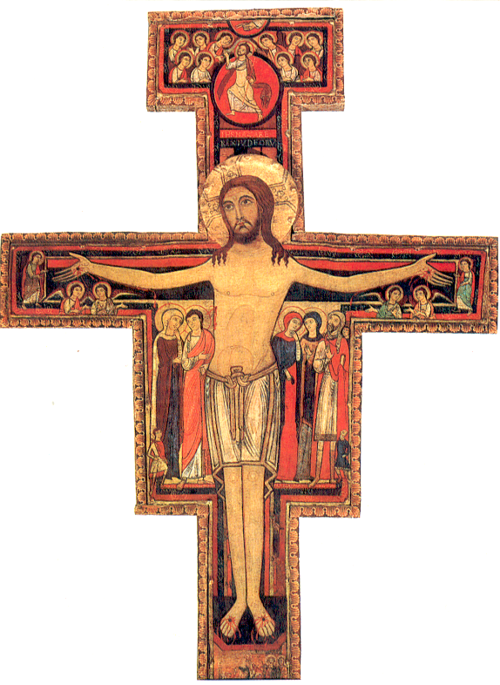
DETAIL OF PARTS OF THE ICON

Christ in Glory:
This is the most significant part of the icon. We noted the crown of glory around the head of Jesus. Jesus stands in glory against a background which expresses feelings of those who accompanied him. The figure of Jesus is very large compared to the other figures. This was to bring out the prominence of Jesus as central to the whole icon. Some have said this also indicates Jesus as the “tree of life” symbolically expressed by the smaller figures who all look to Jesus. Thus, we could say, Jesus is placed in the Kingdom with all his companions through life sharing in his glory.
It has been pointed out that one can see the outline of the cross in the crown of glory above Jesus’ head. Glory is expressed by the bright light surrounding the head of Jesus expressing Jesus’ victory over suffering and death, humiliation overcome by exaltation.

Jesus’ Clothing:
Some have identified the clothing of Jesus as priestly vestments worn in the Temple for sacrifice. Even his face appeared veiled which some would say is symbolic of Jesus’ humanity veiling his divinity.

The Face and Eyes of Jesus
Note also how large Jesus’ eyes are. Some would say that this is symbolic of the all-seeing God who watches over us. Perhaps, it is showing even more the living Jesus, acting still and alive to our needs. Note that Jesus is looking up to heaven towards the Father which could mean his obedience to the Father who allowed him to die for us.
The Wounds of Jesus
Note the colour of the wounds: red – signs of love. Jesus suffered for us out of love for us. Note also the scriptural reference to Jesus’ wounds becoming “fountains of living water flowing abundantly from the side of the Lamb”. Again this sign of our redemption is watched by the two angels who seem to be expressing their astonishment at the event.

The Background
We must take the figure of Christ against the background which also contains certain lessons that we can learn.
- The Border of the Icon: This is made up of many shells which in themselves are symbols of eternity and the beauty of heaven. It is said the shell is marked by it beauty and endurance. Consequently, the border of shells is symbolic of the heavenly mysteries. Yet the border has an opening at the base symbolic of the possibility that others could enter and become believers.
- Near the opening there are some figures which seem to represent believers who are already participants in the heavenly Jerusalem, the Kingdom. This is characteristic of Johanine theology: the “the kingdom of the already and the not yet.”
- The base of the icon: Some have said that the base resembles a block of stone reminding us of the Rock that the Church stands on, Peter or Cephas, the rock.

Other Figures
- Beneath the arms of Jesus: Mary (extreme right of Jesus). To sit at the right hand is the place of honour and this is where Mary is placed. Mary: his Mother, and our Mother. Note some of the details: the gesture of the hands to the face. Mary’s face is turned to John, her newly gained son as Jesus said to her, “Behold your son.” Mary’s garments also indicate her position as Mother of God: white; red again marks love; the precious stones symbolize the many gifts God had given her. The violet tunic indicates the Ark of the Covenant which housed the tablets of stone with the commandments written upon them, so the Word of God within her heart. John, the Beloved Disciple stands nearest to Jesus, and holds the place of honour in love. John represents us, believers, who were gifted with Mary as our Mother. To indicate this Mary is turned towards John. Note that his right hand is pointed to wards Jesus, the same as Mary.
- Mary Magdalene stands closest to Jesus on his left hand side. Her clothes are bright red symbolic of the love she had for him. Note the position of her head and hands. Mary, mother of James who also stood at the foot of the cross when Jesus died. She was one of the women who accompanied Jesus during his ministry and waited in prayer for the Holy Spirit. Her garments represent humility. The Centurion who had his son cured by Jesus is also represented. He has his son’s face drawn on his shoulder and the rest of his family stand in the background.
- Other figures and symbols: The Rooster is a sign of the rising sun, symbolic of the Resurrection. It is not a sign of Peter’s denial as this interpretation would not fit the circumstances. The Inscription INRI (= Jesus of Nazareth, King of the Jews) The notice placed above Jesus by order of Herod. Jesus in the medallion representative of Jesus’ Ascension to the Father (represented by the hand). Garments of Gold are symbols of royalty, victory; red scarf: love.

FRANCIS’ PRAYER FOR CONVERSION

(This is also called ‘The Prayer before the Crucifix’)

O great and glorious God and my Lord, Jesus Christ,
enlighten, I beseech thee, the darkness of my mind.
Give me a right faith, a certain hope, and a perfect charity.
Grant that I may know thee, in order that I may always and in all things act according to thy most holy and perfect will. Amen.

“A few days after Francis’ Cave experience, while he was walking near the church of San Damiano, an inner voice bade him go in and pray. He obeyed, and kneeling before an image of the Crucified Saviour he began to pray most devoutly.

This prayer, as we know it, could be part of those reflections that Francis taught brothers at a much later time.

7. GOD REVEALS HIMSELF TO FRANCIS

At San Damiano, St Francis met God. Brother Thomas of Celano tells us, “From that hour, therefore, his heart was wounded and melted when he remembered the Lord’s passion. While he lived, he always carried the wounds of the Lord Jesus in his heart.” We are again told that a “fundamental truth about this simple man (was) that at the very core of his being and the centre of his life, he was filled with God.” Francis actually met God and experienced God in his life and Francis surrendered himself to him completely.

Francis himself said, “The Lord himself revealed to him the kind of life he had to lead.” Again, it was Lord himself who inspired him to do penance, to change his life and to turn to God with love and confidence. It was this firm conviction on which his religious vocation was grounded. In fact, he was fully convinced that God’s action and inspiration were not because of his own merit but God’s free gift to him.

Francis was convinced of God’s presence in his life. All he wanted to do was to follow ever more closely the will of God and ever thank and praise him for his goodness. Very often in the course of Francis’ writings we find Francis’ heart literally bursts forth in spontaneous prayer and praise to the Lord. The reference here to Francis’ ‘heart’ means to say that it was not simply Francis’ tongue or mind expressing praise but his whole being is caught up in this. A clear example of this can be found in his Rule of 1221 in Chapter 23 where he cannot contain himself in expressing his gratitude to God for his greatness and goodness.

Activity
Read through the “Canticle of the Sun” (also called “The Canticle of the Creatures”). What does Francis praise God for in this prayer?

- GOD’S REVELATION THROUGH HIS WORD AT SAN DAMIANO
“While he was completing the church of San Damiano, blessed Francis wore the habit of a hermit, a staff in his hand, shoes on his feet, and a leather belt around his waist.

Then one day at Mass, he heard these things which Christ tells the disciples who were sent out to preach, instructing them to carry no gold or silver, a wallet or a purse, bread, walking stick, or shoes, or two tunics. Francis did not fully understand what the text meant, so after Mass he went to see the priest to have him explain it to him. After hearing the explanation, he was filled with indescribable joy. ‘This,’ he said, ‘is what I want to do with all my strength.’

And so, after committing to memory everything he had heard, he joyfully fulfilled them, removing his second garment without delay, and from then on he never used a walking stick, shoes, purse, or wallet. He made a very cheap and plain tunic for himself, and, throwing the belt away, he girded himself with a cord.”
9. GOD’S WORD AT THE CHURCH OF ST NICHOLAS
It was after this that Francis began to preach penance in public so persuasively that people were greatly amazed. His teaching and lifestyle became well known to many so that two years after his conversion, some men came to him wanting to follow his example; and leaving all they had, they joined him in his new style of life. The first of these was Brother Bernard. He had seen how Francis went about repairing ruined churches with a good deal of work and Francis’ austere way of life. Before Bernard gave all he had to the poor, he went to the church with Francis to consult the book of the Gospels.

This is how we read about it in the Legend of the Three Companions:

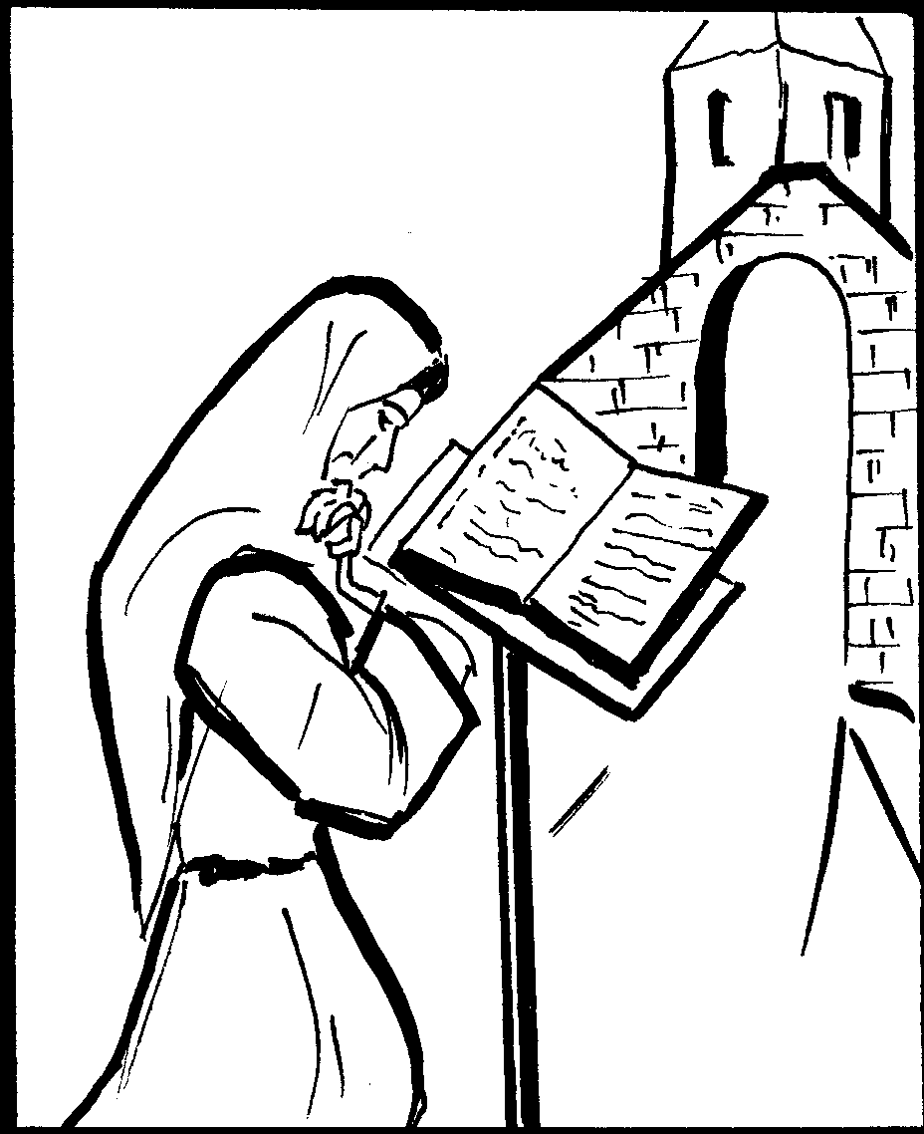
“Rising at daybreak, they went together with another man named Peter, who also wanted to become a brother, to the church of St Nicolas next to the square of the city of Assisi. They entered for prayer, but, because they were simple, they did not know how to find the passage in the Gospel about renunciation. They prayed devoutly that the Lord would show them his will on opening the bible.

Once they had finished prayer, blessed Francis took the closed book and, kneeling before the altar, opened it. At the first opening, the Lord’s counsel confronted them: If you wish to be perfect, go, sell everything you possess and give to the poor, and you will have a treasure in heaven.”

Francis was overjoyed with this, but since “he was a true worshipper of the Trinity he desired it to be confirmed by a threefold opening of the bible. He opened the book a second and a third time. When he opened it up the second time he saw: Don’t take anything for your journey neither walking stick, nor bag, nor bread, nor silver coins; and don’t even take a spare tunic.”., and at the third opening: If any man wishes to come after me, he must deny himself, take up his cross and follow me.”

Each time Francis opened the book, blessed Francis thanked God for confirming his plan and the desire he had conceived earlier. After the third confirmation was pointed out and explained, he said to these men, Bernard and Peter:
‘Brothers, this is our life and rule and that of all who will want to join our company. Go, therefore, and fulfil all that you have heard.”

This last statement of Francis marks an important stage in Francis’ conversion process. It is here that he makes his complete commitment to God and accepts the new way of life that God has revealed to him. From this time on his commitment is deepened and becomes clearer to him and his followers by their daily experiences.
Conclusion

Francis’ conversion, like all others, was a work of divine grace for his personal transformation. The change that took place in Francis was to affect the whole of society not only in Assisi but throughout the world. Even in his own day, Francis was to see the change taking place before his eyes. It did not always take shape as he had imagined it, but he remained always subject to God’s will. We shall see how Francis’ spirituality influenced not only the Church of his time, but civil relationships as well. God wished to use Francis to bring his Gospel message to everyone without exception.

Further study:
Two more events could be considered in the conversion process: His exchange of garments with a knight, and his meeting with robbers who fought him and ridiculed him. See these stories in the Early Documents.

Reflection: How did Francis see his conversion?
Perhaps the best description of this can be found in Francis’ Testament. We read there:

“The Lord gave me, Brother Francis, thus to begin doing penance in this way: for when I was in sin, it seemed too bitter for me to see lepers. And the Lord Himself led me among them and I showed mercy to them. And when I left them, what had seemed bitter to me was turned into sweetness of soul and body. And afterwards I delayed a little and left the world.”
Francis speaks of his life before his “conversion” in this way: “when I was in sin.” What does he mean? Celano interprets this as a sudden conversion experience, like that of St Paul on the road to Tarsus. St Bonanventure, on the other hand, sees Francis’ conversion as slow and gradual which took years. Francis himself distinguishes two different periods; “when I was in sin” and “when I left the world.” Theologians are not clear about exactly what Francis meant by these two terms. “When I was in sin” possibly meant when he did not know Christ as beloved and the Lover of all; or when he was so extravagant and he sought fame and honour for himself without making a conscious effort to help the poor and needy; when he thought mainly of himself and not of others. “When I left the world” seems to mean when he left all that was to offer by the world around him. He had found a greater Good to seek after.
Another phrase which needs consideration is “I began to do penance”. What did Francis mean by these words? It seems to me that he did not mean leaving the world behind and becoming like a monk (in the traditional meaning of the word) and isolate himself from others. Remember at his conversion, when Francis left everything, he took on the garments of a penitent. He was known as the “poor man” or “Poverello” of Assisi. It is true he lived poorly and he loved poverty because it brought him closer to Jesus who “became poor for us.” Francis did not regard himself as a lay-person. This is clear because, when he was challenged by his father, he insisted that he be judged before the bishop, not a civil court.
It seems to me that “I began to do penance” means that he began to live his life of selfless giving to others, living for others in complete obedience to God. His new way of living was to be different from the traditional “monks” who enclosed themselves in monasteries; his life was to be that of a wandering preacher and in service to others in imitation of the Lord Jesus Christ who lived in this way with his disciples.
“I delayed a little” seems to refer to the time when Francis was learning more of his position before God. He stopped where he was to discover God’s will for him, making sure that this was the path God wanted him to follow. First, he had to experience a life of service in serving the lepers before he could be sure of himself. It seems that in serving lepers, in learning more about humility, he was able to discern the will of God for himself.
Kajetan Esser suggests that in the Testament Francis looks back over his life but at the same time, in the light of later events, he publicly recognized himself as a religious even from the first day of his conversion.
Review of Unit One

Here is a story of a Franciscan who felt God calling him and who persevered in his vocation even though he had many trials to suffer on the way. The story is about a man who lived nearly four hundred years ago, St Joseph of Cupertino.

Joseph of Cupertino
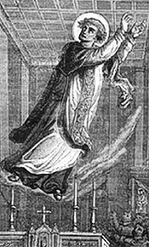
If we were to meet Joseph Desa when he was a youth, we would probably regard him as the least likely candidate for sainthood. He was so bad-tempered, impatient, extremely absent-minded and unreliable. He had had a very unhappy childhood and so it is not surprising to find certain aspects of revolt in his character. And yet there is a firmness of determination about him which was to be his salvation.

Joseph was born in Cupertino (or “Copertino”) which is a small town between Brindisi and Otranto in the Kingdom of Naples in Italy. His father, Felice Desa, was a poor carpenter and when he died before his son Joseph was born, he left a lot of debts to be paid by his wife, Francesca. So much so that her creditors drove her out of her house and she had to give birth to her son in a garden shed. She was full of resentment and treated her son very strictly.

With all this, there were signs of God’s designs on Joseph. When he was at school at the age of eight, he went into ecstasy when he had a vision. This occurred several times so that his schoolmates gave him the nickname “Bocca aperta” (which is the Italian for “Open mouth” or “Mouth agape”). But Joseph was by no means perfect. He had a terrible temper that his mother tried her best to get him to control. He was very absent-minded which made him very unreliable. His mother found him a great burden to her and wanted him to get a job to help with his keep.

Joseph did find work as a shoe-maker’s apprentice. However, it was not to last as his boss found him so slow to learn and absent-minded that he sent him away. Joseph’s mother was upset by this. Joseph then tried to join the Franciscan Conventual friars as a novice, but they, too, rejected him. Joseph felt he had a vocation to religious life, so he went to the Capuchin Friars who accepted him as a lay-brother. Again, after some months and a great deal of patience, they found him so awkward and clumsy, constantly in ecstasy so that he did not do his work, forgetful of what he was told so that they had to dismiss him as unsuitable for religious life.

Joseph’s mother was desperate. She asked a rich uncle for help but he refused also because he saw no good in Joseph and no future for him. As a last resort, Joseph’s mother begged her brother, a Capuchin friar, to accept Joseph as a servant in the friary. He accepted and Joseph went to live with the Capuchin friars as an oblate or lay-worker at La Grotella near Cupertino.

Remarkably, Joseph began to change. He grew in virtue, in humility, obedience and love of penance to such an extent that he was admitted into the novitiate in 1625. He found priestly studies difficult but by “extreme good luck” (as one biographer described it), he passed his exams and was ordained to the priesthood three years later.

Joseph lived a life of great austerity and he experienced a series of visions and ecstasies which came on at any time or place. Moreover, he was gifted with the gift of levitation, being lifted up into the air where he floated around in ecstasy. That is why he is the patron saint of pilots today.

But life was not to be easy for Joseph. He spent 17 years at Grotella where these remarkable events took place. Legends grew up about him, such as, one time his brother friars were erecting a 10 metre cross on a Calvary. The cross was very heavy and they could not set it up even with ten men. Joseph was at the door of the friary watching. When he saw their difficulty, he flew in the air to them, lifted the cross in his arms and put it in position. However, such actions brought people’s attention to him so Joseph’s superiors became concerned that this would not be good for the friars. Joseph was forbidden to celebrate any public Masses for thirty-five years. He was virtually put into solitude. He was not allowed to join the friars in choir, or have his meals with them. He was even reported to the Inquisition in Naples to be investigated. None of the accusations made against him were proven, so Joseph was sent to his Minister General in Rome. The Minister General took Joseph to Pope Urban VIII and Joseph went into ecstasy in the presence of the Pope. The pope was so impressed that he sent Joseph to Assisi where Joseph remained for 13 years.

In Assisi, Joseph had to suffer further trials. He had a great aridity of soul. He was reported to the Inquisition in Perugia who sent him to Pietrarossa to remain with the Capuchin friars as a virtual prisoner and living all alone. There he remained until he was discovered by some pilgrims who recognized him and people flocked to see him there. Of course, the reaction was that his superiors immediately sent him away again, this time to Fossombrone.

When this happened, his own Conventual friars petitioned to have him sent to them in Assisi but again, he was put in seclusion. Two years later, in 1657, he was returned to Osimo where, again secluded, he died in 1663. It was not until 1767 that this patient, humble saint was made a saint. This was not because of his gifts but because of his great patience and humility in the midst of many trials and suffering brought about by suspicion and jealousy.

Questions:
    - Can you identify the stages of Joseph’s vocation and conversion from this story? If so, list them.

    - What are the difficulties that Joseph had to face?

    - Can you identify the action of the Holy Spirit in this story?

    - What lessons did you learn from this study?

    - Do you see similarities in Joseph’s conversion and that of Francis?

SUMMARY: THE MAIN POINTS OF THIS UNIT

What is a Vocation?

- A vocation is a call or invitation from God, freely given, to follow Jesus Christ as his disciple;

- A vocation implies entering into a close relationship with Christ as our Lord and Saviour

- A vocation expects a response: Conversion or change of heart;

- A vocation challenges us to respond but still leaves us free to choose to accept or not;

- Francis accepted this invitation and gradually came to know God’s will for him in the radical following of Jesus Christ especially through his Word (the Gospel).

This story adapted from P. Ribes, SJ. op cit It could be acted out as a mime or a drama, etc.
Nassan, S.J., Maurice, Scrap Book of Scripture Reflections, St Paul Publications, 1968 (adapted)
We could add “secular life” in the Secular Franciscan Order or according to one’s state in life.
Cf. The New Catholic Encyclopedia, Vol. XIV, “Vocation – religious and clerical”
RB VI
Good News Bible (Australian edition) Jn 1:35 - 42
Commentary in Christian Community Bible on Jn 1:35 – 42
Cf. Roland J. Faley, Footprints on the Mountain, Paulist Press, N.Y., 1994, pp.102ff
Cf. Leon-Dufour, X Dictionary of Biblical Theology, Chapman, 1973 and McKenzie, Dictionary of the Bible, Chapman, London, 1966.
Cf. General Directory of Formation OFM Conv., “Il discipolato francescano”, 2001, n.1
Cf. Pope John Paul II, Vita Consecrata, n. 14
cf. GG.CC OFM Art 7
Cf. Ryan, op. cit.
Comments from Christian Community Bible (adapted)
Some writers think that Pietro used to take his young son with him to France from time to time when he made his business trips. It was in France that Francis learnt to love the French language and culture. It was because of this that his friends at home nicknamed him “Francesco”, the Frenchman. Remember also that Pica, Francis’ mother, probably came from France.
See Isabell, OFM, Damien, Workbook for Franciscan Studies, Franciscan Herald Press, 1975, Introduction
Adapted from 1 Celano, chapters 2 and 3.
The Greek word metanoia considers the more intellectual side of conversion: change of opinion, changed attitude or direction. The Hebrew shub refers to the whole person and his basic relationship with God.
Lapsanski, Duane V. The First Franciscans and the Gospel, Franciscan Herald Press, Chicago, p. 6
ibid.
Damien Isabell, ofm, Workbook for Franciscan Studies – companion guide to the Omnibus of Sources, Catholic Theological Union, Chicago, Franciscan Herald Press, 1975, p.8
Testament 1
L3C 2
Cf. Micó OFM, Julio “Francis’ Image of God” in Greyfriars Review, vol. 7, no. 2, 1993, p.133
Francis of Assisi, The Founder, vol.2, L3C p.70
See 1 Cel 3
Cf. Pompei, A, “Dio” in Dizionario francescano, op. cit.
Murray Bodo The Way of St Francis, St Anthony Messenger Press, 1995, p.33
Francis of Assisi – The Founder, vol. 2 L3C, p. 70
Good News Bible translation (Australian edition)
Testament 1 - 3
This story is reported by W. Bausch in Telling Compelling Stories, op. cit. (adapted here)
Legend of the Three Companions in Francis of Assisi – the Founder, p.73
Legend of the Three Companions, VI
ibid p.75
1 Cel 5: 14
Testament
Cf. Lapsanski, Duane V. The First Franciscans and the Gospel, pp.3 ff.
Legend of the Three Companions, VIII, 25ff.(adapted)
ibid.
Lk 9:3
Mt 16:24
L3C, loc. Cit. p. 86
Esser, OFM, Kajetan, The Testament of StFrancis – a commentary, Franciscan Publishers, Wisconsin, p. 26

