**THIS IS BEAUTIFUL**

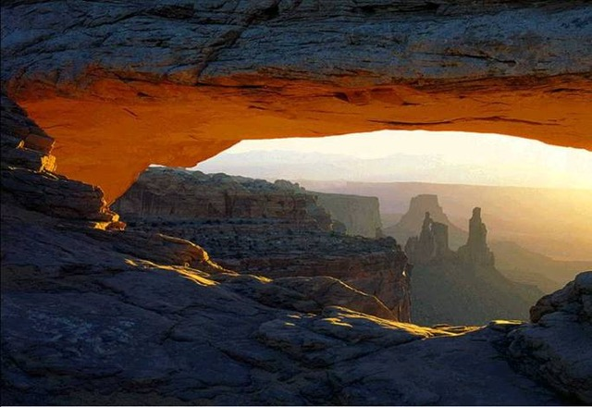

**The best kind of friend**

**Is the kind you can sit on a porch and swing with,**

**Never say a word, and then walk away**

**Feeling like it was the best conversation you've ever had** .     
  
  
  
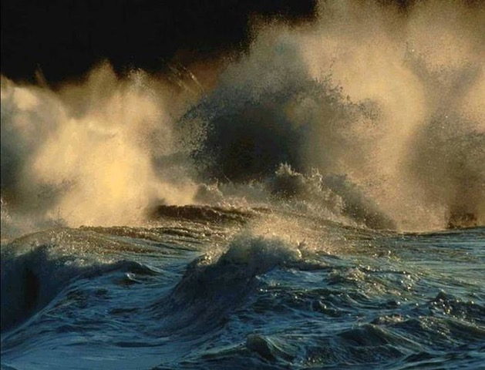

**It's true that we don't know what we've got until we lose it,**

**But it's also true that we don't know**

**What we've been missing until it arrives.**



**Giving someone all your love**

**Is never an assurance that they'll love you back!**

**Don't expect love in return;**

**Just wait for it to grow in their heart**

**But if it doesn't, be content it grew in yours.**

**It takes only a minute to get a crush on someone,**

**An hour to like someone,**

**And a day to love someone,**

**But it takes a lifetime to forget someone.**     
  
  


**Don't go for looks; they can deceive.**

**Don't go for wealth; even that fades away.**

**Go for someone who makes you smile**

**Because it takes only a smile to make a dark day seem bright.**

**Find the one that makes your heart smile.**  


**May you have**

**Enough happiness to make you sweet,**

**Enough trials to make you strong,**

**Enough sorrow to keep you human,**

**Enough hope to make you happy.**

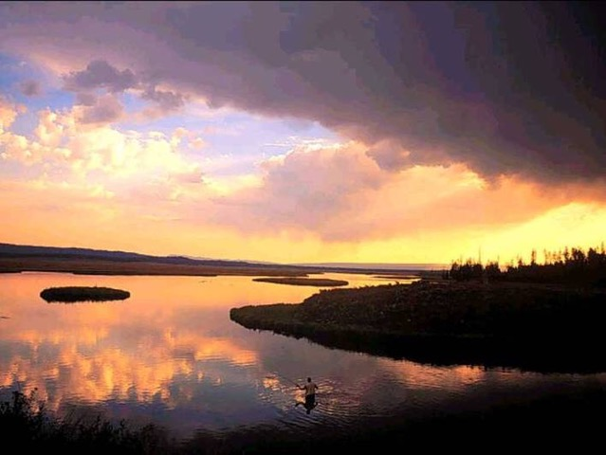

**Always put yourself in others' shoes.**

**If you feel that it hurts you,**

**It probably hurts the other person, too**     
  
  
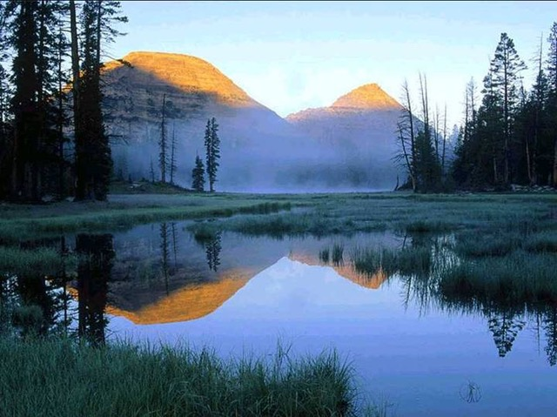  
  
**The happiest of people**

**Don't necessarily have the best of everything;**

**They just make the most of everything that comes along their way.**  
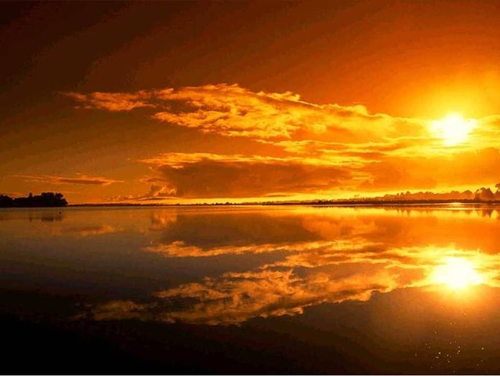

**Happiness lies for those who cry,**

**Those who hurt, those who have searched,**

**And those who have tried,**

**For only they can appreciate the importance of people**

**Who have touched their lives.**  
  
  
  
  
**When you were born, you were crying**

**And everyone around you was smiling.**

**Live your life so that when you die,**

**You're the one who is smiling and everyone around you is crying.**   
  
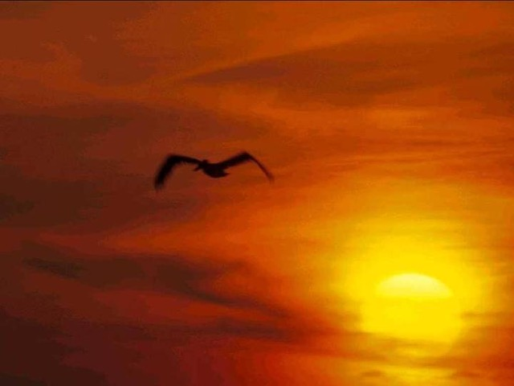

**Please send this message**

**To those people who mean something to you,**

**To those who have touched your life in one way or another,**

**To those who make you smile when you really need it,**

**To those that make you see the brighter side of things**

**When you are really down,**

**To those who you want to let them know**

**That you appreciate their friendship.**

**And if you don't, don't worry,**

**Nothing bad will happen to you,**

**You will just miss out on the opportunity**

**To brighten someone's day with this message...**