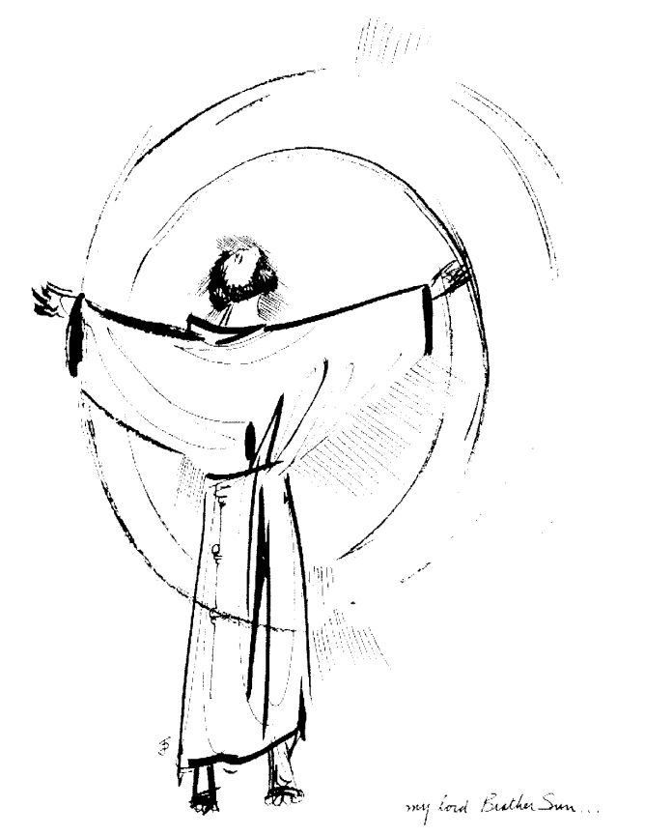
“Praised be you, My Lord, through all your creatures!”
Franciscan Readings for
Week Commencing
31 August, 2008
22nd Week Ordinary Time – A

Sunday 31 August 2008
(A reading from the Remembrance of the Desire of a Soul by Thomas of Celano)
Francis wanted ministers of the word of God to be intent on spiritual study and not hindered by other duties. He said that they were heralds chosen by a great king to deliver the decrees received from his mouth. Francis would say, “Preachers must first secretly draw in prayer what they later pour out in sacred preaching; they must first of all grow warm on the inside, or they will speak frozen words on the outside.” He also would say, “They are the life of the body, the opponents of demons, the lamp of the world.” Francis also revered the doctors of sacred theology. When writing to St Anthony, he wrote, “I am pleased that you teach sacred theology to the brothers providing that, as is contained in the Rule, you ‘do not extinguish the spirit of prayer and devotion’ during study of that kind.”

Lord, you desire us to increase in knowledge and love of you. Help us to extend our understanding of your ways and love for your Word.

Monday 1 September 2008
(A reading from ‘The Assisi Compilation)
There was a novice who could read the psalter but imperfectly. He enjoyed reading the psalter and asked Francis if he could have a copy of this book for himself. Franics said no. “After you have a psalter you will want a breviary, and after you have a breviary, you will sit in a fancy chair like a great prelate and say, ‘Bring me my breviary!’ and with arrogance you will condemn your brothers with the statement, ‘I, a breviary’” And Francis said to his brothers, “I was likewise tempted to own books, to know many things. But I was satisfied with the word of God and realised that there are many who willingly climb to the heights of knowledge; that person be blessed who renounces it for the love of God.”

Lord, let us surrender our smartness and our love of worldly knowledge in order to come closer to you. Let us be your children now and for always.

Tuesday 2 September 2008
(A reading from ‘The Assisi Compilation)
Francis went to the Church of the Portiuncola. On the road, Francis had words with a brother who disobeyed the Rule. Francis sent him away but soon said, “Brother – Come back with me and show me the place where you disobeyed me.” When they returned to the spot, Francis knelt down and said, “Mea Culpa, brother, mea culpa,” And Francis apologised for his harshness. The other brothers were alarmed, “Don’t you wish to admonish the errant friars?” “No,” Francis said, “To you it is given to know the mystery of the kingdom of God, but to the others all things are treated in parables.”

Lord, your mystery is captured in parables, help us to discern your message and to understand your divine will.

Wednesday St Gregory the Great 3 September 2008
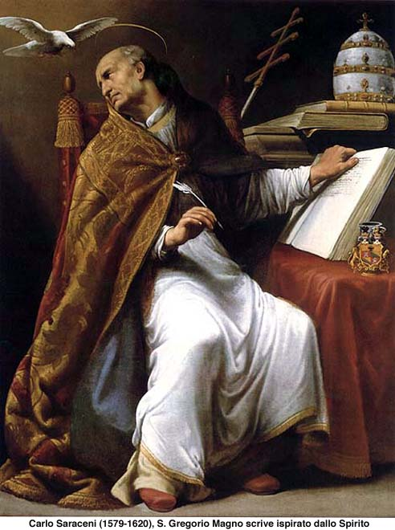
Gregory was born in 540 and lived until 604. He was arguably the most influential figures in ecclesiastical history. The doctrine, organisation and discipline of the Catholic Church, even to this day, can be attributed in part to Gregory’s apostolate as Pope. He was only a boy when the Goths sacked Rome and he ended up in a monastery in Sicily near the Caelian Hill. He was drawn out of his seclusion and ordained in 578 whereupon he ministered to the political factions in Italy. In 590 at the age of 50 he was made Pope – an office he held for the fourteen years up to his death. His revision of the Canon of the Mass, the order and the place of the diaconate, the role of the Holy Spirit and a reinvigoration of the Scriptures marked some of the work he undertook. He was not a man of great learning, not a philosopher or a theologian but a Roman lawyer. Gregory was a missionary and a man of immense holiness and simplicity.

(A reading from ‘The Assisi Compilation)
Francis did not disdain knowledge. On the contrary, he admired the friars who were men of learning. However, he didn’t see it as being a prerequisite for joining the friars – all that was required was a holy discipline and a willingness to preach the Gospel. But he was realistic, saying that occasionally, friars would turn inwardly cold and empty. Can you return to your first vocation if you have lost the will to preach? Will you be the same person if you depart from your vocation?

Lord, you expect of us beautiful things. Come to us in our ordinary lives, let us be ourselves and be together again.

Thursday 4 September 2008
(A reading from ‘The Assisi Compilation”)
There are many brothers who, day and night, place all their energy and care in knowledge and thus lose their holy vocation and commitment to devout prayer. Well, what about it? These brothers are my friends, the one who reveal their souls by their works but not necessarily by their preaching. These are the knights of my round table – weeping over their sins, and those sins of others, let these men be my brothers.

Lord, no one is perfect. Let our imperfections mark our weakness, which we remember as ebing a strength of character. Lord- reduce our weakness for the love of you.

Friday 5 September 2008
(A reading from a the Remembrance of the Desire of a Soul by Thomas of Celano)
When Francis was in Rome, he was asked by a Cardinal about some obscure references from Scripture. The Cardinal said, “I ask you not as a scholar but as someone who has the spirit of the living God in him.”
When Francis fell ill, one of the friars asked if he wished for the Scriptures to be read to him. Francis said, “I have taken much from Scripture – this is enough. For I know Christ poor and crucified.”

Lord, all the study in the world will not give us a love for you or grant us a true faith. Make us truly your disciples, through the knowledge of you poor and crucified.

Saturday 6 September 2008
(A reading from 'The Book of Gentile and the Three Wise Men', by Raymond Llull)
The Christian said, "The Son of God was born with human nature, so that in human nature there would be born greater virtue of justice and humility."
The Gentile asked, "Tell me, this woman you mention who gave birth to the Son of God, of what King was she a daughter? Or what sort of nobility can a woman have so that God would want to take on human nature in her and be born from her?"
The Christian replied, "It is true that our Lady was of the house of David, a noble and kingly family, yet her parents were neither king nor queen. They were humble people. And our Lady was a woman poor in earthly possessions, but in virtues she was richer and nobler than any other creature, with the exception of her Son. So poor was she that she did not even have a house in which to give birth to the Saviour of the world, just a stable. For if the Son of God had wanted to be born of a queen, as ruler of all kingdoms of the world, he could easily have done so; but it would not have shown humility against pride and justice against injutsice."

Lord, you chose a humble, poor girl to be the mother of Jesus. It was on her 'yes' that the Creator of the world waited at the time of annunciation. May we never overlook the power of that which may appear small in the world, for you choose the unlikely candidate to achieve great things for

