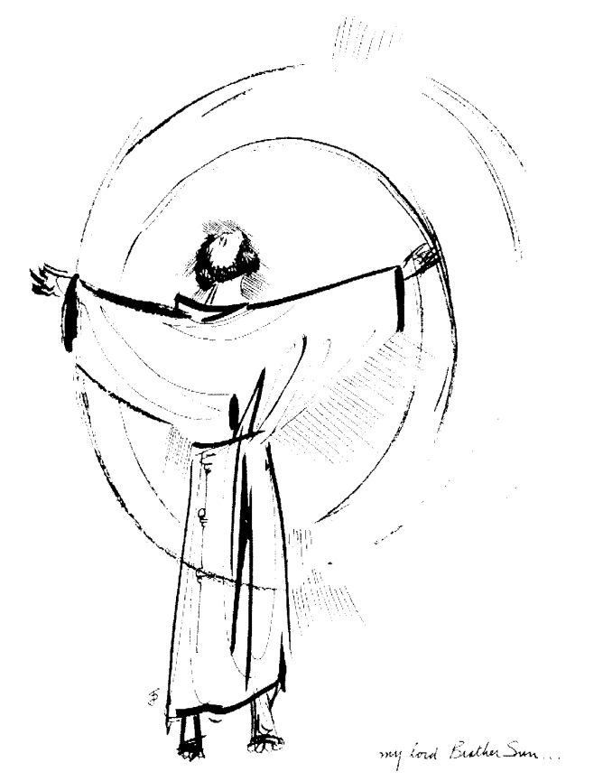
“Praised be you, My Lord, through all your creatures!”
Franciscan Readings for
Week Commencing
30 March, 2008
2nd Week Easter - A

Sunday 30 March 2008
(A reading from ‘The Life of St Francis’ by Thomas of Celano)
How handsome, how splendid! How gloriously Francis appeared in innocence of life, in simplicity of words, in purity of heart, in love of God, in fraternal charity, in enthusiastic obedience, in agreeable compliance, in angelic appearance. Friendly in behaviour, serene in nature, affable in speech, generous in encouragement, faithful in commitment, prudent in advice, tireless in prayer, he was fervent in everything! Firm in intention, consistent in virtue, persevering in grace, he was the same in everything! Swift to forgive, slow to grow angry, free in nature, remarkable in memory, subtle in discussing, careful in choices, he was simple in everything! Strict with himself, kind with others, he was discerning in everything!

Lord, when people catalogue our faults and successes, may they see us enthusiastic in everything, especially virtue in the way of Jesus your Son.

Monday ANNUNCIATION 31 March 2008
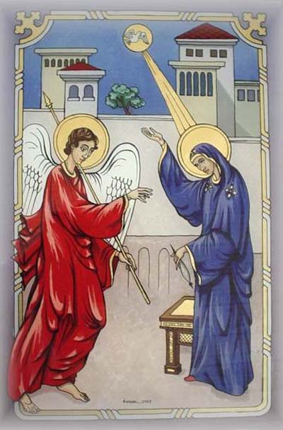
The Annunciation is related to us in Luke’s Gospel whereby Mary, betrothed to Joseph, is surprised by the Angel Gabriel with the extraordinary request that she become the bearer of the Saviour of the world. While Mary was married to Joseph at this point, it is likely that she was still living in her mother’s house, working on her dowry. The remarkable event took place under the most banal of circumstances. Mary, a fifteen year old virgin, was “anxious in spirit” at the angel’s request that she conceive of the Holy Spirit. And all of creation, it is said, waited for Mary to say “Yes” to God thereby facilitating the Incarnation. It all occurred about six months after an elderly Elizabath conceived John the Baptist and the parallel of the two miracles are not lost in the re-telling. For a thousand years, the Redemption of the world has been linked to Mary’s consent. It shows the love of God that a creature of the earth should bring forth his Son to a cold and heartless world.

(A reading from ‘The Salutation of the Blessed Virgin Mary’ by St Francis)
Holy Virgin Mary
among the woman born into the world
there is noone like you.
Daughter and Servant
of the Most High and Supreme King
and of the Father in Heaven,
Mother of Our Most Holy Lord Jesus Christ,
Spouse of the Holy Spirit.
Pray for us
with St Michael the Archangel,
all the powers of heaven
and all the saints,
at the side of your most Holy Beloved Son,
Our Lord and Teacher.

Tuesday 1 April 2008
(A reading from The Assisi Compilation)
There was a friend of the friars and he was afflicted every day by a private demon, one so terrible that he could not even confess it. Walking in the forest, Francis left his brother and went to the afflicted man. “Do not be afraid,” Francis said, “but only trust in God and your troubles will leave you. Don’t confess – say the Our Father with me and we can sort things out together.” Reluctantly, the man did as Francis said and the compassion he received filled him with joy. And immediately those anxieties left him upon having spoken to Francis who treated with such respect.

Lord, it is easy to be sanctimonious. Help us to forget ourselves and becomes “fools for God” just as Francis was the King of the Fools and Lover of the Most High!

Wednesday 2 April 2008
(A reading from 'The Remembrance of the Desire of a Soul’)
Francis was often attacked by his demons. So sure was he that he would lose his life that he called to another friar, “Brother, I want you to stay by me, because I am afraid to be alone.”
Francis was beset by demons and would say that it was God’s police – his struggle against chastity, his struggle against laying in wealthy abodes, his struggles against receiving alms – all was another persecution that, by which, he could live the life he had planned for himself. “I do not recall my offence,” he said, “but I obviously have not washed away my reparation.”

Lord, thank you for your immense love. You show us everyday your gift of life. May we remember that we are not like you – only your weak, human face. Let us be gentle with ourselves and turn to you in the times when we are tempted, You are our joy – bring us back to your love always.

Thursday 3 April 2008
(A reading from 'the Fioretti’)
There was a young boy who joined the Order in Francis’ days. So that he might observe Francis’ holiness more closely, the boy slept nearby and tied Francis’ cord onto his so that if Francis got up in the night to pray, he would feel it. Francis did arise but carefully untied the knot and went into the woods to pray. The young boy followed him and saw Francis in rapture surrounded by angels and with many voices reassuring him. Francis told the boy to say nothing of what he had seen and, many years later, the young boy, an old friar, revealed everything to testify to Francis’ holiness.

Lord, the young are our future. May we not judge them but encourage them in ways of holiness. Bring them close to your Church Lord, in these days that are cold. Give them the warmth of your Holy Spirit.

Friday 4 April 2008
(A reading from 'the Assisi Compilation’)
There was a friar from a large and powerful family. One day, he and Francis were travelling through the snow. Francis was on a donkey and the other friar was trudging along behind. “Look at him,” the other friar thought, “in the world I was mightier than this man and now I am made to walk through the mud.” Francis immediately got off the donkey and said, “True, brother, you are better than I. Here – take my donkey.” And the friar fell to his knees in great distress for Francis had read his heart and soul.

Lord, how stupid we are to think you cannot know everything about us. Our transparency in the eyes of others is equally obvious. May we always act to your glory and edify others by our example.

Saturday 5 April 2008
(A reading from 'the Assisi Compilation’)
It was very cold in Condigliano near Rieti and Francis patched his one tunic with scraps of cloth in order to give himself comfort. He sat by and also patched the tunic of his brother so that he, too, might be spared form the cold. “I must be the form and example of the brothers,” Francis said, “when it is necessary for me to have a patch on my tunic, I must also consider the necessities of my brothers as well.” Francis, even after he resigned as General Minister, always led by example rather than just preaching with words.

Lord, how often we place our comforts before those of our brothers. Help us to be mindful of the needs of others and to “patch” the tunic of our neighbour as well as our own.

