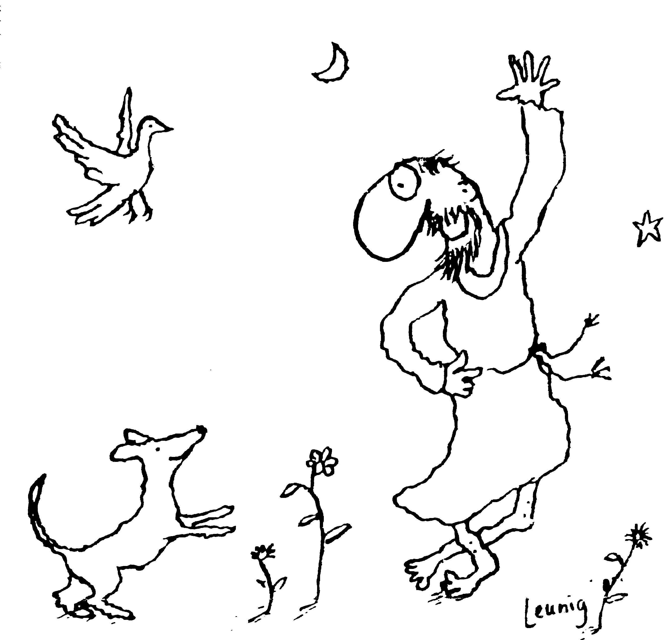
“Praised be you, My Lord, through all your creatures!”
Franciscan Readings for
Week Commencing
29 November, 2009
1st Week of Advent

Sunday 29 November 2009
(A reading from ‘The Legend of the Three Companions’ of St Francis)
Francis was raised in the city of Assisi, which is located in the boundaries of the valley of Spoleto. His mother named him John but his father, who often travelled to France, later named him Francis. When he grew up, he was endowed with many gifts and talents and pursued his father’s profession: that of a merchant. But he was such a different man from his father. He was more good-natured and generous, given over to merry-making and revelry, roaming day and night with his friends throughout the city, singing and dancing. Because of this, his parents often reprimanded him, saying that he spent too much on himself and his friends. His extravagance knew no boundaries but, because his parents loved him so much, they tolerated his excesses. He was so vain in seeking to stand out that sometimes he had the most expensive material sewed together with the cheapest cloth onto the same garment.

Lord, you put up with our weaknesses and sinfulness. Help us to defeat our own pride and vanity to become closer to you.

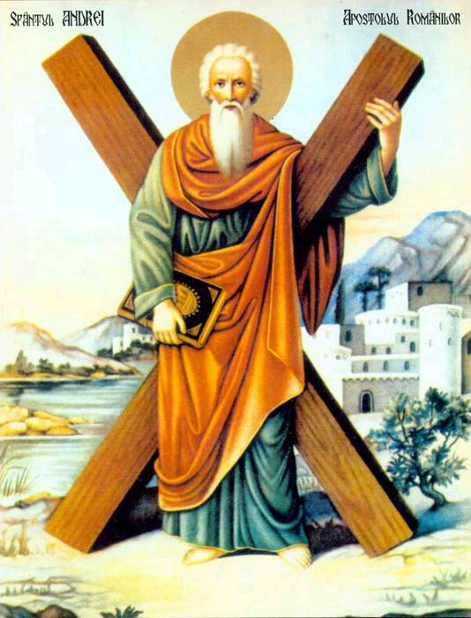
Monday St Andrew 30 November, 2009
Born in Bethsaida of Galilee, Andrew was Simon Peter's brother. Both were fishermen, called by Jesus to be his Apostles. He was very close to Jesus, sharing a house with him at the beginning of his ministry. Andrew at once recognised Jesus as the Messiah and hastened to share this news with Peter. He was also there at the miracle of the loaves and fishes and, apart from appearing in the list of apostles in Acts, little else is known of him. He was of course there to enjoy familiarity of Jesus - at his crucfixion, at his resurrection and ascension into heaven. Cappadocia, Galatia and Bythinia were his mission fields and even among the anthropophagi of Scythia. St Stachys was appointed bishop of Byzantium at his request. His travels were widespread. It is commonly believed that he was crucified in Patrae, Aechaia, by order of the Roman governor, under Nero's reign in 60. Tradition holds that he was tied, not nailed, to the cross in its decussate form - but this is a useless triviality that seems to have emerged in the 14th century. He is the patron of Scotland.
(A Reading from the Fioretti)
A very noble and refined man came to the Order. However, he felt such disgust at the habit that it became an unbearable burden for him - the rough sleeves, the length and dirtiness of it. His distaste for religion also grew and he eventually left the Order and returned to the world. On leaving, he automatically genuflected in front of the friary chapel's altar and, all at once, he was caught up in a vision of an infinite multitude walking two by two in beautiful robes. "Who are you?" he cried. "We are all Lesser Brothers. The rough tunic of penance that we wore on the earth is now replaced with these beautiful robes in heaven." Then they disappeared.
After this great epiphany, the youth ran back to his cell and continued his life of penance and died a holy friar to join all the Franciscan saints in their eternal rejoicing.

Lord, saints are all around us, sharing our lives. Let us acknowledge the holiness of others and join with them in praising you through good works.

Tuesday 1 December 2009
(A Reading from the Legend of the Three Companions)
In 1202, a war broke out between Perugia and Assisi. With many of his fellow citizens, Francis was captured and confined in Perugia but, because of his merchant-class background, he was confined with knights and nobles. While his fellow prisoners became depressed and dejected, Francis remained cheerful and happy. He was rebuked angrily by one of the prisoners as insane for being happy in prison. "What do you think will become of me?" queried Francis, "Rest assured, I will be worshipped throughout the whole world."
One of the knights, in a prison brawl, had injured another prisoner and was ostracised by the inmates. But Francis treated him in a friendly way despite them, spending time with him and talking with him. After a year, when peace was restored, they were set free.

Lord, we are imprisoned by our fears and anxieties. As we await the joyful coming of your son amongst us, may every fear be dispelled and may hope and promise be restored to your waiting people.

Wednesday 2 December 2008
(A Reading from the Legend of the Three Companions)
Some years after returning from prison, a nobleman from Assisi was preparing himself with knightly arms to go to Apulia in order to increase his wealth and fame. Francis yearned to go with him and to be knighted by the count, Gentile was his name. He gathered together his wealthy clothing and prepared to set off on his journey. That night, Francis had a strange dream. A man, calling him by name, led him into a beautiful bride's elegant palace filled with knightly arms and on its walls hung glittering shields and other armour. Overjoyed, he asked who owned this house and all within it. The man said that it belonged to Francis and his knights.
The next day, believing this to be a great omen, resolved to undertake the journey to Apulia. When people asked him why he was so cheerful, Francis replied, "I know that I will become a great prince."

Lord, you wish us to be honourable and great in our own way. May our honour and our dignity not rest on material things or on the trappings of connections and fortune - may our honour be that seed within us that you planted, one of grace and love.

Thursday 3 December 2008
(A Reading from the Legend of the Three Companions)
The dream of Francis had become the sole motivating force behind his journey to Apulia. He donated all that he had acquired to a poor knight in his rapture and expectation of wealth to come. Passing through Spoleto, Francis became ill and was rendered half-asleep and half-awake. He heard a voice ask him, "Francis - who can do more for you: the lord or the servant?" When Francis answered him, "The lord," the voice said, "Then why do abandon the lord to follow the servant, the patron for the client?"
"Lord, what do you want me to do?" asked Francis. "Go back to your land and what you are to do will be told to you." So Francis ran back to Assisi to await the Lord's clarification of these matters.

Lord, you indicate to us in subtle ways the wonder of your holy will. May we discern carefully your path for us and, ever-trusting, may we render all our lives to you.

Friday 4 December 2008
(A Reading from the Works of John Duns Scotus)
Concerning the mother of Jesus and the salvation which was hers; a salvation which preceded her birth, absolute and perfect and for the rest of humanity now only in process. When it does not contradict the authority of the Church and Scripture then it is safer to assert that which conforms to the honour of the Virgin Mary – that she was never tainted by original sin. God wills to love. God wills to be loved. God wills to have co-lovers of himself. The perfect mediator has to effect a perfect mediation in respect of the person in whose favour he mediates and in the perfection of his function as mediator. Mary was the one above all for whom he became mediator.

Lord, you gave us Mary as the mother of your Son. While the world stood waiting, Mary of Nazareth gave us her “yes” that brought our salvation into the world. May we imitate her willing obedience to you and rejoice in your favour for humankind.

Saturday 5 December 2008
(A reading from ‘The Legend of the Three Companions’ of St Francis)
Francis happened to go to Rome on pilgrimage. As he was entering the church of St Peter, he noticed the meagre offerings made by some and said to himself, ‘Since the Prince of Apostles should be greatly honoured, why do they make such meagre offerings where his body is laid?” He threw a large handful of coins into the grate which clattered and caused all to stop and stare. Leaving the church, he secretly exchanged clothes with a beggar and sat on the steps, begging in French for coins. It is here that he experienced that poverty for which he would live and die.

Lord, help us be people of real empathy, stepping into the shoes of others. Teach us to experience real love of neighbour.

