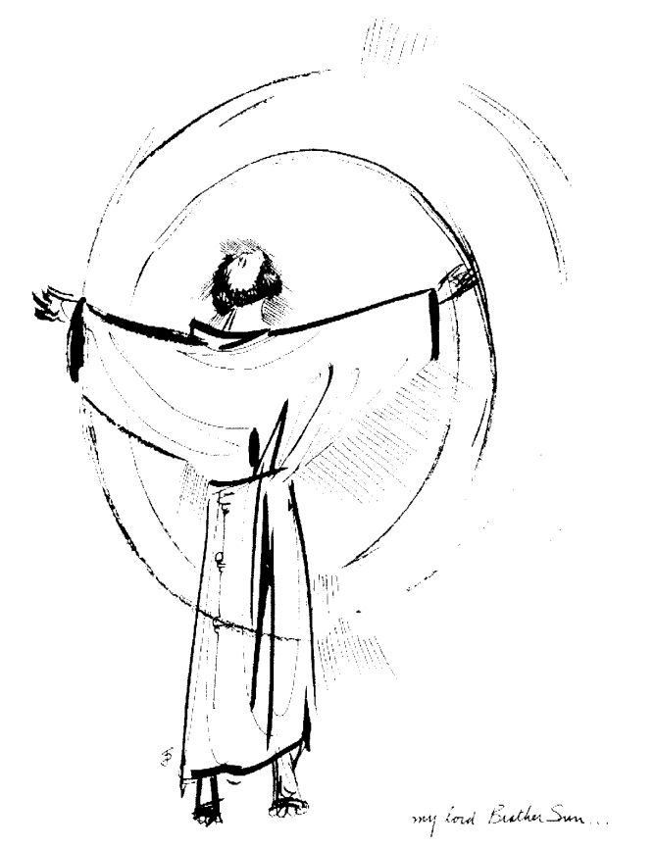
“Praised be you, My Lord, through all your creatures!”
Franciscan Readings for
Week Commencing
18 May, 2008
7th Week Ordinary Time – A

Sunday TRINITY SUNDAY 18 May 2008

(A Reading from the Praises to be said at All Hours)
Holy, holy, holy Lord God Almighty,
who is, and who was an who is to come:
And let us praise and glorify him forever.
O Lord Our God, you are worthy to receive,
praise, glory and honour and blessing.
And let us praise and glorify him for ever.
The Lamb who was slain is worthy to receive
power and divinity, wisdom and strength,
honour and glory and blessing.
And let us praise and glorify him for ever.
Let us bless the Father and the Son with the Holy Spirit:
and let us praise and glorify him forever.

All powerful, Most Holy, Most High, Supreme God:
all good, supreme good, totally good, you who alone are good,
may we gove you all praise, all glory, all thanks, all honour , all blessing,
and all good.
So be it! So be it! Amen.

Monday 19 May 2008
(A reading from “The Legend of the Three Companions” by Francis of Assisi)
Francis admonished the brothers not to judge anyone, nor to look down upon those who live with refinement and dress extravagantly or fashionably. For, he would say, their God is ours, the Lord who is capable of calling them to himself and justifying those called. He also used to tell the friars to look upon the wealthy as their brothers and lords. They are brothers because we are all created by the one Creator; they are lords because they help the good to do penance by providing them with the necessities of life.
‘As you announce peace with your mouth, make sure that greater peace is in your hearts. Let no one be provoked to anger or scandal through you, but may everyone be drawn to peace, kindness and harmony through your gentleness. For we are called to this: to heal the wounded, bind up the broken, and recall those who err. In fact, many who seem to us to be members of the devil will yet be disciples of Christ!’

Lord, how easy it is to judge and place ourselves on a pedestal, even before your greatness! Help us to see the supposed “members of the devil” as possible disciples of Christ and embrace them as our brothers and sisters.
.

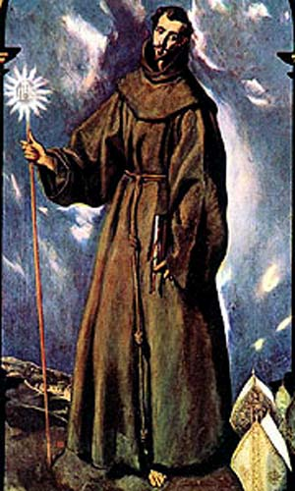
Tuesday St Bernardine 20 May 2008
A few years after joining the Observant friars in 1402, Bernardine began a spectacular career as a popular preacher, travelling all over Italy. His is best remembered fro his propagation of devotion to the Holy Name of Jesus. He rose to high office in the Order and many joined because of his reputation. Not long before he died he resigned office so as to return to his favourite task of preaching.

(A reading from the sermons of St Bernardine of Siena)
The name of Jesus is the crowning glory of preachers. It is due to him that their preaching and its reception are blessed with extraordinary enlightenment. How else in the world could the fervent light of faith be kindled so suddenly if not by the name of Jesus? Is it not by the light of this name that God is said to have called us into his own glorious light? To the enlightened who see light in that light. St Paul says, “You were once all darkness, now you are all light in the Lord; walk then as children of the light.” It is not a name to be hidden, it is to be proclaimed for its light to shine. An unclean heart and a sordid mouth are not fit way to speak this name. The preacher should be a choice vessel, holding and proffering this name.

Lord, you bless St Bernardine with a love for your name. May we speak of you with love in our deeds so that all may come to venerate and proclaim your glory.

Wednesday 21 May 2008

(A reading from “The Legend of the Three Companions” by Francis of Assisi)
When a chapter had ended, Francis would bless all the brothers and assign each of them to individual provinces. TO anyone possessing the Spirit of God and an eloquence suitable for preaching, whether cleric or lay, he gave permission to preach. When those men received his blessing, they went throughout the world as pilgrims and strangers, taking nothing for their journey, except books in which they could say their Hours. When they came upon a priest, rich or poor, good or bad, they bowed deeply with respect. They preferred to stay in the lodgings of priests than of seculars. They came across, also, widows and virgins who had been inspired by their preaching and locked themselves away in seclusion. Many married people, unable to separate because of the law of matrimony, resolved to live lives of penance together. And, thus, three orders sprung up – each gaining approval by the Supreme Pontiff in time.

Lord, with words inspired by your Spirit, we have the power to show your face to those who have not yet seen it. Give us the grace of good speech and uplifting actions. May we be your presence on earth.

Thursday 22 May 2008
(A Reading from the Assisi Compilation)
Five thousand brothers attended the Chapter of Mats. Many learned brothers told the Lord Cardinal (later, Pope Gregory) that Francis should be guided by them for the time being and cited the Rules of Augustine, Benedict and Bernard. After the Cardinal spoke to Francis, the man of Assisi took him by the hand and spoke to the friars in this way, “My brothers! God has called me by the way of simplicity and showed me the way of simplicity. Forget the other rules – for the Lord has told me what he wanted: he wanted me to be a new fool in the world. God will confound you for your knowledge and wisdom. But I trust in the Lord who will send you back to your blame, like it or not.”

Lord, send a spirit of charity upon those who wrongly exert their gifts and talents to manipulate and undermine others. Help us to see the passing nature of authority and let us use our talents for goodness always.

Friday Basilica of St Francis 23 May 2008
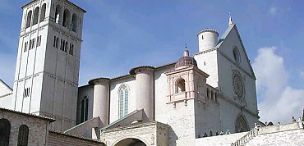
The Basilica of ST Francis in Assisi is one of Italy’s most famous sites. It’s construction period was relatively short – from 1228 to about 1253, a testament to the great love people had for St Francis. For the next one hundred years, the Basilica which is divided into an Upper and a Lower Basilica evolved with the contributions of Italian artists. Most notably, the Giotto Sequence of the life of St Francis adorns the ceiling of the Upper Basilica and the “Enthroned Madonna with Angels and St Francis” by Cimabue. The remains of St Francis are in a small sarcophagus beneath the high altar – visited by thousands of pilgrims each year.

(A reading from ‘The Major Legend of St Francis’ by St Bonaventure)
Just as that blessed man had shone in his life with marvellous signs of virtue so from the day of his passing until the present, in the different parts of the world he shines with outstanding examples of miracles through the divine power that glorifies him. Remedies for all sicknesses, necessities and dangers are conferred through his merits on the blind and the deaf, the mute and the crippled, the paralytic and the dropsical, the possessed and the leper, the shipwrecked and the captive. But also many dead are miraculously brought back to life through him. Thus, the magnificence of the power of the Most High, doing wonders for his saint, shines forth to the faithful. To him be honour and glory for endless ages of ages. Amen.

Lord, may our holiness be enshrined as in your basilica in Assisi. Let those who witness our holiness do so as example of your love for us and of our return to you.

Saturday Mary, Help of Christians 24 May 2008
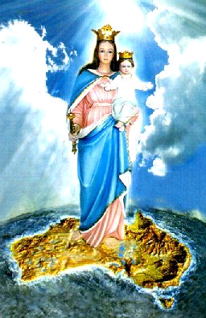
Just as Mary was often invoked as the protectress of armies going to battle, so it was that the invocation Auxilium Chriatianorum was probably first used in relationship to Mary upon the return of warriors from the battle of Lepanto in 1517. It increased in popularity throughout the troubled years of the early 1800s. Several missionary groups, the new soldiers for Christ, operated under Mary’s patronage and spread devotion to Help of Christians in the nations where they evangelised. The Salesians of Don Bosco would be typical of this. Australia was placed under Mary’s patronage in 1888.

(A reading from The Major Life of St Francis by St Bonaventure)
Francis, the herald of truth, cast out devils and healed the sick, but, even greater, he softened the obstinate minds of sinners and moved them to penance. In the city of Toscanella, he was staying at the house of a knight whose son was crippled since birth. At his father’s insistence, Francis lifted the boy up and he was cured instantly – all his limbs were restored to full strength. At Narni, at the request of the bishop, Francis made the sign of the cross from head to foot of a paralytic who was cured immediately. At Gubbio, a woman was healed whose hands had been so withered that she could do nothing with them – by sundown, she had prepared a meal for the townsfolk with her two cured hands. In the village of Bevagna, Francis touched the eyelids of a girl born blind and she could see again.

Lord, miracles are not just the domain of saints. May we be your miraculous presence for others. Show us how we can make the blind see, the deaf hear and the paralysed walk upright again.

