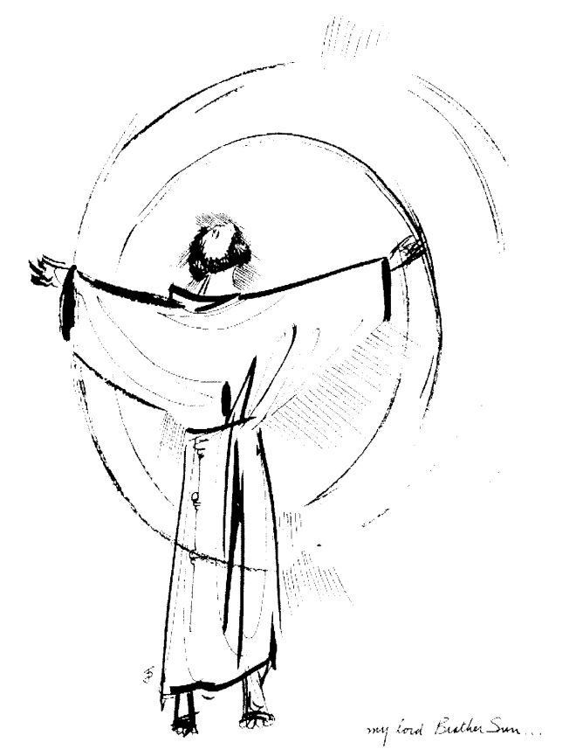
“Praised be you, My Lord, through all your creatures!”
Franciscan Readings for
Week Commencing
15 June, 2008
11th Week Ordinary Time – A

Sunday 15 June 2008
(A reading from A Letter to the Entire Order by St Francis)
Let everyone be struck with fear, let the whole world tremble, and let the heavens exult when Christ, the Son of the living God, is present on the altar in the hands of a priest! O wonderful loftiness and stupendous dignity! O sublime humility! O humble sublimity! The Lord of the Universe, God and the Son of God, so humbles himself that for our salvation he hides himself under and ordinary piece of bread! Brothers, look at the humility of God, and pour out your hears before him! Humbles yourselves that you may be exalted by him! Hold back nothing of yourselves for yourselves, that he who gives himself totally to you may receive you totally!

Lord, create in us the heart of compassion that longs to receive you totally. Hold us in life as you nourish us for the journey through your holy Body and Blood.

Monday 16 June 2008
(A reading from The Testament of St Clare)
When Francis saw that we few sisters that had gathered together were physically weak and frail, we did not shirk deprivation, poverty, hard work, trial, or the shame or contempt of the world – rather, we considered them as great delights, as he had frequently examined us according to the example of the saints and his brothers – he greatly rejoiced in the Lord. And moved by compassion, he bound himself, both through himself and through his Order, to always have the same loving care and special solicitude for us as for his own brothers. We were to dwell in the Church of San Damiano where, in a little while, the Lord, through his mercy, made our number increase so that he would fulfil what he had foretold through his saint. He wrote a form of life for us and he gave us many writings that, after his death, we would never turn away from the love of holy poverty. And our father Francis, having imitated Christ’s footprints, never departed either in example or in teaching from this holy poverty tht he had chosen for himself and for his brothers.

Lord, you set our feet on your path. Help us never to deny the rule you lay down for us. May we, like Clare, have a tenacious spirit and a willingness to live for you alone.

Tuesday 17 June 2006
(A reading from The Fioretii)
Francis would visit St Clare many times when he was in Assisi. Clare wished to dine with him but Francis always said no. One of the friars said that Francis was being too rigid. So Francis agreed to have a meal with Clare at Santa Maria degli Angeli. When the appointed time came, they sat down on the bare ground together: St Francis and St Clare and their companions. Their meal was meagre and yet their conversation seemed to compensate immensely. There discourse was about God and his mercy and his great abundance. The Assisians could hear their partying and ran to see what was going on. They could not believe their eyes – the small saint and his sister Clare with their few companions were gathered on the ground eating some bread but laughing and singing and praising God as though their feast was the ultimate wedding banquet.

Lord, you made us for each other. Let our friendships consist of variety, amusement and intimacy in equal portions. Help us to always see the fun in every situation.

Wednesday 18 June 2008
(A reading from the Remembrance of a Desire of a Soul by Thomas of Celano)
As foretold, an Order of Holy Women was to be established and brought one day as a collection of jewels to the kingdom of Christ. The Poor Clares were ready to undergo any loss and to bear any labour for Christ and never wanted to leave the side of the Lord they loved with all their heart. Francis promised them that he would always support and care for them. The friars were sometimes surprised that he didn’t visit the Clares as often as he should – “Do not think that I do not love them fully,” he said, “ and I cherish them, but I believe that it would be best for those unwilling to see the sisters to be assigned to them, men of long-standing, spiritual lives.” I guess he had his reasons.

Lord, you plan the way for us. Make us visitors in danger, going beyond our comfort zones to see those who need help. Let us always be the first to love our neighbour.

Thursday 19 June 2008
(A reading from The Fioretti)
Francis had a serious eye disease and Hugolino, the Cardinal Protector, referred him to an eye doctor in Rieti. Knowing what was ahead, Francis went to Clare for consolation and she put him up in a drafty room to stay. His sight became worse and the mice in the room bothered his sleep. He believed that his sight had failed due to his sins and cried out, “ Lord my God! I am worthy of this and much worse. Good Shepherd, you have shown your mercy to us sinners in different bodily pains and sufferings, give grace and strength to me, your lamb, and save me from this illness.” Francis was confronted with the words, “Francis, this is the treasure of eternal life.” and, not quite understanding it, went to say goodbye to Clare and go to Rieti full of confidence.

Lord, you are our brother and our sister. Let us lean on those who can support us. Make us strong in our resolve to always be people of faith, however weak, and however in need of rest on our journey.

Friday 20 June 2008

(A reading from The Assisi Compilation)
Although sick, Francis composed a song for the ladies in San Damiano. He wished that the words be proclaimed by the friars. The words were of hope and begged them that, as the Lord had gathered them as one from many different regions in holy charity, holy poverty, and holy obedience, so in these they should live and die. He encouraged them to display cheerfulness and thanksgiving. But more importantly, he asked them to remain patient: the healthy, in the labours which they endure for their sick sister; and the sick in their illnesses and the needs they suffer.

Lord, you are the friend of the ailing. How much time to we devote to the sick and needy? May we remember that we are only dust and give all of ourselves to supporting the sick and lonely, regardless of how difficult this may be. May the sick be brought to wholeness in the love of your presence

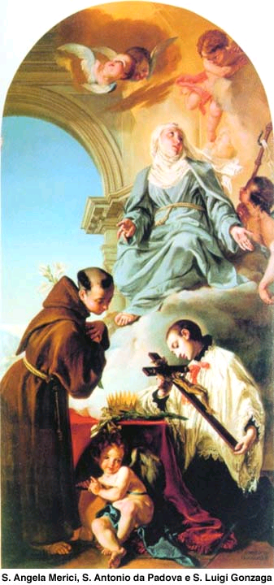
Saturday 21 June 2008
Born in Castiglione in 1568, Luigi was placed in the Court of the Medicis in Florence at the age of 8. At the age of twelve, he came under the spiritual guidance of Charles Borromeo and was eventually despatched to be the page of Philip II. He was of a royal line but that did not deter Luigi from entering the Jesuits, despite opposition from his father and having renounced his inheritance, in 1585. He completed his novitiate with a interlocum in philosophy that brought the house down and took his vows in 1587 at the age of 19. In his fourth year of theology, the famine and pestilence broke out in Italy and, despite his delicate health, Aloysius nursed the sick and the poor. He died in 1591 at the age of 23, a man who had given his life to a vocation that cost him everything. He was beatified thirty years later in recognition of his life-giving work for the poor of Italy.

(A reading from the Assisi Compilation)
Before Francis died, Clare herself was seriously ill. She was worried that she would die before Francis and sent word of this to him as he lay in Assisi. Although on the point of dying, Francis managed to write a letter to Clare absolving her of her failings and giving her comfort because he loved her as his sister. Soon afterwards, though, Francis died. All the people of Assisi took the holy body from where it lay and, all carrying branches, transported the body to San Damiano that Clare and her sisters may see him before he was committed to the earth. And they did. The iron grille was removed and the held up the body of Francis for an hour while the sisters wept and prayed but were offered the greatest of consolations. Theywept profusely and were afflicted with great grief because, after God, he was their one joy in this world.

Lord, we weep when we lose someone who has been our joy. Let us be mindful of those who die who have been our joy and our delight. May we always remember the legacy of grace and elation that they have left behind.

