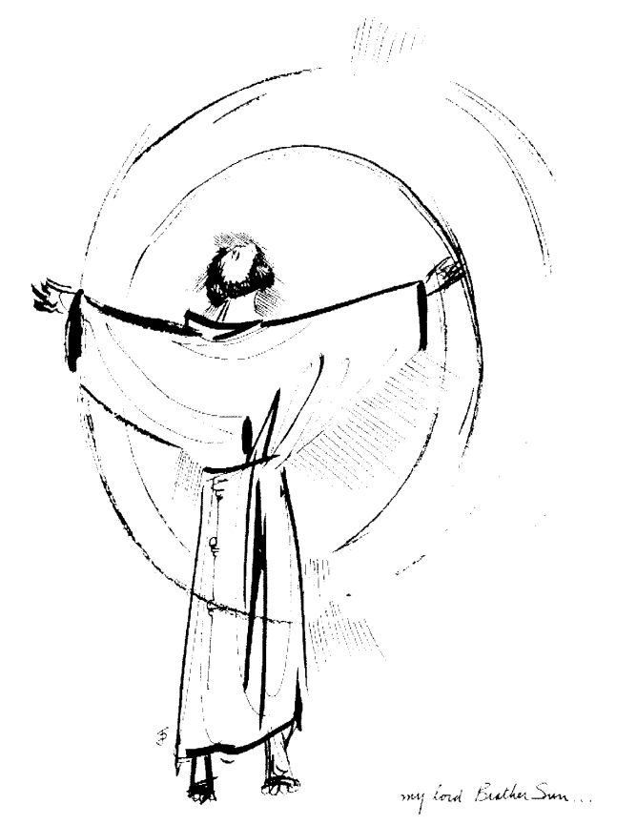
“Praised be you, My Lord, through all your creatures!”
Franciscan Readings for
Week Commencing
14 September, 2008
24th Week Ordinary Time – A

Sunday 14 September 2008
(A reading from the Deeds of Blessed Francis and his Companions by Ugolino of Montegiorgio)
When Francis came to Montefeltro, he climbed a wall in order to be easily seen and heard by the people who had gathered there to hear him preaching. Afterwards, Lord Orlando said to Francis, “I have an abandoned and solitary mountain in Tuscany which is called Mount La Verna. It is very suitable for those who wish to live a solitary life. If this mountain pleases you, I would very willingly give it to you for the salvation of my soul.”
Francis gave thanks to God who, through his faithful people, always provides for his little sheep and then he gave thanks to Lord Orlando. He had desired a place of solitude and accepted the generous offer made to him.

Lord, help us to find our own Mount La Verna within us. May we never try to escape you but wander further into your embrace each day.

Monday Our Lady of Sorrows 15 September 2008
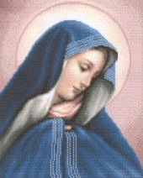
From antiquity, we associate Mary with the seven dolours which are Mary’s sorrow at the prophecy of Simeon; at the flight into Egypt; having lost the Holy Child at Jerusalem; meeting Jesus on his way to Calvary; standing at the foot of the Cross; Jesus being taken from the Cross; at the burial of Christ. It was a cult that spread through Spain in 1506 but bespoke the depth of Mary’s motherhood and was employed by the whole Church soon after, the memorable hymn being the Stabat Mater Dolorosa. It paints Mary as not some pious figure of languid pose but rather a devoted mother who bore with her Son all the trials placed upon him.

(A reading from ‘The Deeds of Blessed Francis and his Companions” by Ugolino of Montegeorgio)
Francis and his companions stopped to rest on the road to La Verna. The birds came down to rest on the hands and feet of the friars. Francis interpreted this as the Lord’s delight, that they had come to the right place. So, they built a little hut where Francis would pray. In such ecstasy, he said that Leo should stand at the door and say “Lord, open our lips.” If the response was made, the friars had matins. If Francis did not respond, they were to go and come again later. Such was the depth of his prayer.

Lord, give us the discipline to pray always. Give us a heart focused on you alone.

Tuesday 16 September 2008
(A reading from ‘The Major Legend of St Francis’ by St Bonaventure)
Francis learned that by opening the book of the Gospels, God would show him what to do. In the three times he opened the book, the Passion of Christ was revealed to him. Before he would pass out of this world, the sorrow and passion of Jesus would be a part of his own life, therefore finding him perfectly conformed to it. In this affliction, he bore the signs of Jesus valiantly. In this life he was like him. In this world, he knew and beheld sinners as a mark of the divine Lord.

Lord, who are we to criticise? You are present in us and in those we meet. Help us to be for them the Christ you sent to redeem us.

Wednesday The Stigmata 17 September 2008
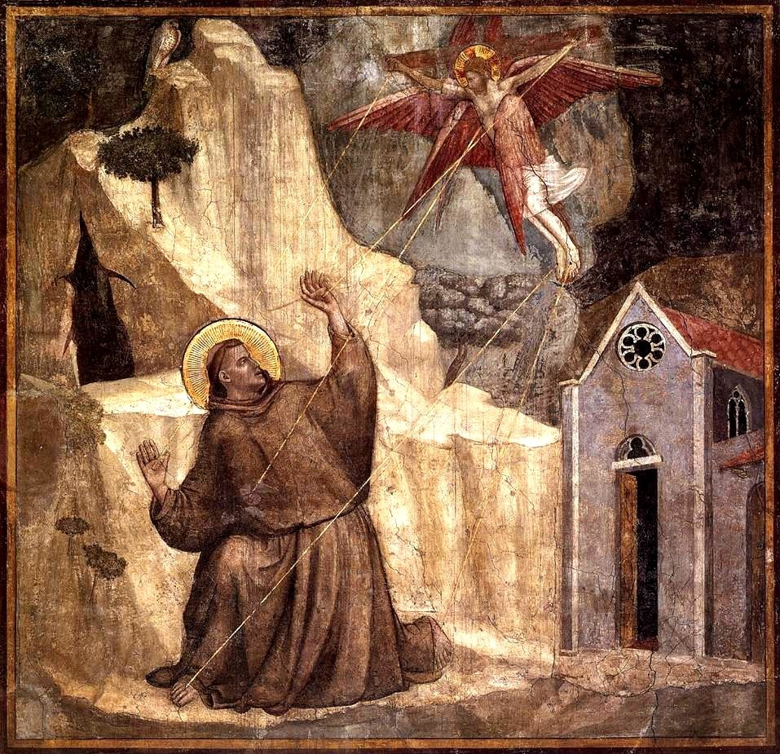
St Francis was the first recorded stigmatic, now one of only 62 canonised stigmatics in the Church’s history prior to the nineteenth century. Francis was chosen by God to bear the marks of the Passion on his hands, side and feet. The affliction he carried hidden caused him immense pain but also delight at his final unity with the Crucified whom he loved so intimately.

(A reading from ‘The Major Legend” by St Bonaventure)
Francis marvelled exceedingly at the sight of so unfathomable a vision, know that the weakness of Christ’s passion was in no way compatible with the immortality of the seraphic spirit. Eventually he understood from this, through the Lord revealing it, that Divine Providence had shown him a vision of this sort so that the friend of Christ might learn in advance that he was to be totally transformed in to the likeness of Christ crucified, not by the martyrdom of the flesh, but by the enkindling of his soul. As the vision was disappearing, it left in his heart a marvellous fire and imprinted in his flesh a likeness of signs no less marvellous.

Lord, mark us with the signs of your passion. Enkindle that fiery love of yours into every human heart.

Thursday 18 September 2008

(A reading from The Tree of the Crucified Life of Jesus by Ubertino da Casale)
When Jesus appeared to Francis, his heart melted within him with a fire that only divine love can inspire. “I beg you, Lord,” Francis said, “draw my mind away from the things that are under heaven, that I may die for love of the love of you, who thought it a worthy thing to die for love of the love of me.” Those sons who have been fashioned in the likeness of their father, by the fire of his seraphic vision, must understand that their fashioning has to take place in their soul and be carried out by the glowing crucifixion of Jesus. So they will be living their lives like “little Christs”, smaller figures of Jesus.

Lord, how much can we become “little Christs” and live our lives in accordance with your love of us? Help us to grow ever in the model of St Francis.

Friday 19 September 2008
(A reading from 'The Major Legend of St Francis', by St Bonaventure)
Francis had learned that in opening the book of the Gospels, Christ would reveal to him what God considered most acceptable in him and from him. After he finished praying, Francis would ask his companion to take the book of the Gospels from the altar and open it three times in the name of the Trinity. All three times, an account of the Lord's passion met his eyes. Francis, filled with God, understood that, just as he had imitated Christ in the actions of his life, so he should be conformed to him the affliction and sorrow of his passion, before he would pass out of this world. With the seraphic ardour of desires, therefore, he was being borne aloft into God; and by compassionate sweetness he was being transformed into him who chose to be crucified out of the excess of his love.

Lord, you are the source of our hope. May we turn to you for guidance and help and, placing all our trust in you, grant us the strength to endure whatever life puts before us.

Saturday 20 September 2008
(A reading from 'The Major Legend’ by St Bonaventure')
Francis tried his best to conceal the stigmata – he always held his hands in his sleeves or wore bandages and he wore sandals from that moment on. However, people could detect that he was bleeding and Francis feared rumours and attention. The brothers that nursed him were trustworthy and touched him as they would the holy gospels. One of the brothers convinced Francis to remove his tunic so that it may be washed and saw the great wound in his side measuring it as three fingers wide. Francis wore special undergarments that would reach to under his armpits and thus conceal the bleeding wound. The brothers were convinced that this was the mark of Christ but kept it to themselves.

Lord, help us to be guardians of the secret pain suffered by others. May we wash tenderly the wounds that life inflicts on those around us and bring them to wholeness through you.

