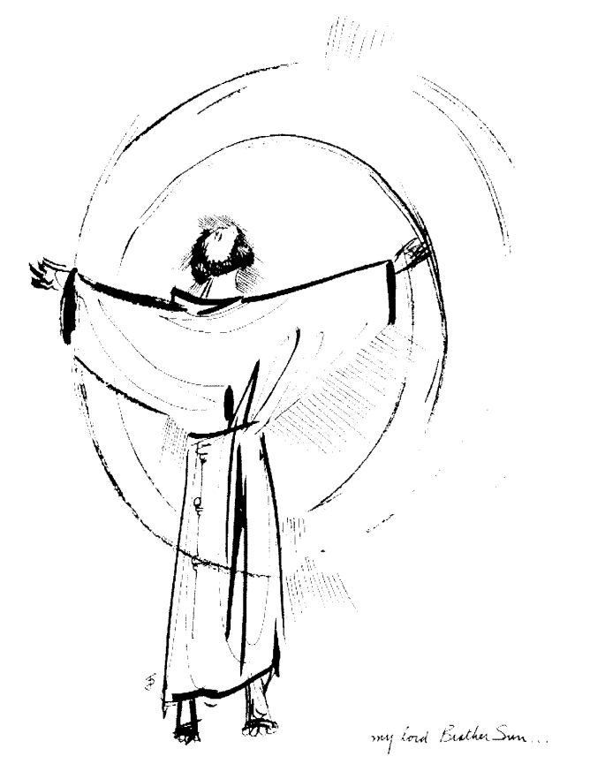
“Praised be you, My Lord, through all your creatures!”
Franciscan Readings for
Week Commencing
8 November, 2008
32nd Week Ordinary Time

Sunday 8 November 2009
For a thousand years the Lateran (A reading from “The Major Legend of St Francis” by St Bonaventure)
Not long after Francis and Bernard, five other men were called by the Spirit. The third to join Francis was a man called Giles. He was a simple and unlearned man and yet he later became known for his heroic virtue. So much was he given to prayer and contemplation that he seemed to live among people more like an angel than a human being.

Lord, just as Giles reached you in prayer, may we too be angels in this world, praising you in word and deed and activity.

Monday Lateran Basilica 9 November 2009
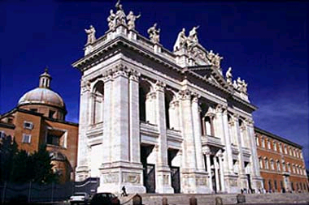
For a thousand years the Lateran was the palace of the Popes until it was destroyed and then greatly embellished by none other than Innocent III -who, incidentally, dreamt that Francis was holding up the walls of the Lateran during an earthquake. It is the basilica of Rome, one of the four patriarchal churches that dates back to the Laterani family who were proconsuls prior to Nero .It is deep in the panting heart of Rome – a memorial to papal decadence but also our long Constantine history

(A reading from ‘A Mirror of the Perfection of a Lesser Brother’)
Francis was staying at Rivo Torto when a poor man came to visit the friars. Turning to Brother Giles, Francis said, “Give him your cloak.” Immediately Giles unhooked his mantle and gave it to the poor man. Funnily, he felt filled with joy and delighted with this act. It was a cold day but he felt nothing but warmth around him. Francis embraced him and he progressed in every virtue.
Lord, you blessed us with generous hearts. Let us give without counting the cost. Fill us with your endless love and help us to share your love with others.

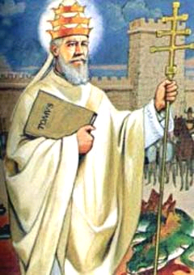
Tuesday St Leo 10 November 2009
Pope Leo I died in 461 after 21 years on the papal throne. After Gregory I, he is the most significant Pope in antiquity, managing to sustain the unity of the Church during a time when everything Catholicism stood for was in dispute. He combated Pelagianism which denied Christian grace and original sin, wrote letters to Eutyches about various other heresies and even help defend Rome from the Vandals, known for their loose ways. His 97 homilies, most of which are still preserved, glorify the papacy and the bishopric of Rome.

(A Reading from the Life of Brother Giles)
Brother Giles went to visit the Church of St James the Great in Galicia – it was a long and difficult journey. Giles only stopped if he really had to, often begging for some food and making do with the fruits growing by the roadside. On one occasion, finding noone to share alms with him, he crept into a barn and ate the beans on the threshing floor, giving thanks to God. He met a man on the road, begging alms and, having nothing, Giles cut the hood away from his habit and gave to the man to wear. He travelled twenty miles to Lombardy with nothing to cover his head. Upon reaching that town, a man called to Giles to throw dice for rewards. “May God forgive you,” he said and went on his way, neither giving into temptation but living a true and just existence wherever he went.

Lord, your blessings multiply each day. May we remember to be grateful and give everything we have to alleviate the sufferings of others, acting always in justice.

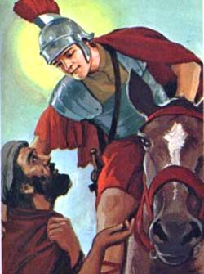
Wednesday Martin of Tours 11 November 2009
Born in Germany in 316, Martin was the son of a Roman officer. He embarked on a career as a soldier, earning respect as quite a devout man, common enough in the army barracks of that time just after the conversion of the Emperor. Martin famously gave half his cloak to a poor beggar and, in a moment of his own conversion, attempted to live as a hermit. The huge numbers that gathered around him made this life of solitude impossible. Martin was elected Bishop of Tours where he died in 397. He is the patron of Europe.

(A reading from 'The Life of Brother Giles')
Our globetrotting Brother Giles was sent by Francis to the Holy Sepulchre in Jerusalem but when he got to the port at Brindisi, he was detained for several days because there was no ship ready. So, wishing to live by his own toil, Giles filled a bucket with water and went about the town earning food by filling the water tanks of the local households. He only earned what was necessary for the life of his body. He got to Jerusalem and visited the Holy Sepulchre and many other holy places.
On his way home, Giles was stranded in Ancona for several days. Accustomed to living by the labour of his hands, he made baskets from rushes and sold them for bread. He also carried the dead to the cemetery. When this failed him, he begged from door to door until he finally returned to Santa Maria degli Angeli impoverished and worn out from working.

Lord, you gave us the grace of working for our daily bread. May we be invested in our work, whatever we do, so that we may give and receive life, not just a wage.

Thursday 12 November 2009
(A reading from 'The Sayings of Brother Giles')
Brother Giles once asked a friar, "What do the professors say that contemplation is?" The friar responded, "I do not know. What do you say that contemplation is?" Brother Giles asserted, "Contemplation has seven stages: fire, perfume, trance, contemplation, zest, equipoise, and glory.
"By fire I mean the light that dawns on the spirit approaching prayer. This prayer is like a perfume that is sweet and rises every time God's name is mentioned. So caught up in this light and heavenly aroma, the senses shut down and the body goes into a trance. When the heart and mind are turned to God, then this is contemplation - it is the zest, the taste of God: as the psalm says, 'taste and see that the Lord is good.' Equipoise is the relaxation of spirit encountered in the stillness which finally gives way to glory and happiness.
"The Bible teaches many works of mercy, like clothing the naked, feeding the hungry and so on. Yet it is prayer that the Lord requires of us. Good actions clothe the soul in splendour but prayer is a many-splendoured thing.
"Friars who live holy lives are like wolves. Only urgent necessity can make wolves prowl, and they never loiter in populated areas."

Lord, you want us to encounter you in the silence. Come to us, Lord, and make us a holy people. May our actions reflect our inner love of you.

Friday Didacus 13 November 2009
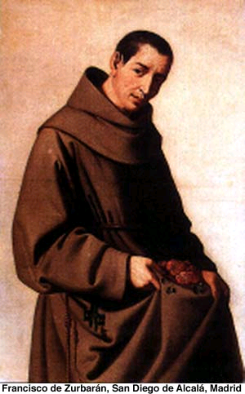
Didacus was born of very humble parents. He felt called to religious life and entered the Franciscan convent at Arizafa where he was professed as a lay brother. In 1445, however, he was sent to the Canary Island of Fortaventura as Superior – which was very much unheard of for lay brothers in those days. Yet, he was known for his zeal and his holiness and it was an excellent decision. He returned to Rome for the canonisation of St Bernardine in 1450 and became the infirmaian at Ara Coeli where it is believed he performed a miracle of healing. He spent the last years of his life in solitude and contemplation, dying in Alcalá, Spain, in 1463.

(A reading from ‘The Deeds of Blessed Francis and his Companions’)
There was a Master of the Dominican Order who had serious doubts about the virginity of Mary – how could she possibly be virgin and mother? So, hearing that Brother Giles was a holy man, he went to him with this conundrum. Taking his staff, Giles struck the earth, “O Friar Preacher, a virgin before the birth!” and immediately a white lily sprung up from the ground. Taking his staff again, Giles struck the earth, “O Friar Preacher, a virgin during the birth!” and a second lily sprung up. For a third time, Giles struck the earth saying, “O Friar Preacher, a virgin after the birth!” and a third lily sprouted. Giles fled, leaving the Dominican convinced.

Lord, let us go to the holy to help us in our doubts about faith. May our faith be galvanised by the lives of the holy people that we encounter.

Saturday Nicolas Tavelic and Co. 14 November 2009
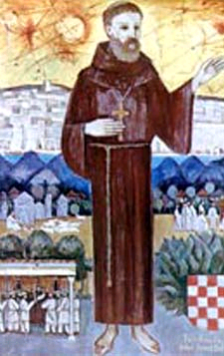
Nicholas and his three companions are among the 158 Franciscans who have been martyred in the Holy Land since the friars became custodians of the shrines in 1335. Nicholas was born in 1340 to a wealthy and noble family in Croatia. He joined the Franciscans and was sent with Deodat of Rodez to preach in Bosnia. In 1384 they volunteered for the Holy Land missions and were sent there. They looked after the holy places, cared for the Christian pilgrims and studied Arabic. In 1391 Nicholas, Deodat, Peter of Narbonne and Stephen of Cuneo decided to take a direct approach to converting the Muslims. On November 11, 1391, they went to the huge Mosque of Omar in Jerusalem and asked to see the Qadi (Muslim official). Reading from a prepared statement, they said that all people must accept the gospel of Jesus. When they were ordered to retract their statement, they refused. After beatings and imprisonment, they were beheaded before a large crowd. Nicholas and his companions were canonized in 1970. They are the only Franciscans martyred in the Holy Land to be canonized.

(A reading from ’The Franciscan Sayings’ by Bartholomew of Pisa)
When Brother Giles came to Assisi, the friars took him around their friary showing him the many splendid buildings they had erected for themselves, obviously with some pride. Brother Giles turned to the friars and said, “Well done, brothers – all you lack now is wives!” They were deeply shocked and panicked. Giles said, “It is the same thing to give up poverty as to give up chastity – after throwing poverty overboard, it is easy enough to throw chastity as well.”

Lord, make us consistent in our dealings with others. May we be true witnesses to the lives we profess and vow ourselves to your constant service.

