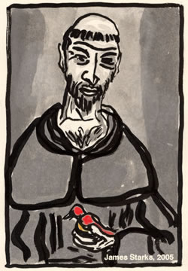
“Praised be you, My Lord, through all your creatures!”
Franciscan Readings for
Week Commencing
7 October, 2007
Twenty-Seventh Week of Ordinary Time - C

Sunday 7 October 2007
(A reading from ‘A Letter On The Passing of St Francis’ attributed to Elias of Assisi)
What I feared has overtaken me and has overtaken you. And what I dreaded has happened to me and to you. Our consoler has gone away from us and he who carried us in his arms like lambs has gone on a journey to a far-off country. He who was beloved of God and of humanity, who taught Jacob the law of life and of discipline, and gave to Israel a covenant of peace has been received in to most resplendent dwellings. We should rejoice on his account and yet darkness surrounds us and the shadow of death covers us.
In truth, the presence of our brother and father Francis was a light, not only for us who were near, but even to those who were in darkness and sitting in the shadow of death, to guide our feet into the way of peace. By preaching the kingdom of God and turning the hearts of our fathers to their children and the rebellious to the wisdom of the just, he prepared for the Lord a new people in the world. His name reached distant coasts and all lands were in awe at his marvellous deeds.

Lord, death is bittersweet when those we love die – we should rejoice and yet darkness utterly surrounds us. Help us to find comfort in the Christian lives of those who have passed from this world.

Monday 8 October 2007
(A reading from ‘A Letter On The Passing of St Francis’ attributed to Elias of Assisi)
God, the father of orphans, will give us comfort and holy consolation. And, if you weep, weep for yourselves and not our brother Francis. For “in the midst of life, we are caught in death”, while he has passed from death to life. After telling you these things, I announce to you a great miracle, never seen before or heard of since the dawn of time except in Jesus Christ, who is Christ our Lord.
Not long before he died, our brother and father appeared crucified, bearing in his body the five wounds which are truly the marks of Christ. His hands and feet had, as it were, the openings of the nails and were pierced front and back, revealing the scars and showing the nails’ blackness. His side, moreover, seemed opened by a lance and often emitted blood. There was no beauty in this man and yet his spirit was alive with this gift. When he died, his skin became dazzling white and his limbs became pliable like those of a child.

Lord, when we come to you, we will be made whole as on that first dawn of creation. Give us hope to hold on to your promise of life eternal.

Tuesday 9 October 2007
(A reading from ‘A Letter On The Passing of St Francis’ attributed to Elias of Assisi)
Hold fast to the memory of our father and brother, Francis, to the praise and glory of him who made him so great among people and gave him glory in the sight of angels. Pray for him, as he begged us, and pray to him that God may make us share with him in his holy grace.

Lord, our memories are not long but throughout our lives, let us always remember those saints whom we have known and have gone to heaven. May they intercede for us to the Father.

Wednesday 10 October 2007
(A reading from ‘The Sermon on the Feast of the Transferal of the Body of St Francis’ preached at Paris, 25 May, 1267 by St Bonaventure)
Jesus calls St Francis his ‘friend’ for a number of reasons. Due to his humble spirit in all that was committed to him, he was a faithful friend of Jesus; because of his utter purity of heart, he was a congenial friend of Jesus; on account of the serenity of his contemplative soul, he was an intimate friend of Jesus; and, finally, because the marks of Christ’s cross were imprinted on his body, he became conformed to the likeness of his friend, our Lord, Jesus Christ.

Let us ask the Lord to give us in this life that grace to buy that pearl so that, together with St Francis, we may obtain the reward of the heavenly kingdom. May he grant us this, who lives and reigns for ever and ever. Amen.

Thursday Pope John XXIII 11 October 2006
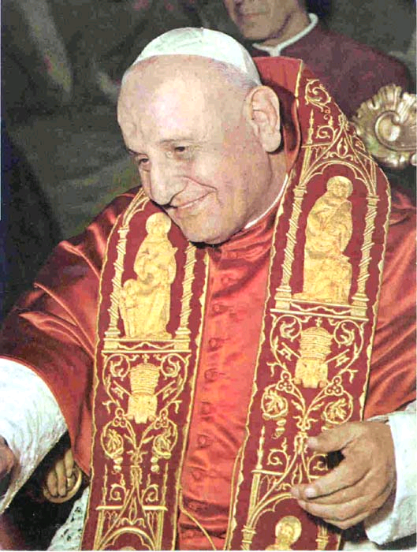
Angelo Roncalli celebrates his feast today as Blessed John XXIII. Born in 1881 to a sharecropping family, Angelo was ordained at the age of twenty. He was given a sequence of jobs that involved a great deal of responsibility. Angelo had a reputation for good humour, kindness and a childlike spirit. With the death of Pope Pius, Angelo was elected Pope John XXIII in 1958 much to his surprise. A highly politicised election had taken place that, due to Pope John’s advanced age, saw the need for a ‘stop-gap’ Pope until Montini could be raised the cardinalate (he later became Pope Paul VI). Indeed, the quiet life was about to come to an abrupt end when the old ‘stop-gap’ Pope started making known his push for aggiornamento and kicked off the Second Vatican Council, one of the most controversial periods of the Catholic Church’s history. He was a remarkably charismatic man, warm and friendly. Many stories are told of his wit and humour – he was notoriously once asked at a press conference “How many people work in the Vatican?” to which he replied, “About half.” On being drilled in protocol for the visit of the US President’s wife, especially to address her as Madame Mrs President, upon seeing her, Pope John dropped his crosier and opened his arms wide saying, “Jackie!” He died of stomach cancer in 1963.

(A reading from The Evening Sermon on St Francis, preached at Paris on 4 October 1262 by St Bonaventure)
We admire the heavens because of their vast extent. They contain all things. St Francis can be likened to this feature of the heavens of his all-embracing love which went out to everyone. Love embraces all that love commands, but such love is found only in the virtuous. It was through love that Christ humbled himself and underwent death. St Francis had love without limit for everyone. Love spends itself for sinners without counting the cost. St Francis was not content with preaching God’s word only to the Christian faithful who listen with glad hearts and accept it willingly. He even went to the Saracens to proclaim the gospel in the hope that he might be put to death for his faith in Christ and so become a martyr. How is it that we, wretched as we are, have such cold hearts that we are not prepared to endure anything for our Lord’s sake?

Lord, when was the last time we endured something for your sake? Give us the courage to be patient in suffering and signs of your lasting hope for the world.

Friday 12 October 2007
(A reading from ‘The Morning Sermon on St Francis’ preached at Paris, 25 May, 1267 by St Bonaventure)
The root of perfect holiness lies in deep humility, its loftiness in well-tried virtue, and its radiance in consummate love. Endowed with deep humility we are sustained by God; by well-tried virtue, we are made pleasing to him; and in consummate love we are taken up to God and brought closer to our neighbour. Who, then, is such a perfect saint? It is the person endowed with deep humility, well-tried virtue and consummate love.

Lord, make us saints in heaven but, more importantly, saints on earth. Brings us out of our doughy holiness and into active love of our enemy and our neighbour alike.

Saturday 13 October 2007
(A reading from The Lauds by Jacopone da Todi)
This is the mission of love, to make two one;
it unites Francis with the suffering of Christ.
It was Christ in his heart that taught him the way
and that love shone forth in his robe streaked with colour.

The burning love of Christ, whose depths are lost to sight,
enfolded Francis, softened his heart like wax,
and there pressed its seal, leaving the marks
of the One to whom he was united.

I have no words for this dark mystery;
how can I understand or explain
the super-abundance of riches,
the disproportionate love of a heart on fire?

