FRANCIS AND CLARE OF ASSISI

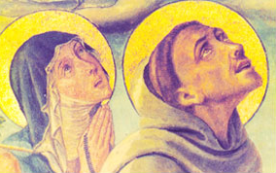

https://www.youtube.com/watch?v=ick5rGLvEjk

