**AMAZING NATURE**

**“Whatever St Francis found in creatures redounded to the praise of the Creator, while all creatures led him to the praise of God.”**

**(Aquasparta, *St Francis*, Sermon 1)**

The Skeleton Flower, Whose Petals Turn from White to Translucent When It Rains

This Is What A 350-Year-Old Oak Tree Looks Like. Isn't It Beautiful?

Turtle's Shell Looks Like a Fireworks Display

An Owl with Heart-Shaped Patterns on Its Feathers

Eruption On Mount Etna (Sicily) Gives the Illusion of a Phoenix in The Sky

Looks Like Stained Glass

The Endangered Mexican Alligator Lizard

Bald Eagle's Nest with A Ranger for Scale. Wow

A Golden Wavy Mouse

Algae Forms on The Head of The Mary River Turtle Making It Look Like a Punk

Stunning Forest Light

Mushrooms: Are Among the One Hundred Fungi Species That Are Bioluminescent. They Are Usually Found in Asia

The Chrysalis of The Metallic Mechanitis Butterfly from Costa Rica

Judas Tree - An Extraordinary Tree Whose Flowers Grow Straight from The Trunk

Rebirth Of a Tree

Stephen Dunn Took This Incredible Photograph with His Flash Illuminating a Spider and Revealing Its Wet Web with A Rainbow Effect

Everlasting Love

The Stunning Helleborus Black Beauty

Amazing Artwork of The Nature

Ghost Fire in The Sky Near Franklin, WV

Heirloom Black Carrot Nebula

"Glass Gem" Or Pearl of Glass

This variety of corn is one of the most original, it produces translucent and kaleidoscopic seeds. It is in the years 1980 that Carl Barnes farmer of Oklahoma, managed to give birth to this variety. By crossing three other varieties of corn resulting from Indian cultures... It is edible and used in the form of flour in general...

Stunning Catasetum "Epiphytic Orchids". How Adorable!

Prairie Smoke Flowers (Geum Triflorum). Looks Like Cotton Candy!

This Creature Is a Saturniidae Moth Caterpillar

Beautiful Natural Rainbow Fluorite Is Just Bands of Different Colours

These Are Skeleton Panda Sea Squirts, Also Known as Ascidians. They're Marine Invertebrate Filter Feeders That Will Probably End Up in A Tim Burton Film at Some Point

Beautiful Rare Black Baccara

This Is What a Baby Flounder Looks Like

The Satanic Leaf-Tailed Gecko

Stunning Black Beauty Sunflower!

Sailfish Have Been Clocked at Speeds in Excess Of 68mph/112km, Some Experts Consider the Sailfish the Fastest Fish in The World's Oceans

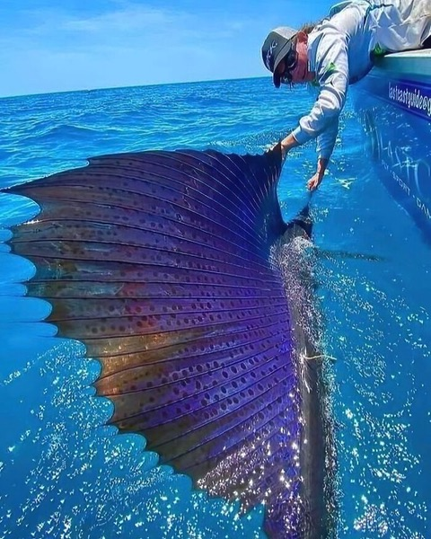

Turtles

Incredibly Detailed Photograph of Our Sun

A Very Geometric Spiderweb

Beautiful Blue Poppies in The Rain

How Beautiful Is This Peacock

Stunning

The Gorgeous Black Calla Lily

The Stunning Golden Tortoise Beetle. Also Known as Charidotella Sexpunctata, It Is Part of The Leaf Beetle Family, Chrysomelidae and Native to The Americas

The 'Hungry Tree', Slowing Devouring a Park Bench in Dublin, Ireland

The World's Biggest Flower, Rafflesia Arnoldii, West Sumatra, Indonesia

Indeed, the largest flower but also the smelliest! And, to the human nose, not in a good way: its gigantic petals emit a putrid scent like rotting flesh to attract pollinators and prey.

Blue-Eared Kingfisher

A Real-Life Dragon! The Five-Banded Gliding Lizard Has Modified Ribs That Extend into A Wing Membrane

So, Some Bees Decided to Make a Hive In Between The Window and The Shutters

This Is What a Peacock Spider Looks Like

Fluffy boy At the Beach

Indian Giant Flying Squirrel in The Air in Broad Daylight!

Valonia Ventricosa, The Largest Single-Celled Organism on Earth. Yep, This Is a Single Living Cell

Glass Frog, Photo by Peter Grob

"Rhodotus Palmatus, Aka The Wrinkled Peach

Rhodotus is a saprobic mushroom, meaning it feeds off of dead organic matter, specifically fallen hardwood logs. It has a circumboreal distribution, and can be found in North America, Europe, North Africa, as well as Asia. It is most likely to fruit during cooler temperatures after long periods of rainy weather. This beauty is not edible and hard to find, but wow what a cool looking mushroom!"