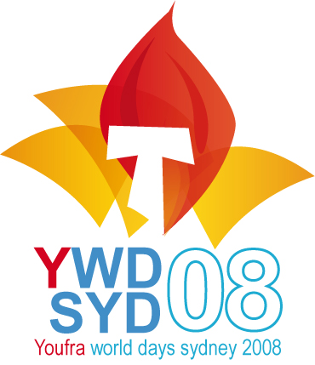
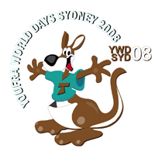
YOUFRA INTERNATIONAL GATHERING
Sydney 12-15 July 2008

and WYD 15-20 July 2008

I had the joy to attend to the Youfra international gathering, which took place in Sydney during the three days before World Youth Day. This meeting gathered Franciscan Youths from the United States, Vietnam, Philippines, Congo, South Africa, Italy, Croatia, Slovenia, Lithuania, Spain, Australia and France.

We were welcomed in the St Francis of Assisi school and parish in Paddington in Sydney, where the parishioners received us as kings. It was besides a very good place really close to all WYD events.

The meeting began with the holy mass during which each Youfra laid the flag of his country in front of the altar, this was the first manifestation of the wealth of our diversity. All in the gathering was joy and good mood especially during the first evening where each group presented us a song, a game or an animation to introduce his country.

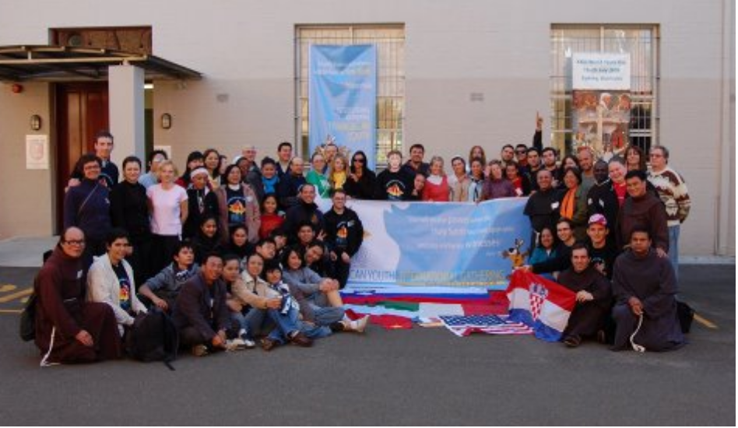

I really feld that we were all illuminated with the same Franciscan spirit, and this despite our differences . Indeed each Youfra evolve in very different contexts, from the Youfra of Italy which celebrated its 60th birthday, to Vietnam, where despite of a religion control and a catholic rate of only 6%, the Youfra count 4000 members.
It was great to find people who we hadn't seen before, but with who we have a lot in common because we share the same life's foundation : Jesus's love and St Francis spirit.

The functioning of these Youfra is also a bit different. For instance my Youfra in France pay manly attention to the formation and evangelisation, whereas other Youfras are manly oriented to the help to the poorest, as in Italy where they share every month a meal with poor people and in Croatia where, besides their weekly meeting, they lead every month a mass in an hospital.

During our meetings, the international supervisor of Youfra, Xavi Ramos, remind us the importance of the link between Youfra and the SFO. Every Youfra must have one person, different of the supervisor of the group, to be the reference of the SFO, in order to pass its experience on Youfra ; the OFS must also be suggested to young people as a continuity of what they live in Youfra. Moreover the Youfra must receive an spiritual assistance from the OFM or the TRO.
The community is the most important part of the Youfra in order to celebrate the joy and live the Franciscain way of life, but this community needs availability from its members.
The Youfra shouldn't be a closed group, it must be visible and the local church must know that it exist. Xavi told us also his wish to increase the sense of fraternity on the international plan. It would be also great to have a same terminology, a same hymn, a same formation and the same commitment texts. He also affirm the importance of such international meetings.

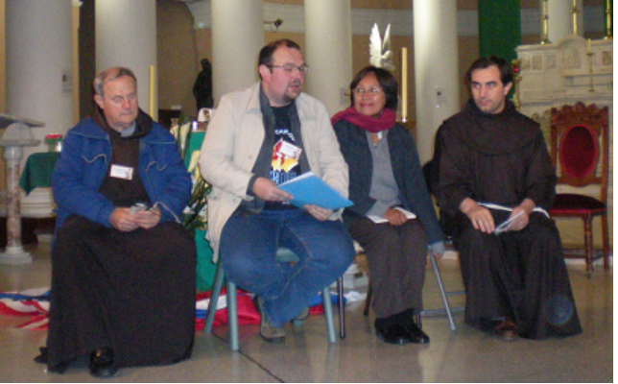
During the gathering we got a little speech form the international Youfra assistant, Ivan Matic OFM. He told us that God must be the only conductor of our life. He began with a beautiful practical demonstration of the utility of a conductor in conducting our applauses and then he explained us that if we have several conductors, that means several gods (money, sex,...) it is impossible to know which one to follow and we get lost ; but if we have the simplicity to follow only the word of God, the way will light up and we will be able to choose the right way.

After this gathering, we stayed together to take part to the week of WYD. This allowed us to learn to know us each other and to built links with brothers in Saint Francis. Our group attended notably to a worldwide franciscain gathering which took place on one of the lovely beaches of Sydney. We took part together the important events of WYD, which were the opening mass with the cardinal Georges Pell, the catechesis, the daily mass, the stations of the cross played by actors in Sydney's streets, and the peak of our week, the evening and the final mass with the Holy Father.
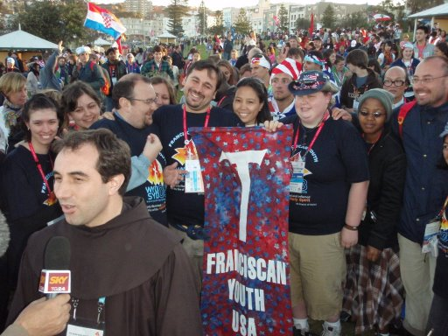
Deo gratias for all these graces received in Sydney !

Jean GEOFFROY
Youfra of France.

