Pets can lead to heaven: Franciscan friar

Published: October 06, 2008
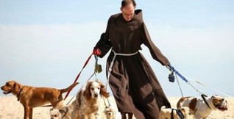Pets can be our ladders into heaven, Friar Matthew Hufer said yesterday at a blessing ceremony for pets at Port Melbourne beach in a celebration for the Feast of St Francis of Assisi.
As part of celebrations for the Feast of St Francis of Assisi, renowned for his love of animals, the City of Port Phillip and Kilbride ecumenical centre invited pet owners to a blessing ceremony at the Port Melbourne Lifesaving Club, The Age reports.
Matthew Hufer, a friar from St James of the March Friary in Box Hill, blessed hundreds of dogs, and their owners, for long lasting life and good health.
Despite the invitation, most other animals stayed away from the blessing, with word going around that most cats had decided to stay home and bask in the sunshine. But there was a pair of rabbits that popped out of their box in time to be blessed with the holy water.
Br Hufer was joined at the ceremony by Buddhist nun Carolyn Lawler, who shared the Dalai Lama's mantra of universal compassion.

Using readings from the Bible to demonstrate how important animals could be in people's lives, Br Hufer said God did not discriminate between his creations.
Yesterday's blessing was the eighth such event. Councillor Dick Gross said it was important to promote the role pets played in keeping their owners in good health and good spirits.
SOURCE
Friar takes the lead in lauding God's creatures (The Age, 6/10/08)
LINKS
St Francis of Assisi (Wikipedia)

