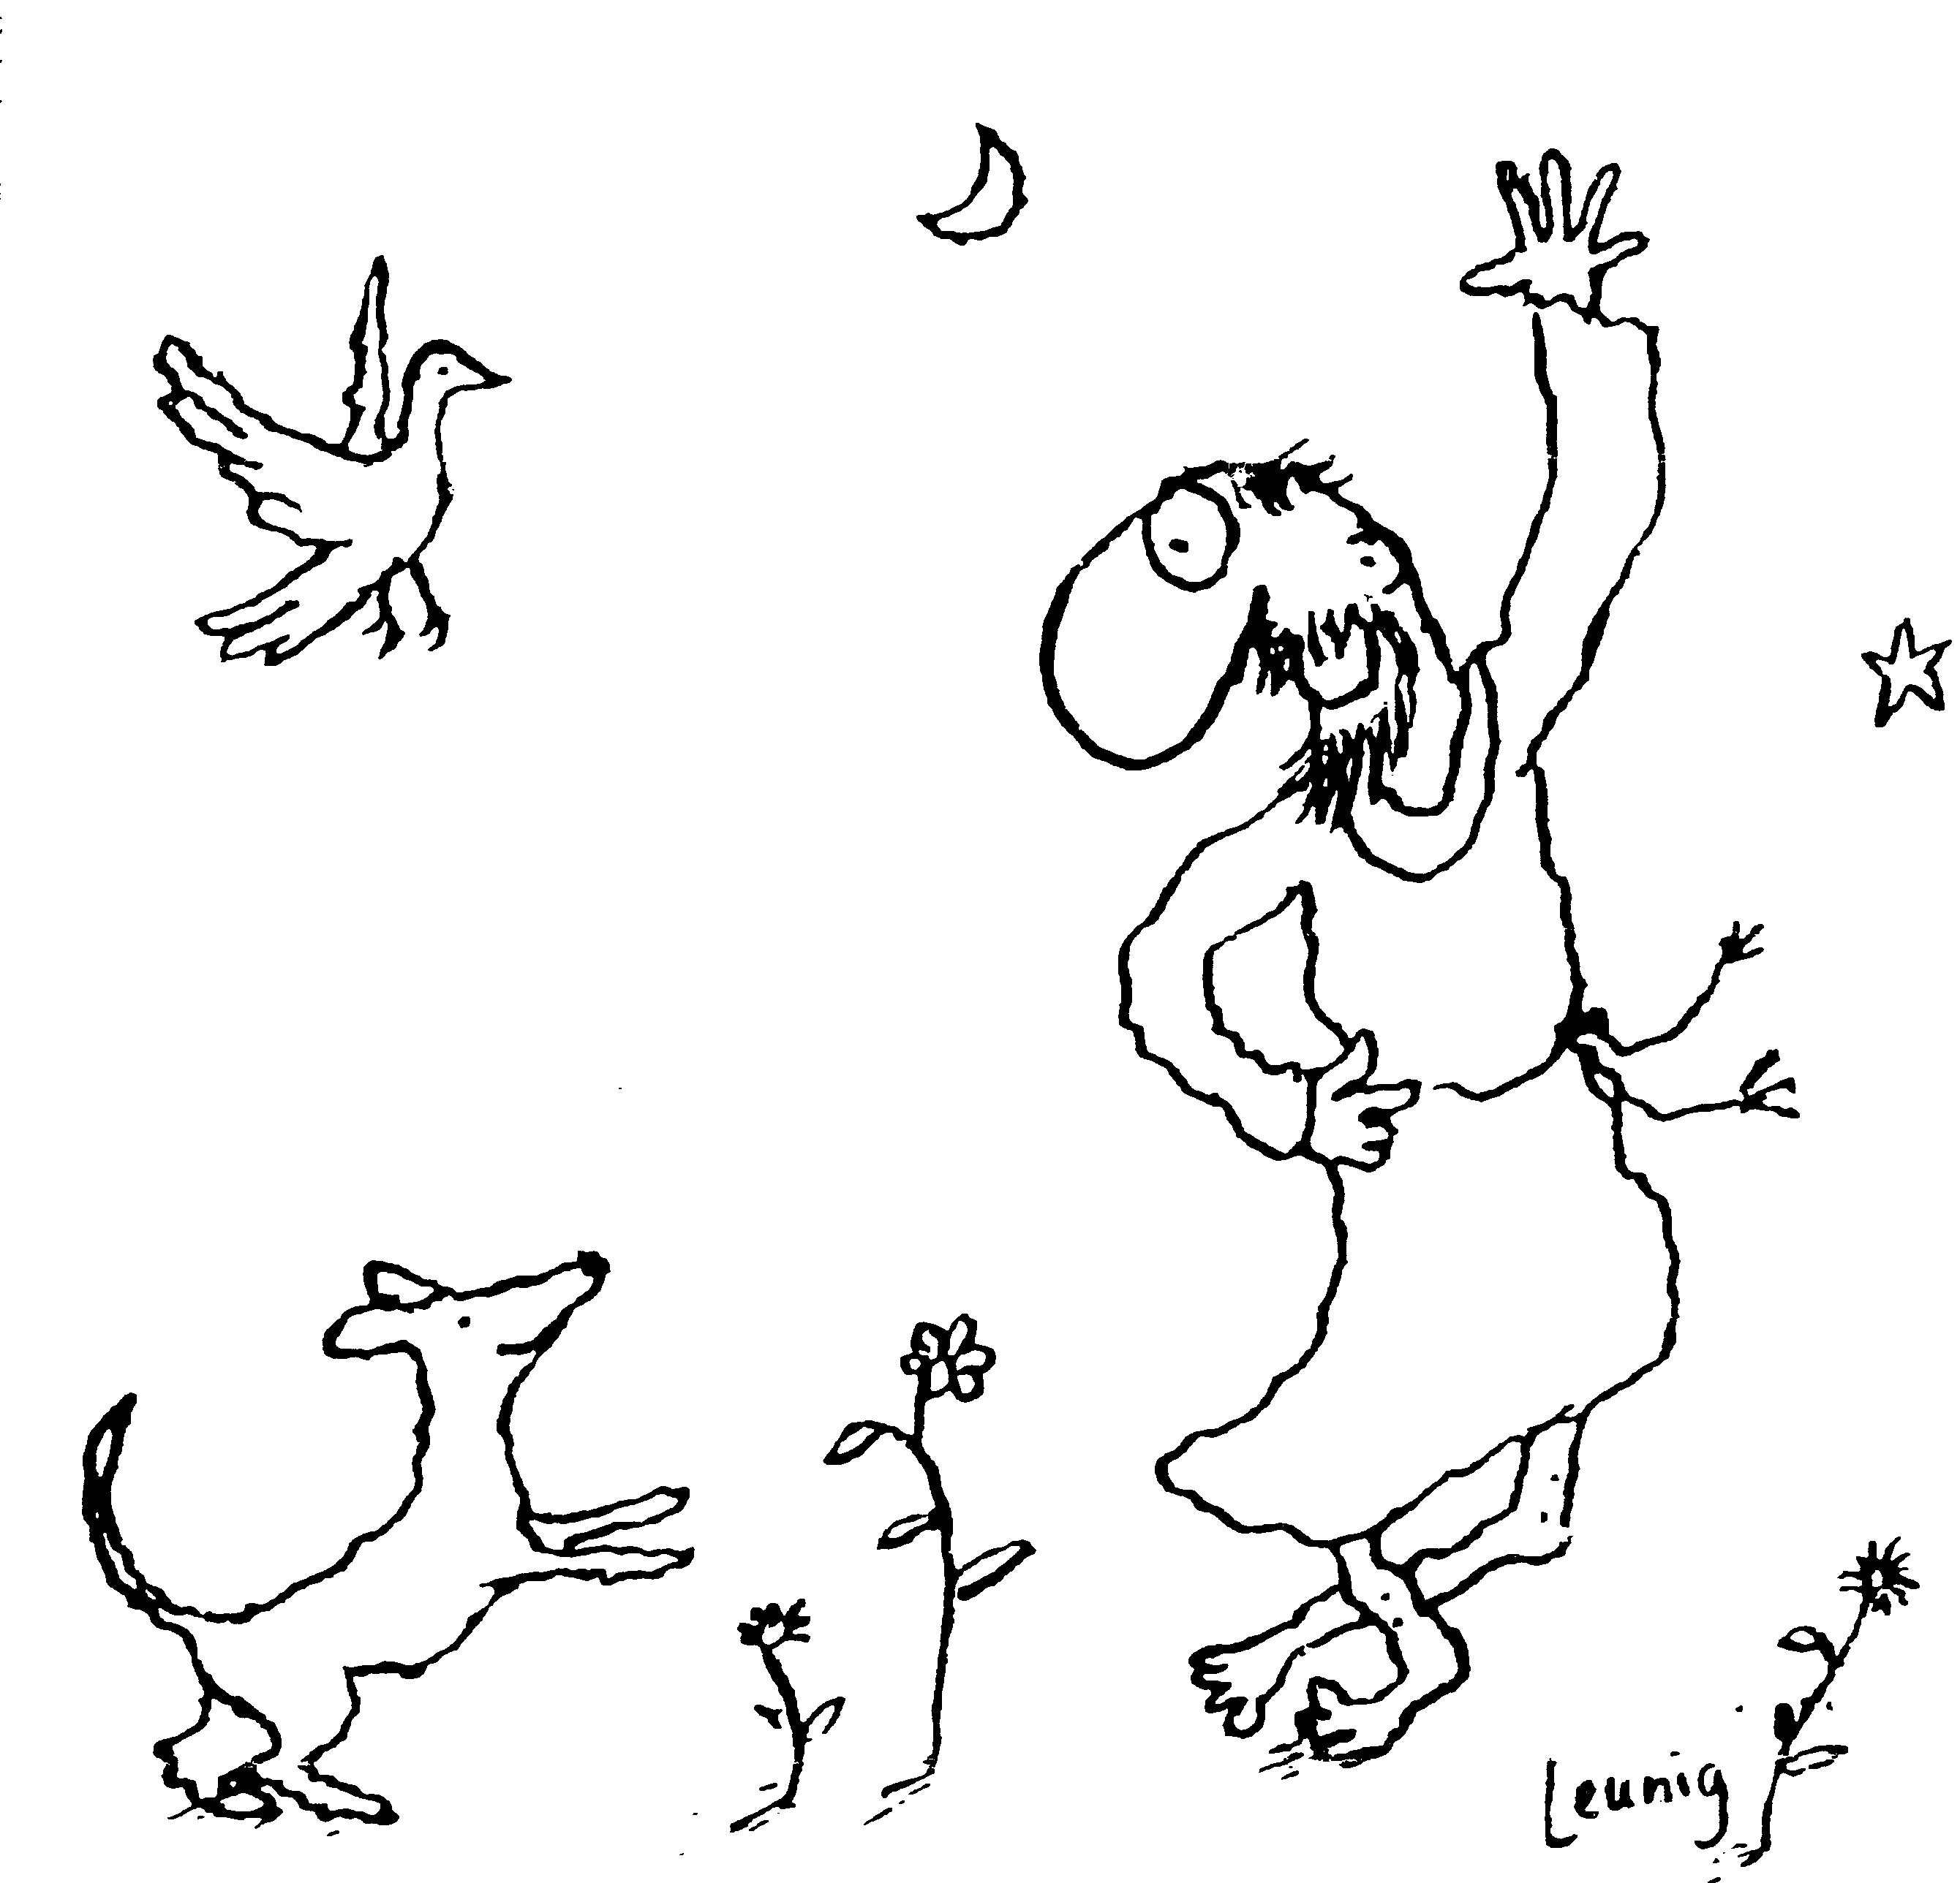
“Praised be you, My Lord, through all your creatures!”
Franciscan Readings for
the Week Commencing
29th April, 2007
4th Week Easter – C/1

Sunday 29 April 2007
(A Reading from the Fioretti)
Francis and Leo were in a place where they did not have books for saying the Divine Office. “Since we don’t have breviaries, I will speak and you respond as I teach you – regardless what I say in praise of God, you will respond only as I tell you. Leo, when I say, ‘O, Brother Francis, you have done so many evil things and so many sins in the world that you are worthy of hell,’ you must reply, ‘That’s true: you deserve the lowest place in hell.’” Leo agreed in all simplicity. Yet, with every moment that Francis reproached himself, Leo would describe the great joys Francis would receive when he went to heaven. “Leo!” Francis cried, “why don’t you respond as I have asked? Why do you keep disobeying me?” “Surely,” Leo said, “God has put it in my heart only to the speak the truth of you – that you will receive grace and be exalted forever.”

Lord, let us forget our pride and our vanity and be honest with ourselves. Let us rejoice in our strengths and be forgiven for our weaknesses. May we respond to your shepherding call and be beacons of your love for all.

Monday 30 April 2007
(A reading from a medieval Franciscan manuscript)
Francis and Leo went out preaching and, after a while, Leo started to become weak with hunger. So, Francis went in to a nearby vineyard and took a bunch of grapes to give to Leo. The farmer saw Francis do this and was infuriated, beating Francis with many blows. As they went on their way afterwards, Francis was whingeing about the beating he had incurred. He said, “Brother Leo has well eaten, but Brother Francis has been well beaten. Brother Leo has had a good meal, but Brother Francis, with his body, well paid for it.”

Lord, you give us many chances to give something to others for free, without hooks. May we be the first to give the bonus, the free gift, of ourselves to others, a gift that does not need repaying. Let our generosity be a sign of your grace.

Tuesday 1 May 2007
(A reading from a medieval Franciscan manuscript)
Brother Leo would refer to a friar of such holiness that he was on a par with the apostles. Yet in the end he left the Order. In the world, that ex-friar still gave an example of holiness. One day when the friars were walking on the way, they were discussing why that friar had left the Order. Francis said, “I am going to read something and ask myself some questions which I myself will answer.” And then he said the word ‘Humility’, which he repeated three or four times. Then ‘Chastity’, ‘Abstinence’, ‘Poverty’. And in this way he ran through many virtues, to each he asked himself , “Do you know that?” and answered “Yes, I know that.” Finally, Francis said ‘Fear’ and, after a while, admitted that he knew fear. “It is useless for a man to seek all virtues and leave out Fear,” he said, “yet few have it, and therefore it is hard to teach them.” And finally, “It was because he had no Fear that this friar left the Order.”

Lord, you come to terrify and disturb us. Let us be still in our fear, trusting always in your loving-kindness

Wednesday Athanasius 2 May 2007
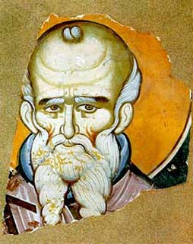
Born in 296, Athanasius was the biggest champion of the Catholic belief in the Incarnation throughout all history, earning himself the name “Father of Orthodoxy”. These were dangerous times in the church with the persecutions of Maximium in 303, the witness of which Athanasius was traumatised having been a young boy. The story goes that when the Bishop, Alexander, was waiting for guests, he looked across to the shore and saw some boys irreverently pretending to baptise each other. When he went down to speak with them, he discovered the boy playing the bishop was, in fact, Athanasius.

A reading from the Fioretti)
When Francis was seriously ill and Brother Leo was taking care of him, Brother Leo had a vision of a great river and he saw many friars with heavy loads trying to cross it. But because of the turbulence of the river and the loads carried by the friars, they fell in and drowned. The friars carrying nothing had no trouble crossing the river of Brother Leo’s dreams.
“What you saw is true,” said Francis, “the great river is the world; the brothers who drowned in the river are those who do not follow their evangelical profession especially in regard to poverty. Those who crossed without danger are those who neither seek nor possess anything but are content having only basic food and clothing, following Christ naked on the Cross.”

Lord, how much do we need? You are all-providence and have given us life, the greatest gift. May we turn our thoughts away from the transient and focus on what lies ahead – the kingdom of your gentle reign.

Thursday Philip And James 3 May 2007
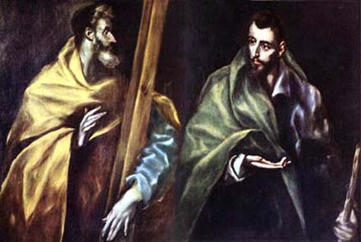
As in the case of the other apostles, we see in James and Philip human men who became foundation stones of the Church, and we are reminded again that holiness and its consequent apostolate are entirely the gift of God, not a matter of human achieving. All power is God’s power, even the power of human freedom to accept his gifts. “You will be clothed with power from on high,” Jesus told Philip and the others. Their first commission had been to expel unclean spirits, heal diseases, announce the kingdom. They learned, gradually, that these externals were sacraments of an even greater miracle inside their persons—the divine power to love like God.

(A reading from the “Remembrance of the Desire of a Soul” of Thomas of Celano.)
When Francis was secluded in a cell at La Verna, Leo was yearning with great desire to have something encouraging from the words of our Lord, commented on briefly by Francis written in his own hand. Leo suffered from a great temptation and believed that consolation from Francis was put pay to this. So Francis jotted down a reflection on scripture. On the back of the parchment, he wrote a personal blessing for Br Leo. He told him to hold on to it forever.

Lord, your blessings are abundant. How often do we bless each other? Let us find ways of blessing the small things of life and canonising the saints in our midst.

Friday 4 May 2007
(A reading from ‘A Letter to Brother Leo’)
Brother Leo, health and peace from Brother Francis!
I am speaking in this way – as a mother would – because I am putting everything we said on the road in this brief message and advice. If, afterwards, you need to come to me for counsel, I advise you thus: In whatever way it seems better to you to please the Lord God and to follow his footprint and poverty, do it with the blessing of the Lord God and my obedience. And if you need and want to come to me for the sake of your soul or for some consolation, Leo, come.

Lord, we all suffer and we all hurt. In our pain, we discover your mercy. May we be your source of mercy and compassion to those who suffer in our midst – not just the poor and destitute but the sufferers close to us.

Saturday 5 May 2007
(A Reading from “A Mirror of Perfection of a Lesser Brother”)
Once, the Lord Jesus Christ said to Brother Leo, the companion of blessed Francis, ‘Brother Leo, I have a complaint about the brothers.’ ‘About what, Lord?’ Brother Leo replied. ‘About three things: they do not recognise my gifts which, as you know, I generously and abundantly bestow on them daily, since they neither sow nor reap. All day long they are idle and complain. And they often provoke one another to anger, and do not return to love, and do not pardon the injury they receive.’

Lord, what legacy will we leave behind for others? May we be mindful of the impression our lives will make.

