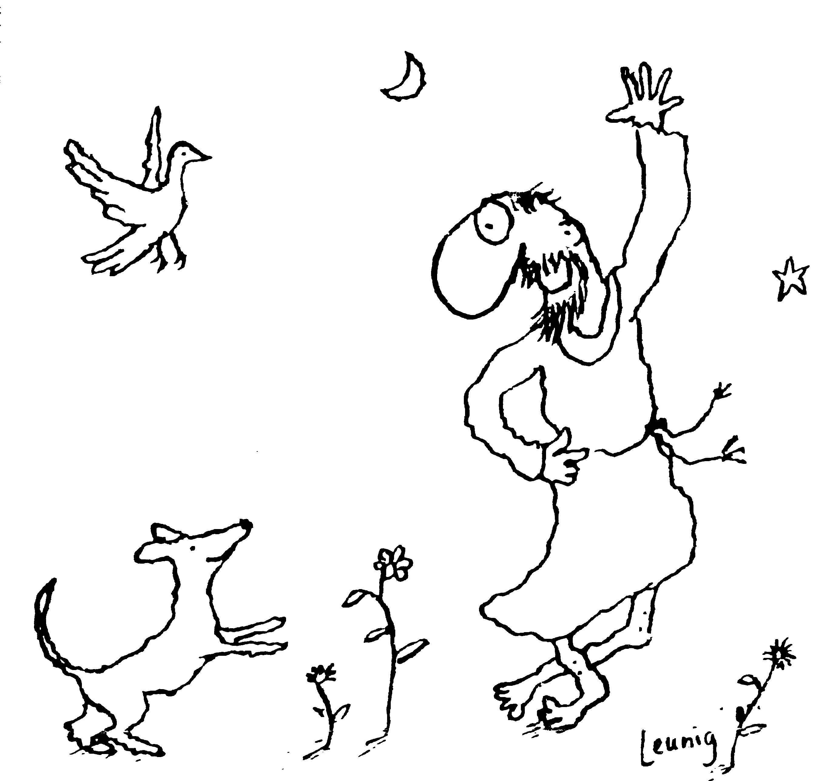
“Praised be you, My Lord, through all your creatures!”
Franciscan Readings for
the Week Commencing
21st January, 2007
3rd Week in Ordinary Time – C/1

Sunday 21 January
(A Reading from the Legend of the Three Companions)
When Francis and the other brothers arrived in Rome and found the Bishop of Assisi there, they were welcomed with great joy. Not knowing why they were in Rome, the Bishop became anxious that they had come here to leave their homeland permanently, where the Lord had begun to work marvels through them. He rejoiced at having them in his Diocese, men of such life and conduct. When he learned that they were in Rome to seek approval from the Pope, the Bishop was overjoyed and promised them every assistance.
The Bishop was known to the Cardinal of Sabina, Lord John of St Paul. Upon hearing of the works of the friars, the Cardinal was anxious to meet them. He sent for them and welcomed them with love.

Lord, you once asked Francis – “who can help you more – the Master or the Servant?” May we place our faith in our ultimate Master and all-good God, regardless of how flagging our hopes may become.

Monday 22 January
(A Reading from the Legend of the Three Companions)
The friars were staying in Rome of Cardinal John of St Paul. The Cardinal was so impressed with their words and their holiness that he commended them to his prayers. He even asked Francis if he may be considered one of these little brothers. On meeting Pope Innocent III, Cardinal John of St Paul told the Pope of his encounter with the friars. “These men,” he said, “will reform the faith of the holy church throughout the world.” He told him of their evangelical life. The Pope was amazed and asked that Francis be brought to him.

Lord, our desire to impress others is strong, especially the mighty and influential. May our good acts shine out for their own sake and may we be an example of your Word in the world to everyone equally.

Tuesday Timothy and Titus 23 January
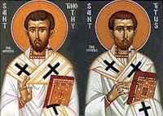
These two companions of St Paul, with Silas, were pivotal in the mission of the Church, especially around Ephesus. Timothy had a Greek father and a Jewish mother named Eunice. Being the product of a “mixed” marriage, he was considered illegitimate by the Jews. It was his grandmother, Lois, who first became Christian. Timothy was a convert of Paul around the year 47 and later joined him in his apostolic work. He was with Paul at the founding of the Church in Corinth. During the 15 years he worked with Paul, he became one of his most faithful and trusted friends. He was sent on difficult missions by Paul—often in the face of great disturbance in local Churches which Paul had founded. Timothy was with Paul in Rome during the latter’s house arrest. At some period Timothy himself was in prison (Hebrews 13:23). Paul installed him as his representative at the Church of Ephesus. Timothy was comparatively young for the work he was doing. (“Let no one have contempt for your youth,” Paul writes in 1 Timothy 4:12a.) Several references seem to indicate that he was timid. And one of Paul’s most frequently quoted lines was addressed to him: “Stop drinking only water, but have a little wine for the sake of your stomach and your frequent illnesses” (1 Timothy 5:23).
Titus has the distinction of being a close friend and disciple of Paul as well as a fellow missionary. He was Greek, apparently from Antioch. Even though Titus was a Gentile, Paul would not let him be forced to undergo circumcision at Jerusalem. Titus is seen as a peacemaker, administrator, great friend. Paul’s second letter to Corinth affords an insight into the depth of his friendship with Titus, and the great fellowship they had in preaching the gospel: “When I went to Troas...I had no relief in my spirit because I did not find my brother Titus. So I took leave of them and went on to Macedonia.... For even when we came into Macedonia, our flesh had no rest, but we were afflicted in every way—external conflicts, internal fears. But God, who encourages the downcast, encouraged us by the arrival of Titus...” (2 Corinthians 2:12a, 13; 7:5-6).
When Paul was having trouble with the community at Corinth, Titus was the bearer of Paul’s severe letter and was successful in smoothing things out. Paul writes he was strengthened not only by the arrival of Titus but also “by the encouragement with which he was encouraged in regard to you, as he told us of your yearning, your lament, your zeal for me, so that I rejoiced even more.... And his heart goes out to you all the more, as he remembers the obedience of all of you, when you received him with fear and trembling” (2 Corinthians 7:7a, 15).
The Letter to Titus addresses him as the administrator of the Christian community on the island of Crete, charged with organizing it, correcting abuses and appointing presbyter-bishops. Timothy died in 97ad, three years after Titus

(A Reading from the Legend of the Three Companions)
Francis was taken before the Pope to whom he revealed his entire holy proposal, his way of life as revealed by God to him. The Pope, a man of discernment, assented to Francis’ request to go about the world preaching and living a life of simplicity. “Go, then Francis,” said Pope Innocent, “and when your number increases, return and we will grant you more and entrust you with a greater charge. But my young sons, your life seems to us exceptionally hard and severe. While we have no doubt that you can live it according to your zeal, we must take into consideration those who will come after you, lest this way of life seem too burdensome.” The Pope saw that their constancy of faith and the anchor of their hope were so firmly grounded in Christ, that they did not want to be shaken from their enthusiasm. “Know the Lord’s will, Francis, that we may acceded to your desires.”

Lord, we are tempted to jump on the bandwagon when opportunities arise for heroic displays. May our enthusiasm never flag for what is exciting and beneficial to others. May we enliven and ignite your spark in the hearts of the people we encounter on our adventures in life.

Wednesday St Francis de Sales 24 January
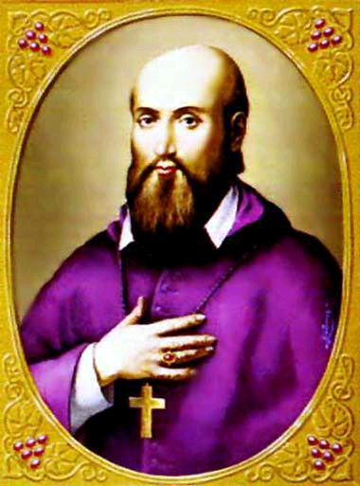
Born in 1567 in Savoy, Francis de Sales was the son of aristocratic parents. Francis was packed off to study with the Jesuits at Clermont in Paris. His father intended him to be a magistrate and had handpicked a nice heiress for his future partner. But Francis had other ideas and, after receiving an ecstatic vision in front of the miraculous image of Our Lady at St Etienne-des-Grés, he consecrated himself to chastity, giving his life to Mary. His father was very angry but, with the help of the Bishop, Francis was ordained in 1593. Eventually, Francis became the Bishop of Geneva with Pope Clement VIII telling him, “Drink, my son", said the Pope to him. "from your cistern, and from your living wellspring; may your waters issue forth, and may they become public fountains where the world may quench its thirst." With Jane Francis de Chantal, he founded the Visitation Sisters. His theological defences were based on the primacy of love and he was known to be a zealous yet kind preacher. He died in Lyons in 1622.

(A Reading from the Legend of the Three Companions)
There was once a beautiful woman who lived in the desert, whose beauty fascinated a great king. He married her and they had many fine sons. The mother said to her sons, “Do not be ashamed, for you are the sons of the king. Therefore, go to his court and he will provide for all your needs.” When they went to see the king, he was struck by their beauty and said, “Whose sons are you?” When they answered that they were the sons of a poor little woman who lived in the desert, the king said, “Do not be afraid, for you are my sons. If strangers are fed at my table, how much more will you, who are my lawful children?” He then order the woman to send to his court all of her children to be fed.

Lord, you speak to us in riddles that are sometimes unclear. May we identify you in the mundane things of life as well as the significant events. Let us be invested in discovering you daily.

Thursday Conversion of St Paul 25 January
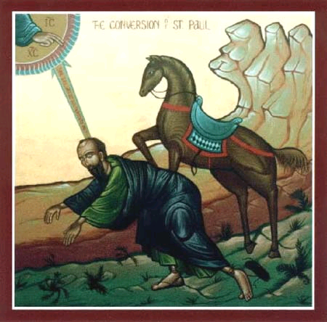
Paul (Saul) was from Tarsus, born around the year 20. His conversion story is legend. Paul was a Jew, a tentmaker and, it is said, a persecutor of the early followers of Jesus. He was not present at the stoning of Stephen as some believe. On his way to Damascus, Paul believed that Christ appeared to him. This occurred at a time when Paul was full of remorse, doubts, fears about his activities. "An excitable, nervous temperament; a soul that had been violently agitated and torn by the most terrible doubts; a most vivid phantasy, occupied with the awful scenes of persecution on the one hand and on the other by the ideal image of the celestial Christ; in addition the nearness of Damascus with the urgency of a decision, the lonely stillness, the scorching and blinding heat of the desert -- in fact everything combined to produce one of those ecstatic states in which the soul believes that it sees those images and conceptions which violently agitate it as if they were phenomena proceeding from the outward world" Pfleiderer wrote. Whatever about that, Paul’s faith in Christ drove him to change his life completely and he went on to become the most significant figure in the spreading of the Good News.

(A Reading from the Legend of the Three Companions)
The Pope had had a bad dream – he dreamt that the Church of the Lateran was threatening to collapse and a religious, small and of shabby appearance, was supporting it on his own shoulders. When he awoke, he was stunned and shaken. Then Francis arrived in Rome with his Rule. The Pope, being a thoughtful and slightly superstitious man, said to himself, “This is indeed that holy and religious man through whom the church of God will be sustained and supported.” And, embracing Francis, he approved his Rule of Life.

Lord, you send us signs and wonders. May we make time to reflect on the things that affect us and see the broader significance of our actions in the great panorama of life. Strike us with your magnificent light, bring us to conversion of heart, mind and spirit.

Friday AUSTRALIA DAY 26 January
It is the day when we give thanks to God for the Great Southern Land of the Holy Spirit, Australia. We give thanks for our people, the spirit of sticking together through hardship and achieving beyond expectations. We give thanks for our land, fragile and enduring, harsh and extreme, ancient and self-renewing. We give thanks for diversity, for those who live in the city and the country, for those from different cultures and backgrounds – we give thanks that we can be one people, living together. We give thanks for our indigenous cultures, the resilient spirit, knowledge, art and history of Aboriginal and Torres Strait Islander people who define our identity and culture. We give thanks for freedom and democracy, for our fundamental rights and responsibilities, for participation and equality. We give thanks for the egalitarian ethos of our society, where everyone is given a fair go, our compassionate society where all are identified as friend.

(A Reading from the Legend of the Three Companions)
The friars promised their obedience to the Pope. In return, the Pope gave them the tonsure, making eleven of them clerics. Francis left in rapture. He had once stood by a tall, strong tree and touching it, watched the powerful branches stoop to the ground. And so, Francis thus had touched the core of the Pope who had stooped low to give him approval for his way of life. He was full of the trust and hope of the Saviour who had led him, little Francis, among the mighty and powerful to get approval for their way of life. He had succeeded and now there was much to do.

Lord, good fortune comes to us at odd times. Help us to be people of faith and persistence, reaping good fortune for the labours we exert. May we take risks and place all our trust in your providence.

Saturday 27 January
(A Reading from the Legend of the Three Companions of St Francis)
Having gained approval from the Pope, Francis went from city to city preaching fearlessly and more perfectly the Kingdom of God. He spoke without the trickery of human thought but through the inspiration of the Holy Spirit. Strengthened by Apostolic authority, he was a speaker of the truth. He did not employ fawning words or seductive flattery because he first convinced himself by action and then others by words. A great number of educated people marvelled at his power and truth, which no human had taught, and they hurried to see him and to listen to him. Drawn by divine inspiration, many people, well-born and lowly, cleric and lay, began to cling to the footsteps of St Francis, and, after they had abandoned the concerns and vanity of the world, to live under his discipline.

Lord, you sent Francis as an example of the power of the truth. Help us to cling faithfully to his footsteps and to abandon the passing things of this world, our hearts set only on your kingdom and bringing it to birth again in our day.

