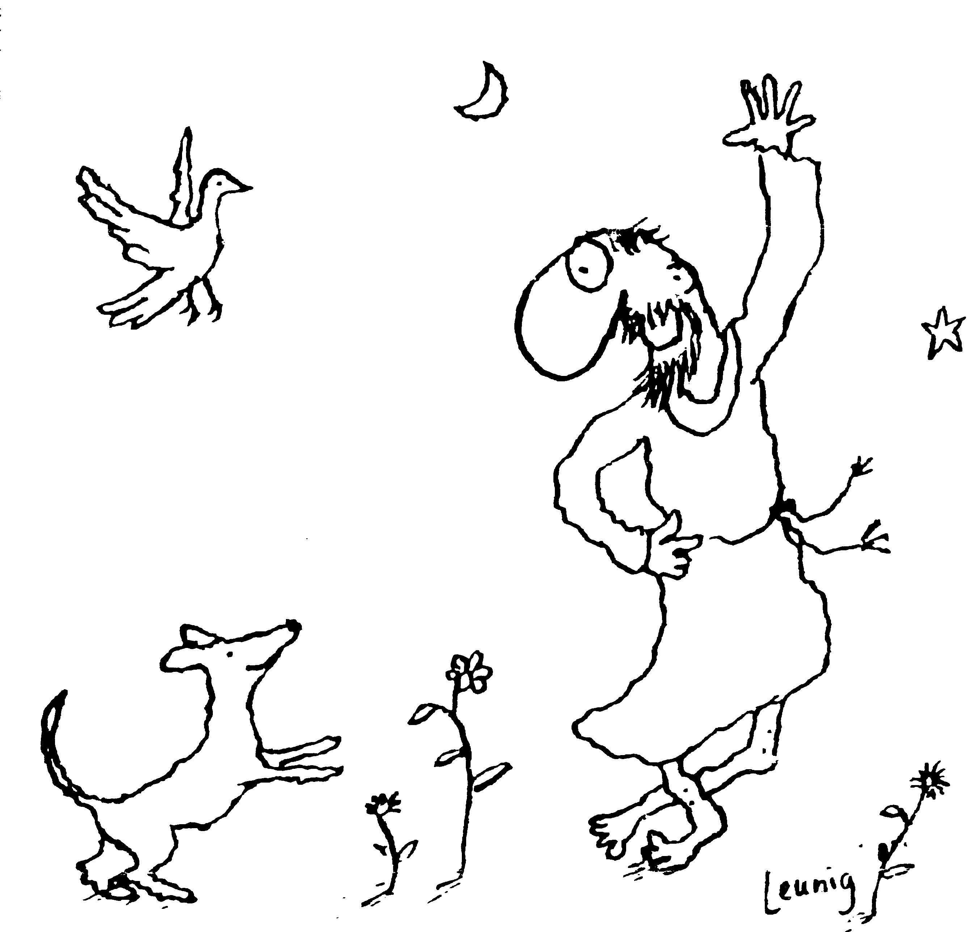
“Praised be you, My Lord, through all your creatures!”
Franciscan Readings for
the Week Commencing
20th May, 2007
7th Week Easter – C/1

Sunday ASCENSION DAY 20 May 2007
(A Reading from the Office of the Passion)
Sing to the Lord, kingdoms of the earth,
Sing psalms to the Lord.
Sing psalms to God who ascends above the heights of the heavens
to the rising of the sun.
Behold, the Lord will give his voice the voice of power;
give glory to God!
whose greatness is over Israel;
whose power is in the skies.
God is marvellous in his holy ones;
the God of Israel himself will give power and strength to his people.
Blessed be God!

Monday 21 May 2007
(A reading from ‘The Major Legend of St Francis’ by St Bonsaventure)
The power of the prophetic spirit in the man of God was certainly extraordinary, which restored vigour to dried up limbs and impressed piety on hardened hearts. The transparency of his spirit was no less wondrous; for he could foresee future events and even probe the obscurity of conscience, as if another Elisha rivalling the two-fold spirit of Elijah.

Lord, give us the spirit of insight. Help us to be the wise counsellors, the ones to whom people turn in distress. Let us be the face of mercy to all.

Tuesday 22 May 2007
(A reading from The Major Life of St Francis by St Bonaventure)
There was a friar who, devoted to God and Francis, had decided that those whom Francis embraced as friends would be worthy of divine favour but those who were excluded by Francis, on the other hand, would not be regarded among God’s chosen ones. This created much anxiety for the friar who desperately tried to get on Francis’ good side and to be near him. Finally, Francis said to the friar, “Let no thought disturb you, brother, for you are among the ones who are very close to my heart.” From that day on, the friar was placed at ease and grew in grace over the years.

Lord, the desire to be thought of as especially favoured by people that we admire is strong, just as the need for affirmation and attention drives us to impress and ingratiate ourselves with others. Help us Lord to be people of faith and may we feel your loving presence embracing us tenderly in our daily struggles.

Wednesday Basilica of St Francis 23 May 2007
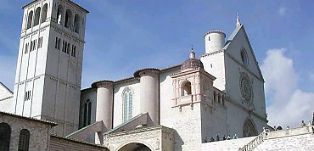
The Basilica of ST Francis in Assisi is one of Italy’s most famous sites. It’s construction period was relatively short – from 1228 to about 1253, a testament to the great love people had for St Francis. For the next one hundred years, the Basilica which is divided into an Upper and a Lower Basilica evolved with the contributions of Italian artists. Most notably, the Giotto Sequence of the life of St Francis adorns the ceiling of the Upper Basilica and the “Enthroned Madonna with Angels and St Francis” by Cimabue. The remains of St Francis are in a small sarcophagus beneath the high altar – visited by thousands of pilgrims each year.

(A reading from ‘The Major Legend of St Francis’ by St Bonaventure)
Just as that blessed man had shone in his life with marvellous signs of virtue so from the day of his passing until the present, in the different parts of the world he shines with outstanding examples of miracles through the divine power that glorifies him. Remedies for all sicknesses, necessities and dangers are conferred through his merits on the blind and the deaf, the mute and the crippled, the paralytic and the dropsical, the possessed and the leper, the shipwrecked and the captive. But also many dead are miraculously brought back to life through him. Thus, the magnificence of the power of the Most High, doing wonders for his saint, shines forth to the faithful. To him be honour and glory for endless ages of ages. Amen.

Lord, may our holiness be enshrined as in your basilica in Assisi. Let those who witness our holiness do so as example of your love for us and of our return to you.

Thursday 24 May 2007
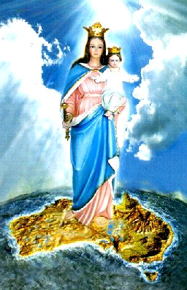
Just as Mary was often invoked as the protectress of armies going to battle, so it was that the invocation Auxilium Chriatianorum was probably first used in relationship to Mary upon the return of warriors from the battle of Lepanto in 1517. It increased in popularity throughout the troubled years of the early 1800s. Several missionary groups, the new soldiers for Christ, operated under Mary’s patronage and spread devotion to Help of Christians in the nations where they evangelised. The Salesians of Don Bosco would be typical of this. Australia was placed under Mary’s patronage in 1888.

(A reading from The Major Life of St Francis by St Bonaventure)
Francis, the herald of truth, cast out devils and healed the sick, but, even greater, he softened the obstinate minds of sinners and moved them to penance. In the city of Toscanella, he was staying at the house of a knight whose son was crippled since birth. At his father’s insistence, Francis lifted the boy up and he was cured instantly – all his limbs were restored to full strength. At Narni, at the request of the bishop, Francis made the sign of the cross from head to foot of a paralytic who was cured immediately. At Gubbio, a woman was healed whose hands had been so withered that she could do nothing with them – by sundown, she had prepared a meal for the townsfolk with her two cured hands. In the village of Bevagna, Francis touched the eyelids of a girl born blind and she could see again.

Lord, miracles are not just the domain of saints. May we be your miraculous presence for others. Show us how we can make the blind see, the deaf hear and the paralysed walk upright again.

Friday 25 May 2007
(A reading from ‘The Acts of the Process of Canonisation’ of St Clare)
Sister Benvenuto of Perugia, nun of the monastery of San Damiano, said that a certain friar called Stephen was mentally ill. Francis sent him to the monastery of San Damaino so that Clare could make the sign of the cross over him. After she had done this, the friar stayed for the afternoon and rested. When he left, his mind was restored to wholeness. But Clare and Francis did not limit themselves to the great miracles! Sister Benvenuto also tells the tale of a little boy from Spoleto called Mattiolo who had put a small pebble up his nose in such a way that it could not be extracted. Clare made the sign of the cross over the little boy’s nose and the pebble dropped out immediately.

Lord, we witness greatness all around us. May we take as much notice of the small miracles people perform as well as the larger, more impressive feats. In every instance, may we be appreciative and thankful for your blessings upon us.

Saturday 19 May 2007
(The Acts of the Process of Cononisation of St Clare)
Sister Cecilia of the monastery said that St Clare had the gift of insight and would use her wisdom for the benefit of the sisters. She would cure many sisters by the sign of her cross. Once, Clare told a woman not to enter because she would not even last three years let alone six months. The woman entered but left very shortly after. Clare’s knowledge was not that of the shrew or the clairvoyant but that of a woman who understood the world around her.

Lord, you bless us with the gift of insight. Grant us the discernment and honesty to use our skills of insight with discretion.

