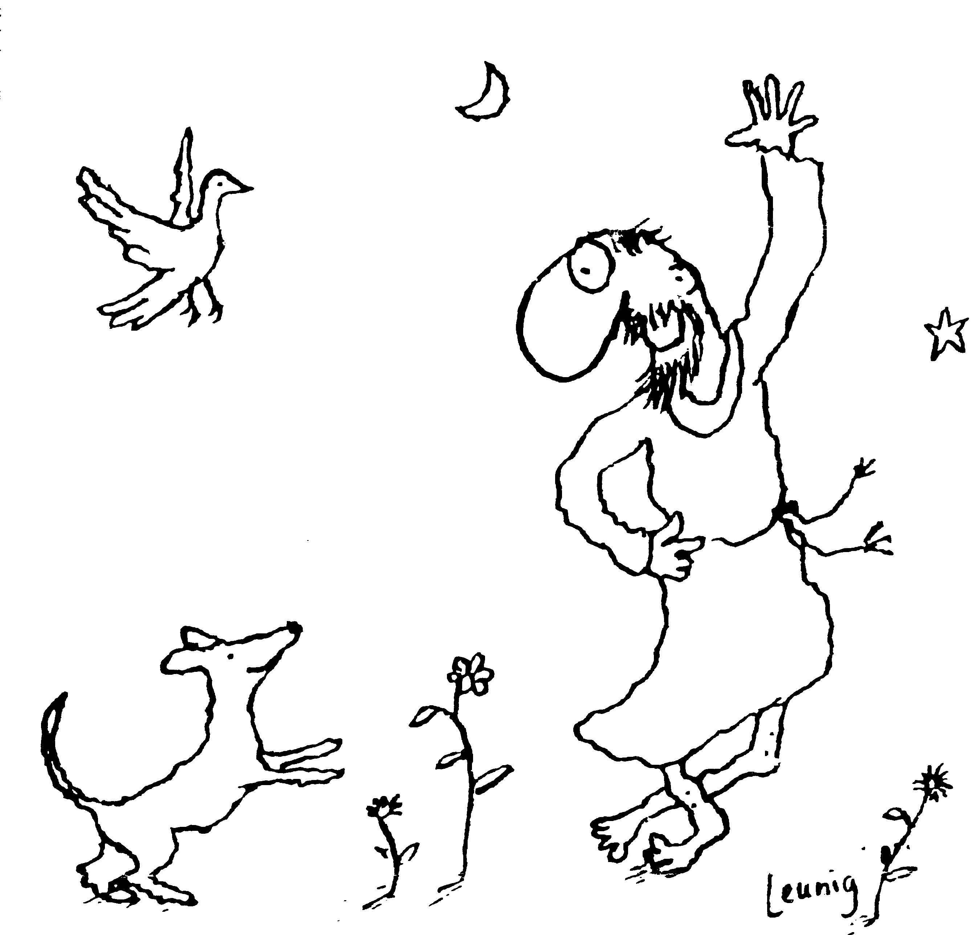
“Praised be you, My Lord, through all your creatures!”
Franciscan Readings for
the Week Commencing
14th January, 2007
2nd Week in Ordinary Time – C/1

Sunday 14 January
(A Reading from the Legend of the Three Companions)
Two of the brothers were in Florence and were finding it difficult to find lodgings as they went begging throughout the city. The came upon a house with a big verandah, beneath which was an outdoor bread oven. The lady of the house was somewhat reluctant to let them inside but acceded to their request to sleep on the verandah near to the bread oven. Her husband, upon discovering the friars asleep on their doorstep, remonstrated with his wife saying, “How could you let these scoundrels into our home? They will rob us blind!” But, fearing only the loss of firewood, he let them stay on account of it being so cold outside. In the morning, the friars went to the Church for Matins. The wife was also at the church and said to herself, “If these men were just common thieves, surely they would not persevere so faithfully in prayer.” She welcomed them into her home and the friars gratefully responded, “May the Lord bless you for your good will.”

Lord, make our homes a place of welcome for the stranger. Help us to welcome you just as Jesus embraced the sinner to himself.

Monday 15 January
(A Reading from the Legend of the Three Companions)
A man named Guido was distributing alms to the poor in the church. He came to the friars and offered them alms but they refused. “But,” he said, “you are poor – why don’t you accept offerings?” The first companion, Brother Bernard, said, “It is by the grace of God that we have made ourselves poor. It is his counsel we fulfilled.” Guido was astonished and he asked them if they had ever possessed anything. They answered that they had but had given everything to the poor for the love of God.

Tuesday Berard and Companions - Protomartyrs 16 January
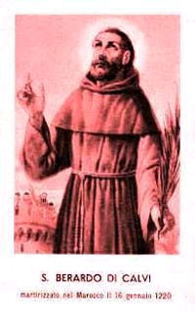
Berard of Carbio joined the Order in 1213. He was an intelligent man, spoke Arabic. He was a passionate preacher and was admired by Francis who thought that Berard would make a fine missionary as the Order extended through Northern Europe. On their maiden voyage to Germany, things did not go very well. While his Arabic was fine, the friars discovered that their total knowledge of German was the word for ‘yes’, ‘Ja.’ Asked if they required food and shelter, they enthusiastically replied, “Ja!” But then asked if they were heretics sent from the devil, they replied in the same way which saw them beaten and imprisoned. Not to be put off, Berard and two priests, Otto and Peter, with two brothers, Accursius and Adjunta, set off for Morocco in 1220. They were beheaded by the King for preaching against Mahomet and became the first martyrs of the Order. When the friars were later rejoicing in this, Francis said, “Their legend should be written with the words, ‘Let each rejoice in his own suffering and not that of another.” When challenged about the fruitlessness of this expedition, Francis replied, “There is a time and opportunity for every business.”

(A Reading from the Chronicle of Jordan of Giano)
In the year 1219, St Francis held a Chapter at St Mary of the Angels whereby he sent brothers to Spain, Francis, Germany and Hungary and the other Provinces of Italy. Those who went to Germany did not know the language and when asked if they wanted shelter or food or the sort, they answered ‘Ja’ and in this way received good welcome. However when they were asked if they were heretics, they also replied, ‘Ja.’ Some were beaten, some imprisoned and some stripped and dragged naked to court. They returned to Assisi. Five of these brothers, Berardus, Peter, Otto, Accursius and Adjutus went to Morocco whereupon they were martyred for preaching against Mohomet. Francis would not have the assembly glorify these martyrs, saying “Let each glory in their own suffering and not in that of another.”

Lord, you do not require martyrdom of us but wish for us to die a little to our wants and desires each day. Let us think first of our own self-discipline before casting an opinion on that of another.

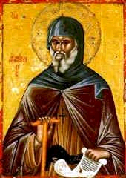
Wednesday St Antony 17 January
Antony was the founder of Christian monasticism and is known as significant among the Desert Fathers, so-called for their penchant for spending their lives in solitude. He was born in Northern Africa in the mid 200s to well-to-do parents. Given to an ascetical life, he retired from the world to Egypt when he was in his early thirties. There he did battles with his demons. For twenty years he did not see or speak to another person, food being thrown to him over the wall of his fort. Then, at the pleadings of those around him, he emerged just as he had entered – fit and healthy. He committed the rest of his life to a less-exclusive self-exile, assisting in the Arian problem and in giving sermons on the religious life. He died at 105 years of age, according to St Athanaisius, in the mid fourth century.

(A Reading from the Legend of the Three Companions)
People saw that they friars rejoiced in their trials, persisted in their prayers, neither accepted or carried money and possessed a great love for each other. As a result, many men asked to join the friars and were sent to Santa Maria degli Angeli for a predetermined time. Each day they were conscientious in prayer and working with their hands to avoid idleness, the enemy of the soul. They rose in the night to pray and they loved one another greatly, as a mother loves her child. Charity burned within them so that it seemed as though they lived purely for others.

Lord, help us to be people of commitment – commitment to our work, to our prayer and to our neighbours. May we live the example of Jesus Christ more closely each day.

Thursday 18 January
(A Reading from the Legend of the Three Companions)
One day, two friars were walking into a town when a simpleton began throwing rocks at them. One friar ran to stand in front of the other, preferring that the rocks strike him than his brother. They were so grounded in humility and love that one respected the other as father and master, while those who excelled by way of the office of prelate, seemed humble and more self-effacing than others. They dedicated themselves to obedience, prepared for the will of the one giving orders. They did not distinguish between a just or unjust command – for they believed that all commands came from the will of God. If they ever uttered a harsh word, their conscience troubled them until they confessed their fault and made amends.

Lord, let us be peacemakers. May we sacrifice our own particular will for the benefit of hearing your voice more clearly.

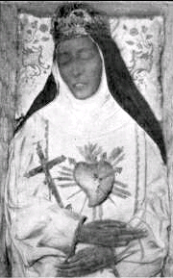
Friday Eustochium Calafato 19 January
Foundress and Poor Clare. She was born circa 1435, the daughter of Countess Matilda Carafata, at Messina, Sicily. Betrothed, Eustochium lost her fiance before they could wed. When her father died in 1446, she became a Poor Clare at Bascio convent and devoted herself to penance and charitable activities. Her mother and sister were at Monte Vergine Convent, and Eustochium went there for the stricter observances. She became abbess in 1462. She was canonized in 1988. In some lists her name is Eustachia or Smaragda.

(A Reading from the Legend of the Three Companions)
The friars did not appropriate anything as their own but they had the use of books and other common items. Although there was real poverty in and among them, they were generous and openhanded with everything given them for God’s sake. If they met a poor beggar on the road and they had nothing to give, they would tear off part of their habit to give to them, sometimes tearing off their capuche, or tearing off a sleeve. Francis himself would do this. He was given a new cloak at the Portiuncola but, encountering a poor woman on this way out of the town, he gave the cloak to her. He did so freely and quickly.

Lord, how much more can we give to the poor? Help us to have the courage to share their condition and to lighten their burden. May our comforts and needs be a lesser priority than the love of other people.

Saturday 20 January
(A Reading from the Legend of the Three Companions of St Francis)
Seeing that the Lord would increase his brothers in number and merit, since there were already twelve, including St Francis, Francis said to the eleven, “Since we are blessed with numbers, let us go to our mother, the holy Roman Church and inform the Supreme Pontiff what the Lord has begun to do in us that, with his will and command, we may continue to do what we have undertaken.” So, all agreed, they set off for the Curia in Rome. Francis said, “Let us make one of us our leader and consider that man a kind of vicar of Jesus Christ, so that wherever he wants to go, we will go, and whenever he wants to rest, we rest.” And they chose Brother Bernard and they served him as Francis had said.

Lord, we often must make risky decisions that involve sacrifice of our own will. Let us follow happily those who represent kindness and the will of Christ. Make us true examples of Francis in his ability to lead as well as follow.

